

Internet Banking
for Corporate clients
User manual
Web Client

Internet Banking for Corporate clients User manual Web Client 1
1 Preparing for the First Login 6
1.1 System Requirements 6
1.2 Recommended browser settings 6
1.2.1 Caching 7
1.2.2 Browser security settings 7
1.2.3 Recommended platforms 7
1.2.4 Deletion of cookies 7
1.2.5 Printing documents 7
1.2.6 List of allowed characters 8
2 First login 9
2.1 Changing the primary password 9
2.2 Working key and certificate generation 10
2.3 Saving the certificate 12
3 Login 13
4 document Signing 16
4.1 Sign documents on behalf of another user 18
5 Functionality 20
5.1 System Menu 20
5.2 Main page 22
5.3 Work with documents in national currency 25
5.3.1 Operations depending on the status of the document 28
5.3.2 Create a new payment 29
5.3.2.1 Description of the "Budget" section 34
5.3.3 Templates 35
5.3.4 Import documents in national currency 37
5.4 Regular orders 38
5.4.1 Creating a Regular Order 40
5.4.2 View payments created by regular orders 43
5.5 Work with documents in foreign currency 44
5.5.1 Currency transfer within the bank 45
5.5.1.1 Creation of a new currency transfer within the bank 47
5.5.2 Request for currency purchase 48
5.5.2.1 Creating a new request for currency purchase 50
5.5.3 Request for currency sale 55
5.5.3.1 Creating a new request for currency sale 57
5.5.4 Request for currency conversion 61
5.5.4.1 Creating a new request for currency conversion 64
5.5.5 SWIFT currency payment orders 66
5.5.5.1 SWIFT MT document 68
5.5.5.2 SWIFT MX Document 72
5.6 Register of documents 81
5.7 Cards 83
5.7.1 Card statement 86
5.7.2 Card cancellation 87
5.7.3 Card blocking 87
5.7.4 Card limits 88
5.8 Accounts 89
5.8.1 Statement of accounts 90
5.8.2 Account limits 94
5.8.2.1 Limit by document type 95
5.8.2.2 Limit for one payment amount 96
5.8.2.3 Limit for daily payment amount 96
5.8.2.4 Limit for one payment amount by correspondent 97
5.8.2.5 Limit for daily payment amount by correspondent 98
5.8.2.6 Setting authorization limits for an account 98
5.8.2.7 Edit and delete limits 99
5.8.2.8 Formation of payment documents 101
5.8.2.9 Additional signing of documents 101
5.8.2.10 Document processing rules 101
5.9 Salary 104
5.9.1 Salary projects 104
5.9.2 Employee applications 106
5.9.2.1 Creating a new employee application 107
5.9.2.2 Linking an employee to the enterprise 110
5.9.3 Payroll 112
5.9.3.1 Creating a new payroll 114
5.10 Loans 117
5.10.1 Operations with loans. Loan repayment 119
5.10.1.1 Loan repayment 120
5.11 Deposits 121
5.11.1 History of deposit documents 123
5.11.2 Interest accrual schedule 123
5.11.3 Operations with deposits. Creating a new deposit transaction 124
5.11.3.1 Creating a new deposit transaction 125
5.11.4 Requests for opening deposits 127
5.11.4.1 Creating a request for opening deposits 129
5.12 Document exchange 132
5.12.1 Statuses and operations when working with documents 132
5.12.2 DocUpload documents (unilateral signing, initiator – user) 133
5.12.2.1 Downloading a document 136
5.12.2.2 Linking a document to a request 137
5.12.3 DocUpload documents (dual-signed, initiated by the bank) 139
5.12.3.1 Single-signed documents 139
5.12.3.2 Dual-signed documents 140
5.13 Reference books 140
5.13.1 Details of payment correspondents in national currency 141
5.13.2 Payment purposes in national currency 143
5.13.2.1 Description of the elements of the form with information on the structured purpose of payment to the budget 146
5.13.3 Authorized persons 146
5.13.4 SWIFT correspondents 147
5.13.5 Payment purposes (currency) 149
5.14 Messages 150
5.14.1 Creating and editing messages 152
5.14.1.1 Create a new message 152
5.14.1.2 Edit a message 153
5.15 Settings 153
5.15.1 Security settings 153
5.15.1.1 Change your login password 154
5.15.1.2 Certificate change 154
5.15.1.3 Certificate Printing 157
5.15.2 Setting up the display of blocks on the main page 157
5.15.3 Settings on forms with lists 158
5.15.4 Personal settings 160
5.16 Key recovery 164
5.17 Working with external keys 166
5.17.1 Connecting an external key 167
5.17.2 Login with an external key 169
5.17.3 Signing documents with an external key 170
5.17.4 Blocking the work with the external key 172
5.17.5 Printing an external certificate 172
5.18 Ordering services 172
5.19 Product Portfolio 174
5.19.1 Opening a current account 176
5.19.1.1 Creating and signing a request 177
5.19.1.2 Viewing the request 182
5.20 Bank facsimile on printed documents 185
5.21 OpenBanking consents 186
5.21.1 Consent to the transfer of information on the account 187
5.21.2 Consent to confirm payment 188
5.21.3 List of consents given 189
6 System Security Information 191

Preparing for the First Login
Please note: the instructions below are universal and describe the general principles of how the functionality works.
The design of your version may differ from what is shown in the screenshots below.

System Requirements

Hardware requirements
Parameter | Value
Processor | AMD, Intel
CPU clock speed | 2 GHz +
RAM | 2048 Mb +
Hard drive | 80 GB
Software Requirements
Operating System | Other software
Win 10+  macOS Sequoia + | Microsoft EDGE (Chromium),  Safari, Chrome, FireFox (the latest two versions).  For correct operation with EDS (with iSign Desktop), the latest version of Java must be installed, OpenWebStart java 21 for client seats under Mac OS

Recommended browser settings
Depending on the bank's settings and the available method of actions confirming in the system, we recommend using one of the following Internet browsers to work with the following:
- Mozilla Firefox;
- Safari;
- Google Chrome.
Before connecting to the system, you need to set several settings for the browser. The location and name of the custom settings depends on the type of browser. You can find a more detailed description of the recommended settings in the help files and manuals for your browser.

Caching
The browser stores (i.e. caches) copies of web pages, images, and media files in temporary folders to speed up subsequent attempts to view them. To receive updated versions of pages when working with the system, you should disable caching in your browser settings. The sequence of this operation depends on the browser.

Browser security settings
For security purposes, the Internet browser checks the content of web pages for dangerous elements. To get access to pop-up tips, banners and other content of the web page when working with the system, you need to set the security settings of the browser.
To do this, in the security settings:
- Add the address of the site by which you are connecting to the system to the trusted sites/allowed sites zone.
- In the security level settings, set the minimum value of the protection level for the zone of trusted sites/allowed sites (the need for this setting is determined by the security requirements of your browser).

Recommended platforms
The target platform for working with the Web version of the system is a personal computer or laptop with a standard processor architecture (x86) and a screen width no less than 1000 pixels (with an aspect ratio of 4:3).
That is why we do not recommend running the applications on platforms which differ from the standard one (for example, mobile phones or tablets) to avoid interface elements incorrect displaying or failures caused by the platform restrictions, which may interfere with the normal run of the application.

Deletion of cookies
Cookies are small text files that a website uses to recognize your browser. They contain information about the user's preferences (for example, the chosen language of communication), as well as account information.
To ensure the protection of the system, we recommend that you periodically delete cookies. You can delete these files in the user settings of your browser.

Printing documents
For settings for correct printing of documents in the settings of the browser page settings, set the values of the fields on the right and left to 5 mm (or 0) and save the settings.

List of allowed characters
The system implements checking the contents of all document fields. The characters allowed for encryption are provided below:
- Cyrillic symbols: а б в г д е ё ж з и й к л м н о п р с т у ф х ц ч ш щ ъ ы ь э ю я А Б В Г Д Е Ё Ж З И Й К Л М Н О П Р С Т У Ф Х Ц Ч Ш Щ Ъ Ы Ь Э Ю Я ґ Ґ і І ї Ї є Є
- Latin characters: a b c d e f g h i j k l m n o p q r s t u v w x y z A B C D E F G H I J K L M N O P Q R S T U VW X Y Z
- Numbers: 0 1 2 3 4 5 6 7 8 9
- Other symbols: ! " # $ % & ' ( ) * + , - . / : ; < = > ? @ [ \ ] ^ _ ` { | } ~ Ђ Ѓ ‚ ѓ „ … † ‡ € ‰ Љ ‹ Њ Ќ Ћ Џ ђ ‘ ’ “ ” • – — ™ љ › њ ќ ћ џ Ў ў Ј ¤ ¦ © ¬ ® ° ± µ № ј Ѕ ѕ

First login
Follow the Internet banking link and follow the steps to log in for the first time.

Changing the primary password
- On the login form, enter your login and password to enter the appropriate fields, click on the "Enter" button.
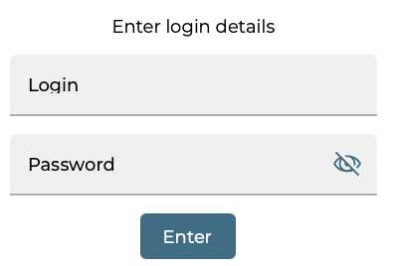
The number of login attempts with incorrect credentials is limited and is determined by the settings in the bank. After they expire, the user will be blocked.
2. If you use a verification with an OTP code sent via SMS to log in, enter the verification code and click on the "Enter" button.
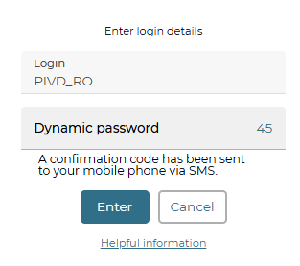

3. The system will prompt you to change your password to log in. Enter your current password in the appropriate field. Please create a new password, enter and confirm it, click on the "Next" button.
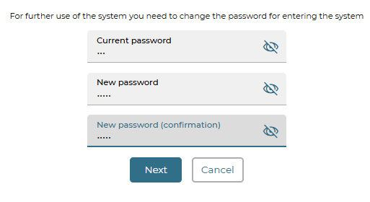
Allowed characters include: a b c d e f g h i j k l m n o p q r s t u v w x y z A B C D E F G H I J K L M N O P Q R S T U V W X Y Z 0 1 2 3 4 5 6 7 8 9 ! " # $ % & ' ( ) * + , - . / : ; < = > ? @ [ \ ] ^ _ ` { | } ~
4. A message about successfully changing the password will be displayed, please close it.
The system will redirect you to the login page.

Working key and certificate generation
- On the login form, enter your login and password to the appropriate fields, click on the "Enter" button, if necessary, enter the OTP code, click on the "Enter" button.
- If you don't have keyless login, the working key and certificate generation form will open (see below).
- If you have the right to enter without a key, the system will prompt you to proceed to the generation of working certificates when you try to sign the document(s).
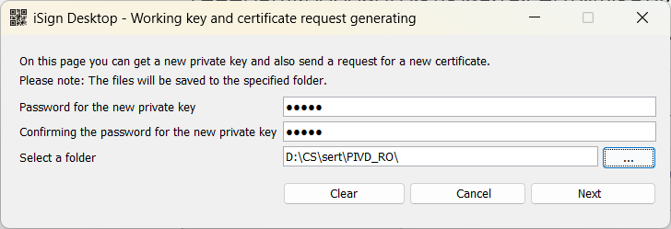
4. On the form for generating a working key and certificate, please create a password for the new certificate, enter and confirm it.
Allowed characters include: a b c d e f g h i j k l m n o p q r s t u v w x y z A B C D E F G H I J K L M N O P Q R S T U V W X Y Z 0 1 2 3 4 5 6 7 8 9 ! " # $ % & ' ( ) * + , - . / : ; < = > ? @ [ \ ] ^ _ ` { | } ~
5. Select the folder where the keys and certificates will be saved. If the folder contains files, select the "Clear folder" checkbox.
6. Click on the "Next" button.
7. If to confirm the key generation, a confirmation with OTP code sent via SMS is used, enter the confirmation code and click on the "Next" button.
8. Confirm the action to send the certificate request, click on the "Yes" button.
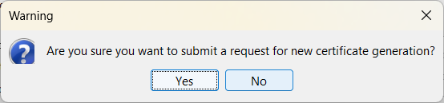
9. If the OTP code sent via SMS is used to confirm the transaction, enter it and click on the "OK" button.
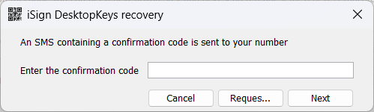
10. The system will display a message about the certificate generation. Click on the "Print" button.
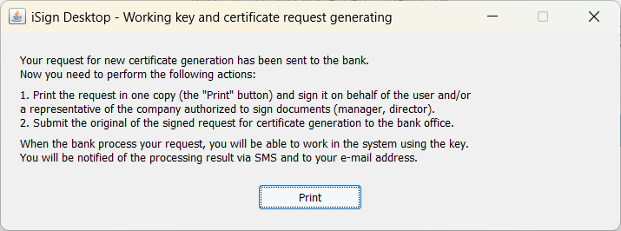
11. Information about the certificate will be displayed in a PDF file. Save it, print it, sign it on behalf of the user and/or a representative of the company with the right to sign the documents (head, director) and submit it to the bank branch.
The system will redirect you to the login page.
If you have keyless login, you can log in until you receive the certificates, signing is not available.
Before authorizing the certificate request, you can re-download the certificate request (pdf file).
When you use the login keys, the message will be displayed after entering the login and password. Select the request file in the folder where the key is located, click on the "Print" button. If you have keyless login, you can select the Security/Printing Request for a New Certificate menu item.
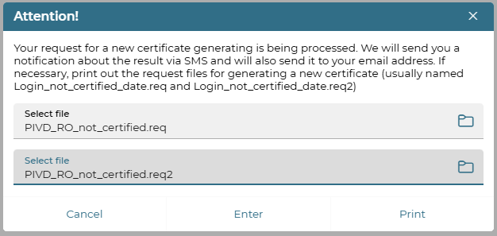

Saving the certificate
You will be provided with information when your request is processed and the new certificate is ready for delivery.
- On the login form, enter your login and password, click on the "Enter" button, if necessary, enter the OTP code, click on the "Enter" button. Proceed to save certificates.
Note: If you have the right to log in without keys, you can go to the Settings/Security/Certificate change to save the certificate. In addition, when you try to sign documents, the system will prompt you to go to save the certificate.
2. In the new form "Save certificate", enter the password to the key, specify/check the path to the key, click on the "Save" button.
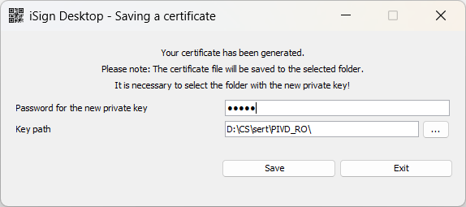
3. Confirm the action to obtain the certificate, click on the "OK" button.
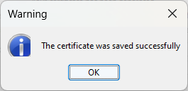
The system will redirect you to the login page.

Login
To connect to the system, follow the internet banking link. A system connection form will appear on the screen.
Please note: for the system to work correctly, it is recommended to set a number of browser settings (see "Preparing for the first login").
The system is multilingual. Use the list to select your preferred interface language at the top right of the page:
- "UA" – Ukrainian;
- "EN" – English;
- "RU" – Russian (if available).
For information about the system, follow the link "Helpful information".
In the new window, you can view useful links, links/downloads, additional information/system information, system security information. The information is provided in the form of sections.
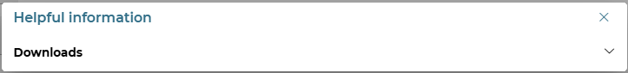
Use the / buttons to expand/collapse the section. The information can be contained in the form of links, download files, and text.
If you use tokens for your work on the system, you can download the driver to work with tokens in the downloads section.

To log in:
- Enter your login and password.
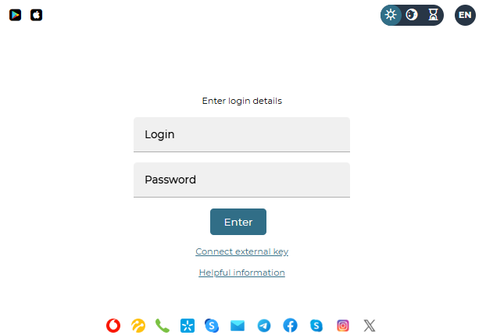
Please note: for security reasons, passwords on the login form are displayed in a disguised form. You can click on the icon to see if you have entered the password correctly. The number of login attempts with incorrect credentials is limited.
- Click on the "Enter" button.
- If you have keyless login and the details are entered correctly, you will be logged in.
- When working with keys, a message will be displayed that you need to perform a login operation in the iSignDesktop application. To continue the operation, launch the iSignDesktop application.
- On the login form, enter the password to the private key, select the folder with the private key.

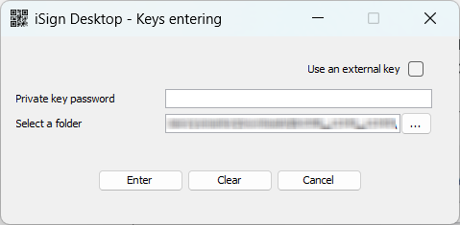

6. Click on the "Enter" button.

7. If you are using an SMS OTP code verification to log in, enter the verification code and click on the "Login" button.

8. If the data is entered correctly, you will be logged in to the system.

document Signing
To confirm an active transaction, you must sign the document(s) before sending it to the bank.
You can sign using an electronic digital signature (EDS):
- On the form with detailed information about the document. To do this, click on the "Sign" button.
- On the form with a list of documents.
On the form with the list of documents, use the checkboxes to mark the document(s) to be signed and click on the "Sign" button. A list of documents to be signed will be displayed. Click "Sign".
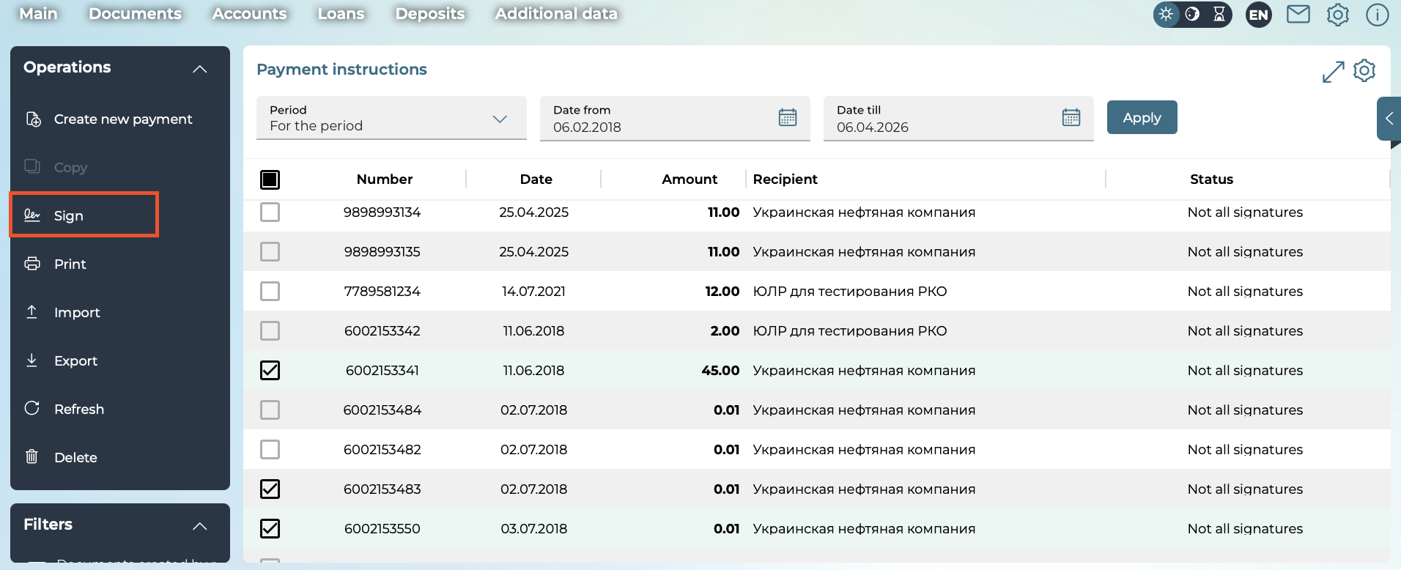
If you use an SMS OTP code confirmation to sign, enter the verification code and click “Next”.
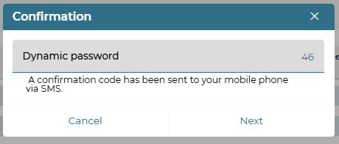
The system will display a message that you need to use iSignDesktop application for signing.
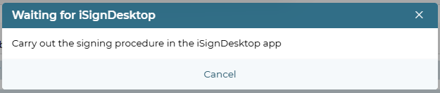
A new window will open with information about the document(s). Check the details, click on the "Sign" button.
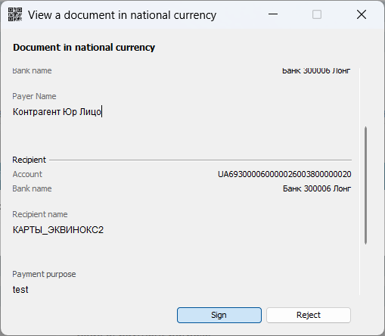
In the new window, enter the password to the private key and specify the path to the key.
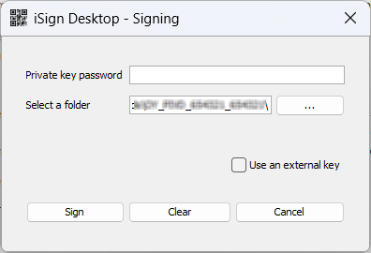
Click on the "Sign" button.
If the data is entered correctly, the system will display a message about the successful result of the signing.
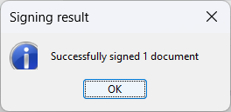
In addition, documents can be signed on the main page, in the "Documents to be signed" panel. At the same time, mass signing of documents of different types, in different currencies, can be performed, see "Setting up the display of blocks on the main page".
Depending on the bank's settings, the option "Signing documents on behalf of another user" may also be available.

Sign documents on behalf of another user
To sign a document on behalf of another user (if available), do the following:
- On the form with the document or list of documents to be signed, click on the "Sign on behalf of another user" button.
- In the new form, select the user on whose behalf the document will be signed from the drop-down list. Alternatively, you can use the search for the right user. To do this, enter the username in the search bar.
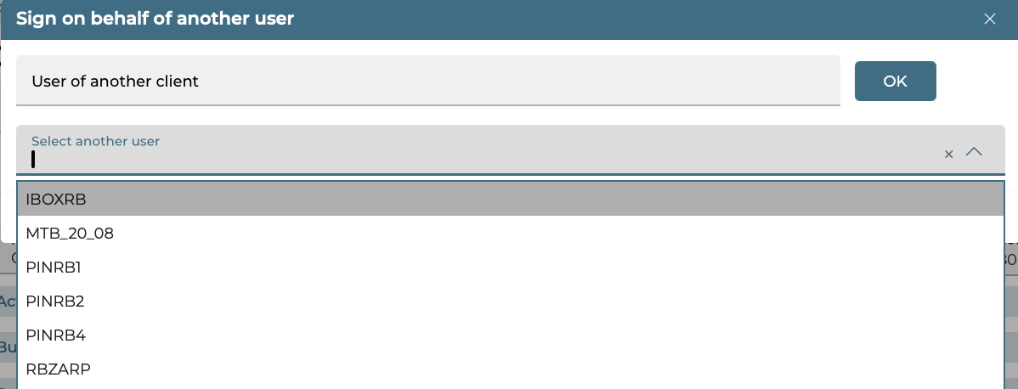
- A message will be displayed stating that you need to perform a signing operation in the iSignDesktop application. To continue the operation, launch the iSignDesktop application. A new window will be opened with information about the document(s). Please check the details of the document(s) and click on the "Sign" button.
- In the new window, enter the password to the private key and specify the path to the key.
- Click on the "Sign" button. If the data is entered correctly, the system will display a message about the successful result of the signing.
In addition, documents can be signed on behalf of another user on the main page, in the "Documents to be signed" panel. In this case, mass signing of documents of different types, in different currencies, can be performed, see "Setting up the display of blocks on the main page".

Functionality

System Menu
The upper dashboard contains the username, the date of the system and the date of the current business day of the bank, the button for switching the placement of the main menu (horizontal or lateral location) - , the exit button for the correct end of the session - .
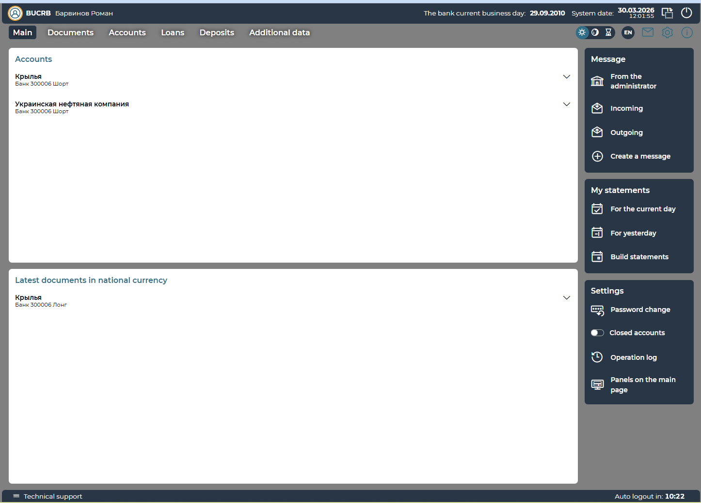
Please note: menu items are displayed depending on the configuration of the system and the rights granted to you, so some of them may be missing from your version of the application
With the help of the main menu items, you can proceed to perform the following actions/view the following information:

Menu section | Description
Main | Return from any page of the system to the main page
Documents | Payment instructions – go to documents in hryvnia (see Payment instructions). "Work with documents in national currency");  National currency payment templates – see Payment templates. "Templates";  Currency transfer within the bank, SWIFT, Currency purchase, Currency sale, Currency conversion, see "Work with documents in foreign currency"  Documents approved by bank (see "Register of Documents");  Regular Orders (if available)
Accounts | All accounts – view accounts (see "Accounts");  Statement of accounts – order a statement of accounts (see "Statement of accounts")
Loans | Go to working with loans (see "Loans")
Deposits | Go to working with deposits (see 'Deposits')
Additional data | Reference books – view reference books (see "Reference books");  Salary - go to work with the salary system (if available)  Document exchange - go to secure exchange of electronic documents with the bank (if available);  Additional services/Connecting products and services (if available)
 | Switch to change the interface design.  - system design in light colors;  - system design in dark colors;  - automatic color changes based on the time of day  Please note: depending on the settings set by the bank, this switch may not be displayed on the form
 | System language selection buttons:  - UA – Ukrainian  - EN – English  - RU – Russian (if available)
 | Go to the messaging section with the bank
 | Go to settings
 | Go to viewing system reference information

Main page
Use the / buttons to reveal/hide information in blocks.
1. The "Accounts" block displays a list of your accounts. Accounts are grouped by correspondents. Account balances are displayed grouped by currency.
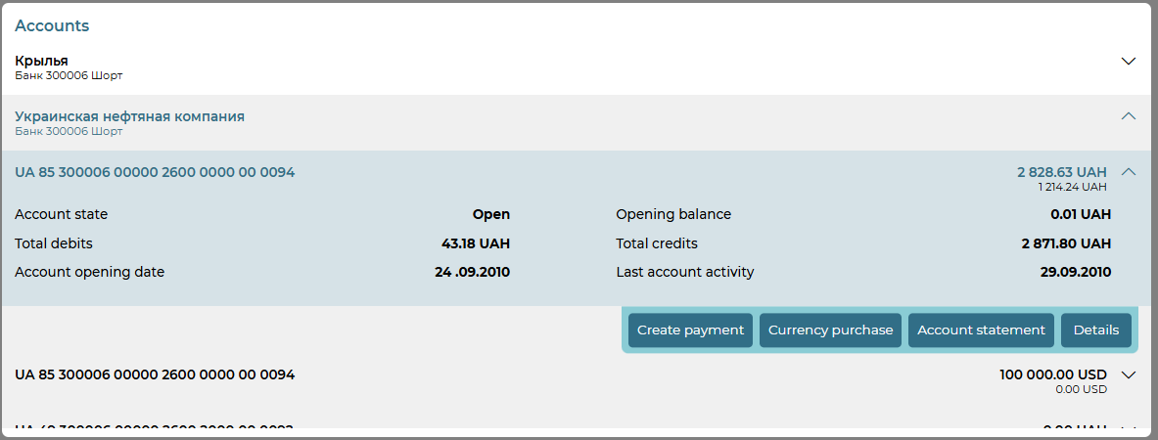
After selecting an account from the list, you can view the following information:
- Account status.
- The balance at the beginning of the current day. At the same time, only archival documents on customer accounts on closed days, which were sent by the user of the system and processed by the manager in the bank CBS, are taken into account.
- Amounts of total debits and credits.
- Account opening date.
- The latest account activity.
You will have access to buttons for quick transition:
- "Details" – to view account details.
- "Account statement" – receipt of a statement.
- "Create payment" – for hryvnia accounts to which debit is allowed, proceed to create a new payment in the national currency. currency.
- "Purchase of currency" – for hryvnia accounts to which debit is allowed, proceed to the creation of an request for the purchase of currency.
- "Create SWIFT" – for foreign currency accounts to which debit is allowed, proceed to the creation of a SWIFT document.
- "Currency sale" – for foreign currency accounts to which debit is allowed, proceed to the creation of an request for the sale of currency.
2. The "Latest documents" block displays the last documents that the user worked with. The status of the document is displayed in the form of an icon. To view the details of the document, select it from the list.
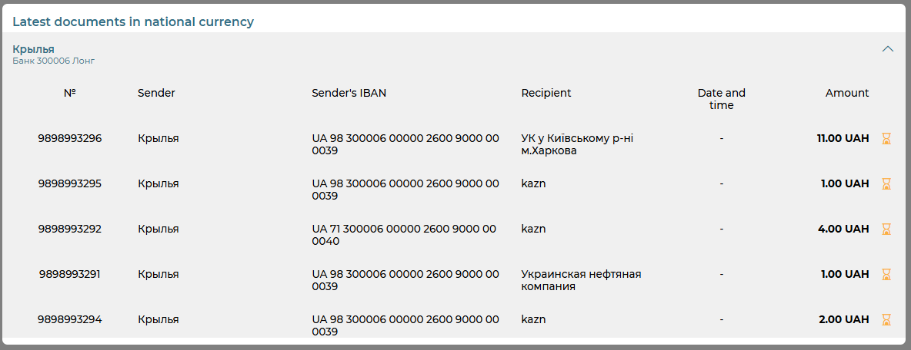
3. The "Documents to be signed" block displays your unsigned documents. Documents are grouped by type.
To sign the document(s), follow these steps:
- Specify the date/period of the documents to be signed (the button ), click on the "Apply" button.
- Select the checkboxes next to the documents you want to sign.
- The total amount of documents will be displayed. Click on the "Sign"/"Sign on behalf of another user" button, see "Signing documents".
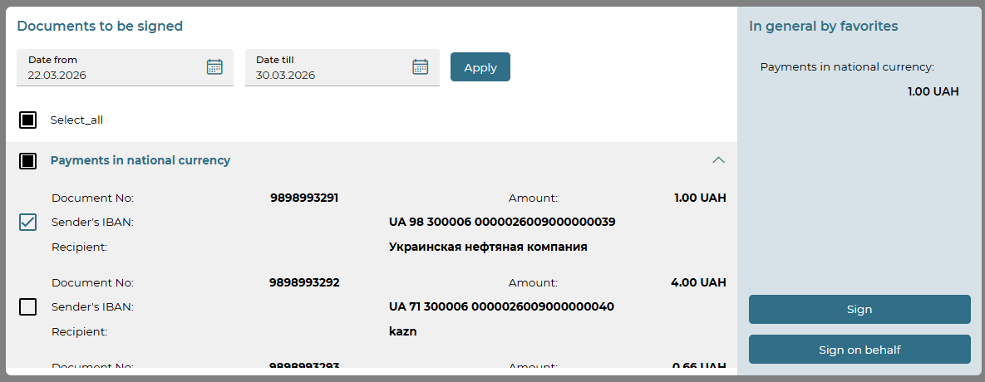
Please note: when signing documents in the "Documents to be signed" block, mass signing of documents of different types, in different currencies can be performed.
4. The "Exchange rates" block displays the current exchange rates. Using the </> buttons, it is possible to view the NBU exchange rates, cash and non-cash.
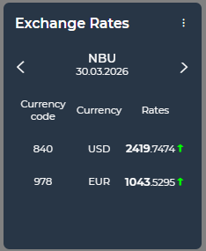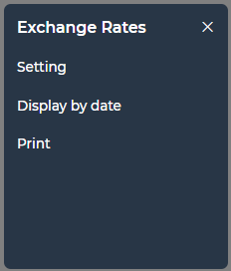
By pressing the button, you can:
- Go to the settings of the list of currencies whose rate you want to display in the list (click on the "Setting" button, select currencies using checkboxes, click on the "Save" button).
- View the exchange rate for the selected date. To do this, click on the "Display by date" button and select the desired date from the displayed calendar.
- Print information on exchange rates. To do this, click on the "Print" button, set the period or date, and click on the "Print" button.
By default, if the user has not selected the currencies to display, the NBU rates and cash rates for USD, EUR, NON-CASH RATES for USD/UAH, EUR/UAH should be displayed. The widget displays at least one user-selected currency or default currencies (unless there were appropriate settings from the user).
5. In the "My statements" block, you can proceed to the formation of a statement for the current working day, the previous day, or go to setting up the statement parameters, see "Statement of accounts".
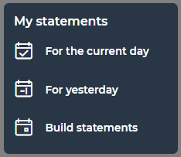
6. The "Message" block displays incoming and outgoing messages, messages from the administrator and their number. To create a new message, click on the "Create a message" button see "Creating and editing messages").
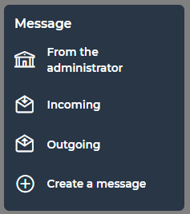
7. The following options are displayed in the "Settings" block:
- Password change (see "Security Settings").
- Closed accounts. To display closed accounts in the list of accounts, turn on the toggle .
- Operation log (see "Personal settings").
- Panels on the main page (see "Block Display Settings").
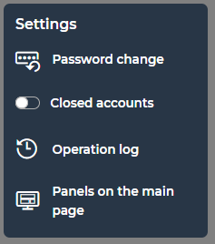

Work with documents in national currency
To view payments in national currency, select the Documents/Payment instructions menu item.
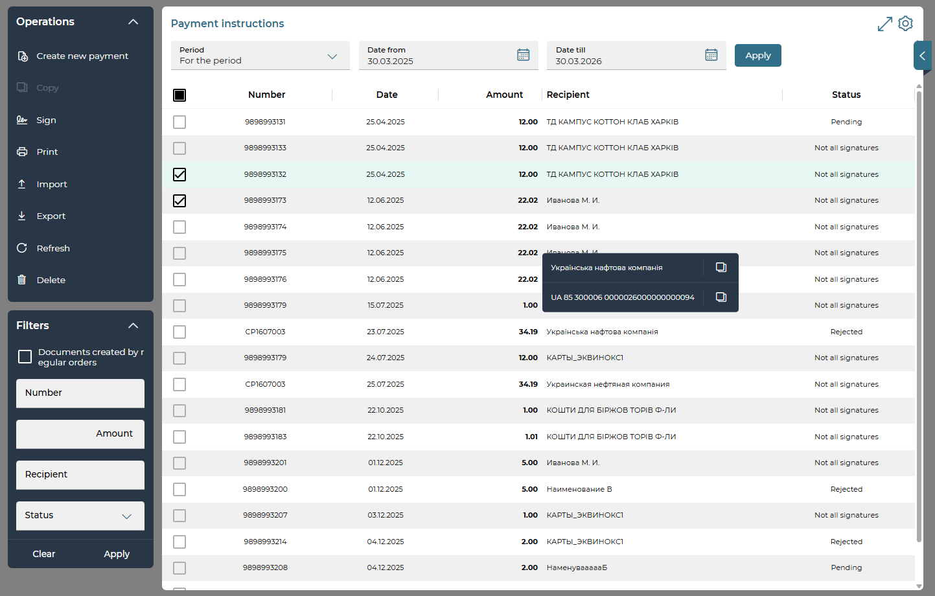
Select one or more documents (turn on the checkboxes in the first column). Above the list of documents, when you click on the button, the number and total amount of selected documents are displayed.
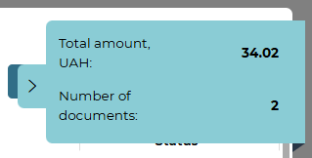
At the same time, the following operations are available with the document(s):
- At the top of the form, select the period for displaying data: for the date, for the previous day, for the month, for the period. If necessary, use the built-in calendar (the  button) to set the date/period, click on the "Apply" button.
- You can set additional filters, sort data, configure the form (see "Settings on forms with lists").
- If the "Not all signatures" status is selected in the "Filters" block, the "Waiting for my signature" switch will be displayed. When you select it, documents that already have a signature and require your signature, or documents on which there is no signature, and you have the right to sign are displayed.
- Signing a payment(s) – the "Sign"/"Sign on behalf of another user" button (becomes active if the user marks one or more payments in the "Not all signatures" status), see "Signing documents".
Please note: mass signing of payments is available only when using an electronic digital signature (EDS).
- Printing the selected document(s) – the "Print" button.
- Import of UAH documents (BOL, DAT, TXT, CSV, DBF, XML, XLS, XML(pain.001)) – the "Import" button (see "Import of documents in national currency").
- Export of UAH documents – for the period specified on the page, taking into account the set checkboxes, the "Export" button. In the form displayed, select the format (XLS, XML, TXT), click on the "Export" button.
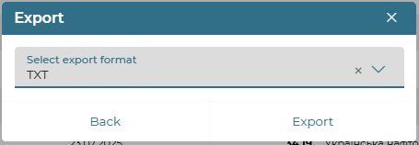
- To create a new UAH payment, click on the "Create new payment" button (see "Create a new payment").
Each line of the document list is a link that you can use to go to the form to view or edit a document in detail, depending on its status and type.
For more information about the elements of the form, see "Create a new payment".
On the detailed view form, depending on the status of the document, the following options may be available to you (the "Operations" block):
- creating a new document – the "Create new payment" button (see "Creating a new payment");
- Document editing (available for documents with "Not all signatures" statuses)
- signing – "Sign"/"Sign on behalf of another user" button (see "Signing documents");
- saving a document without a signature – the "Save without signature" button;
- creating a copy of the payment – the "Copy" button;
- printing a document – the "Print" button;
- deleting a document – the "Delete" button.
For payments in the "Rejected" status, the reason for the rejection of the document is displayed at the top of the form.
To cancel the changes and return to the form with the list of payments, click on the „Back“ button.

Operations depending on the status of the document
Document status | Description | Operations
Creating a document  _______________________________ |  | "Back";  "Save without signature";  "Sign"/ "Sign on behalf of another user"
Not all signatures | The document does not have all signatures | "Back",  "Create a new one",  "Save without signature",  "Delete",  "Copy",  "Print"  "Sign"/ "Sign on behalf of another user"
Pending | The status of the document before it is received by the CBS for processing by the operator | "Back",  "Create a new one",  "Delete",  "Copy",  "Print"
In progress | Intermediate status of the document in the process of transferring the document to the database for a while, while the real status of the document has not yet been determined | "Back",  "Create a new one",  "Copy",  "Print"
Processing | The document was received by the CBS | "Back",  "Create a new one",  "Copy",  "Print"
Rejected | The document was not carried out by the bank indicating the reason for the rejection | "Back",  "Create a new one",  "Copy",  "Print"
Postponed | The document is postponed by the bank (for example, if it is necessary to check certain details or if the document cannot be processed during the business day | "Back",  "Create a new one",  "Copy",  "Print"
Deleted | Document deleted | "Back",  "Create a new one",  "Copy",  "Print"
Approved | The document was conducted by the bank | "Back",  "Create a new one",  "Copy",  "Print"

Create a new payment
To create a new payment in the national currency, please follow these steps:
1. On the form with the list of payments, click on the "Create new payment" button or on the detailed payment view form, click on the "Create a new one" button.
2. A new form "Payment Instruction" will open.
3. In the "Document parameters" section, specify the document date and the value date. The document number will be assigned automatically after selecting the account from which the payment will be made. You can edit this field. If necessary, you can specify the priority of the document in the Priority field.
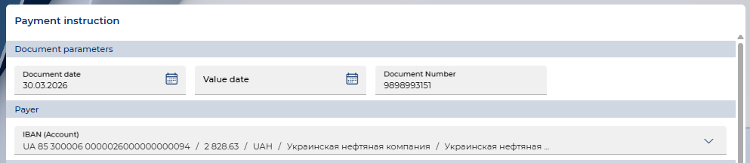
4. In the "Payer" section, from the list available in the IBAN (Account) field, select the account from which you plan to make the transfer.
5. If you need to enter the data of the actual payer (in accordance with the ISO 20022 standard), click on the "Actual payer" button and fill in the appropriate fields. The description of the fields is given in the table below. Alternatively, you can use the “Details of payment correspondents in national currency” reference book to automatically fill in the fields – the button.
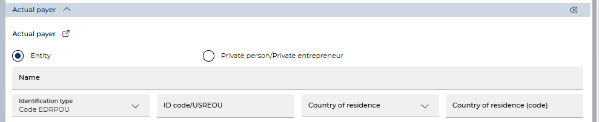
6. In the "Recipient" section, you can enter the recipient's details manually, or select from the “Details of payment correspondents in national currency” reference book by clicking on the button . You must enter the account number in IBAN format, the amount of payment (the forecast balance will be displayed) and fill in other fields of the "Recipient" section, see the table with information on payment participants below.
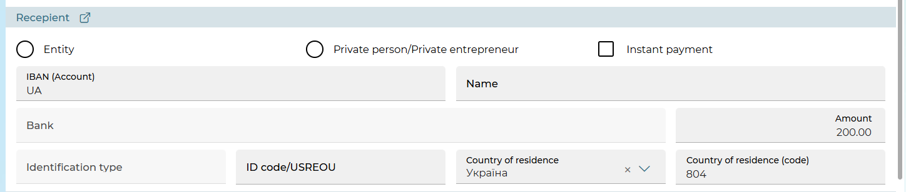
If the bank is configured to work with instant payments, the "Instant payment" checkbox will be displayed. Check it to create an instant payment.
For instant payments, the assignment of the actual payer and/or recipient and limited work with the "Budget" block is not supported (see "Description of the elements of the "Budget" section),.
When editing a payment instruction, editing the "Instant payment" checkbox is prohibited.
In addition, the amount of instant payments may be limited. You can set your own limits for instant payments, see "Personal settings". User limits cannot exceed the limits set by the bank.
7. If you need to enter the data of the actual recipient (in accordance with the ISO 20022 standard), click on the "Actual recipient" button and fill in the appropriate fields. The description of the fields is given in the table below. Alternatively, you can use the reference book to automatically fill in the fields – the button.
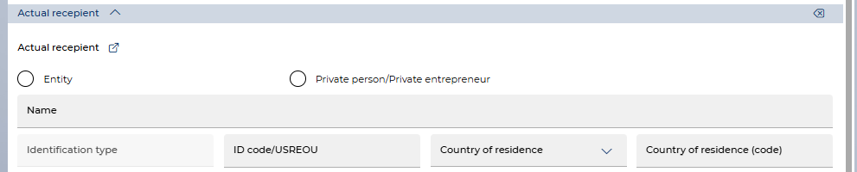
Description of the elements of the section with information about the participants of the payment
Element | Req. | Description
"Entity" / "Private person" | + | With the help of the appropriate switch, it is indicated that the participant in the payment is a legal entity or an individual entrepreneur (according to ISO20022 is identified as an individual)
Name | + | The field for entering the name of the payment participant (recipient/actual recipient/actual payer) is up to 140 characters.  Acceptable characters: letters of the Cyrillic and Latin alphabets, numbers from 0 to 9, other characters (! " # $ % & ' ( ) * + , - . / : ; < = > ? @ [ \ ] ^ _ ` { | } ~ ~ Ђ Ѓ ' ѓ " ... № ј Ѕ ѕ and Space)
Identification type | + | Select the type of identification from the list. Depending on the selected value, the Id. code/USREOU field is filled in.  For legal entities  - USREOU code – 8 digits (not zeros),  - Tax ID (taxpayer registration number), displayed for the recipient – 9 digits (not zeros),  - Code not assigned (Id. code field is filled with the value 0000000000)  For private person:  - Individual tax number (registration number of the taxpayer's registration card) – 10 digits (not zeros),  - Passport – 2 letters and 6 digits or 9 digits (ID card) or 000000000 (for a non-resident),  - Other document – 2 letters and 6 numbers (for a resident),  - No information (the display depends on the settings in the bank) – the Id. code field is filled in with the value 99999
Id. code/USREOU | + | For the field for entering data according to the selected type of identification, see above
Country of residence/ Country of residence (code) | + | Select the name of the country of residence from the list
Location | -/+ | The block is displayed if the following is selected:  - For entities: type of identification – code not assigned (for all participants in the payment) and Tax ID (for the recipient),  - For private persons: type of identification – no information.  Fill in the following fields:  - Country, Country (code) – select a name from the list or enter a code,  - Region,  - District,  - Place (mandatory),  - Street,  - House number (mandatory),  - Apartment,  - Postal code.  If at least one field of this block is filled in, then the required fields of the block must be filled in. The obligation to fill in the data on the location depends on the settings in the bank
Date and place of birth | -/+ | The block is displayed if selected for physical. Person type of identification – no information.  - Place (mandatory),  - Country, Country (code) - select a name from the list or enter a code (required),  - Date of birth (required).  The obligation to fill in data on the date and place of birth depends on the settings in the bank

8. The "Budget" block allows you to proceed to filling in the budget purpose of the payment. Fill in the fields of the displayed form (see "Description of the elements of the "Budget" section). The text "Payment to the budget" will be automatically inserted in the Payment purpose field, while the text of the purpose of payment is not editable and is a link to the "Budget" form. You can add directions of crediting (the "Add enrollment" button, the number of records available for adding is regulated by the settings in the bank) and delete them (the button ).
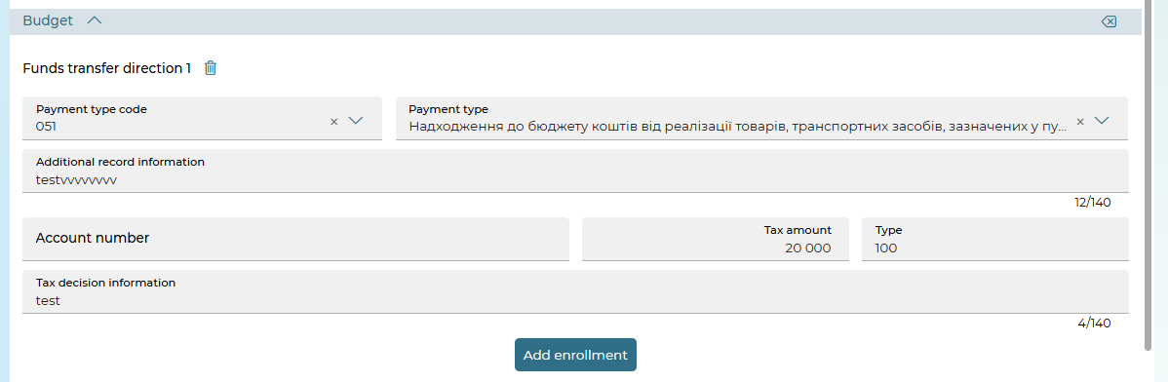
9. In the "Payment details" section:
- From the drop-down list, select Code of payment purpose.
- Using the "VAT" button, you can choose one of three options for displaying value added tax: "VAT 20%" and "VAT included 20%", "without VAT", or enter your own VAT value.
- Enter or select Payment purpose from the reference book – the button .
- If necessary, enter the Additional details of the document.
- If necessary, enter a Payment comment.
- Select the "Save as a template" check box to save the payment purpose in the payment assignment reference book for this correspondent.
- Select the "Save the payment as a template" check box to save the document in the template list.
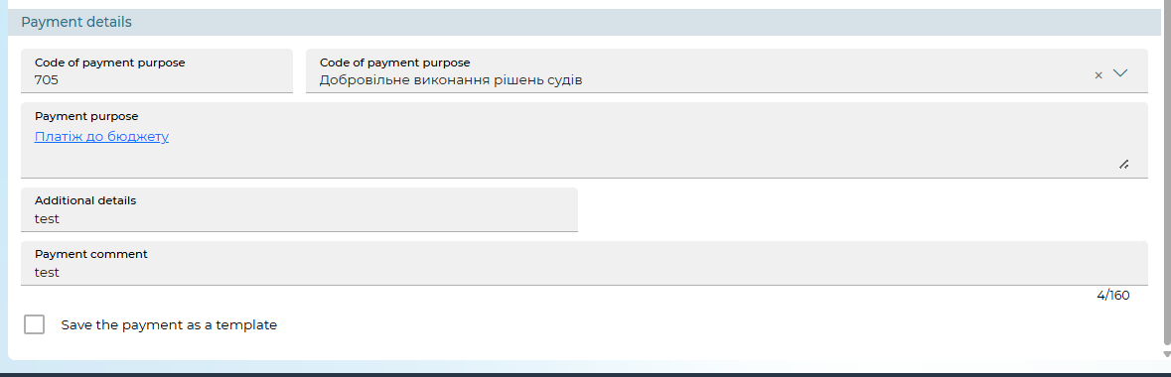
To save a payment without a signature, click on the "Save without signature" button.
To send a payment to the bank, sign the document (see Table 1). "Signing documents"). If the document was successfully sent to the bank, a corresponding message will appear on the screen.
To return to the previous page unchanged, click on the "Back" button.

Description of the "Budget" section
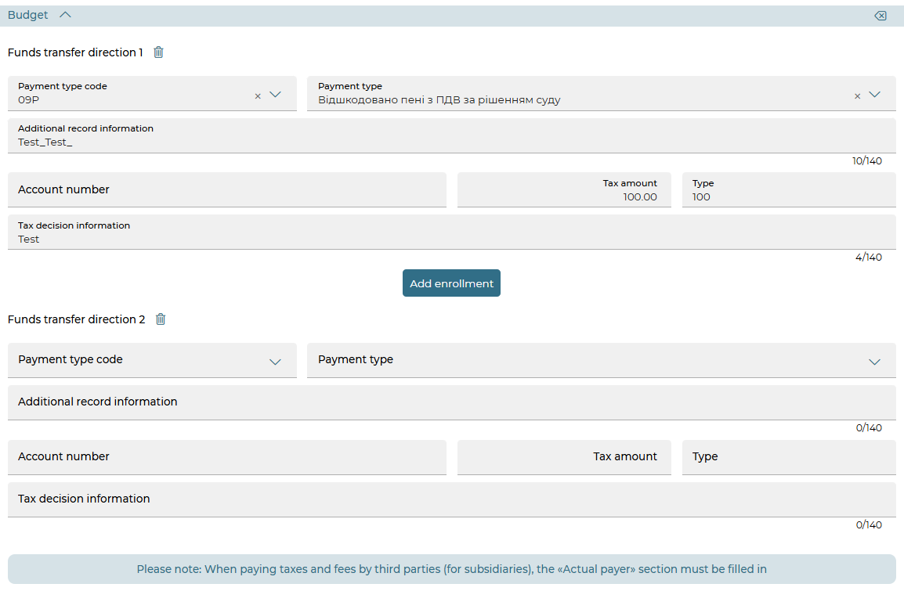

Element | Req. | Description
Payment type code, Payment type | - | Select the desired value of the payment type code or payment type from the list
Additional record information | - | Enter additional recording information (up to 140 characters)
Account number | - | Enter the account number in IBAN format.  For instant payments, the field is not available
Tax amount | - | Enter the amount of tax.  Attention! The total amount of all directions of crediting should be equal to the amount of the hryvnia document.  For instant payments, the field is not available
Tax decision information | - | Enter information about the tax notice (decision) (up to 140 characters).  For instant payments, the field is not available
Type | - | Enter the budget revenue classification code (up to 35 characters)
 |  | The button to delete the entered data on the "Budget" form
"Add enrollment" |  | The button to add a new entry for enrollment in the budget. The number of crediting directions available for addition is regulated by the setting in the bank.  For instant payments, the button is not available (instant payments do not support more than one crediting to the budget)
The button to remove the funds transfer direction in the budget.
For instant payments, the button is not displayed

Templates
The system allows you to create documents based on templates. In this case, the fields of the new document are filled with values from the template. You can view the list of templates by selecting the Documents/National currency payment templates menu item.
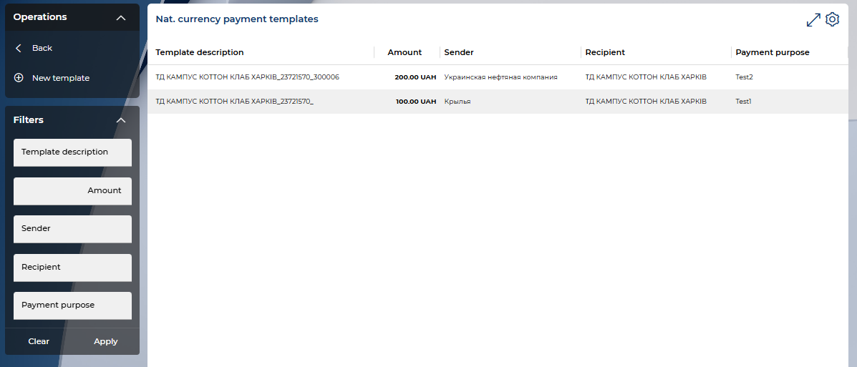
On the form with a list of templates, you can perform the standard settings of the form with a list of documents, see “Settings on forms with lists”.
The template creation and editing form is identical to the form of creating UAH documents, however, the value date is set not as a date, but as the number of days that will be added to the document date (at the time of creating a hryvnia document based on the template) to generate a value date for a new hryvnia document (Days till value date field).
To create a document template:
Method 1
Create a regular document (see "Create a new payment"), and before saving (signing) it, check the "Save the document as a template" box.

Method 2
- Select the Documents/National currency payment templates.
- Click on the "New template" button.
- Fill in the template fields with the required values.
- Save the recording.
Please note: if you want the template to be available to other users, check the box "Set the template public". If the template should be available only to you, uncheck the option.
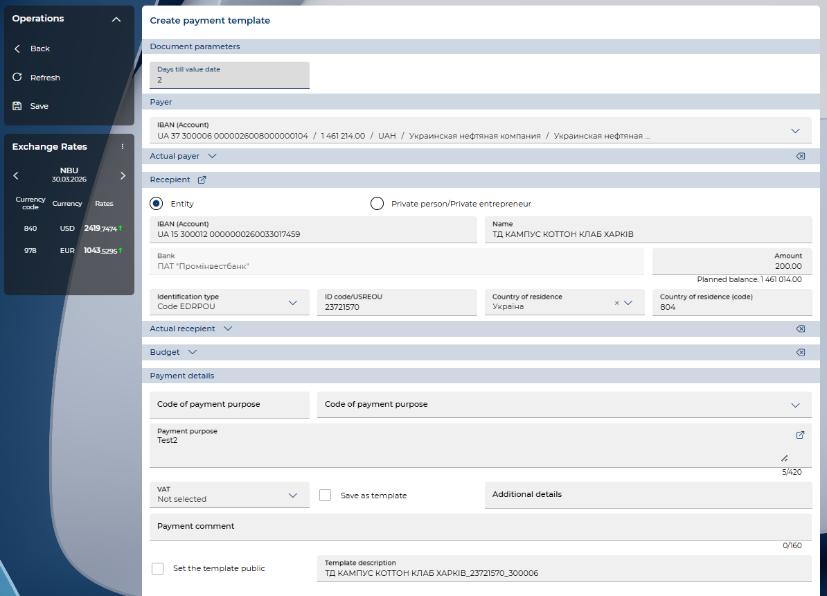
To edit a document template:
- Select the menu item Documents/National currency payment templates.
- Click on the record line with the desired template.
- Make the necessary changes to the template fields.
- Save the recording (the “Save” button).
To delete a template, click on the "Delete" button.

To create a document based on a template:
- Select the Documents/National currency payment templates.
- Click on the record line with the desired template.
- Click on the "Create payment" button.
The system will create a new document and fill in its fields with the values of the template fields. You can sign and send the document to the bank (see "Signing documents").
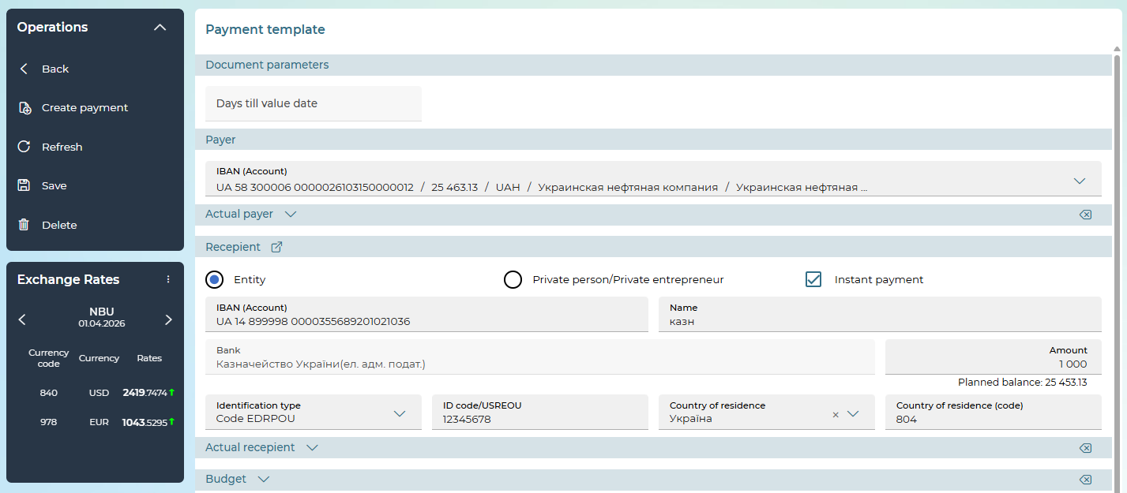
Please note: if you create a new document template with key parameters similar to the template that is already in the database, the system will automatically replace the previously created template with a new one.

Import documents in national currency
The system implements the ability to import hryvnia documents from files of BOL, DAT, XML, TXT, XLS, DBF, CSV and pain.001 formats.
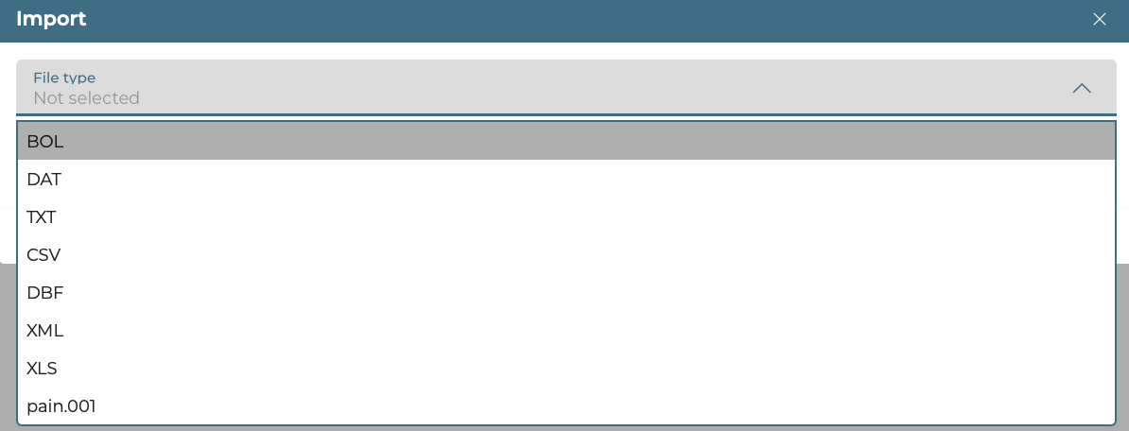
In order to import documents, go to the Documents/Payment Instructions menu item and click on the "Import" button.
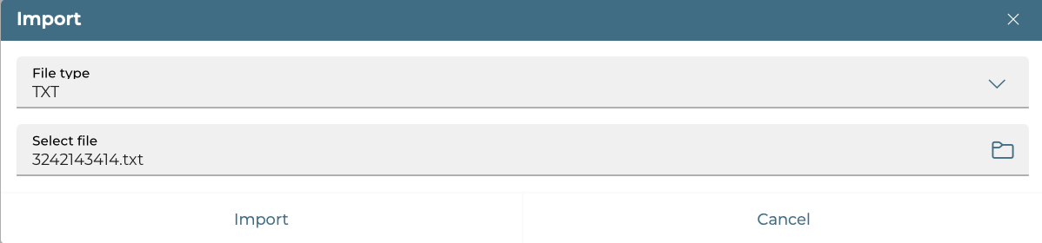
Select the format for importing documents, then specify the local file with the documents you want to import, and then click on the "Import" button.
The new form will display a list of documents that can be imported without errors, and a list of documents that have not been verified by the bank due to errors.
Documents that do not contain errors can be saved without a signature or signed (the buttons "Sign" and "Sign on behalf of another user") and sent to the bank.
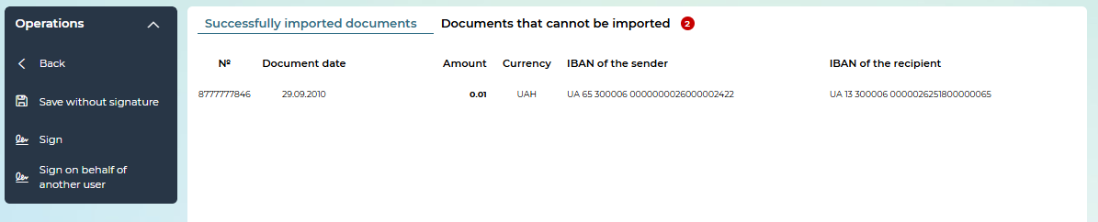
Click on a line in the list of documents that cannot be imported to see the decryption of the error(s) that occurred during import. Click to hide the line with the decryption.
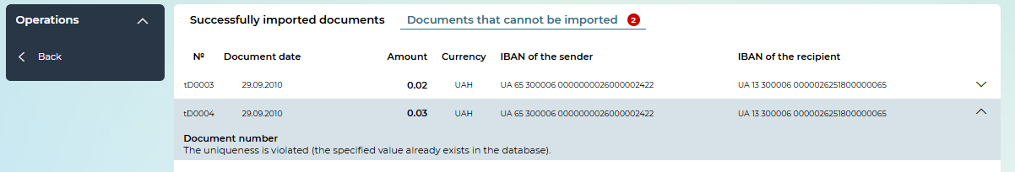

Regular orders
The functionality of regular payments allows you to schedule transfers of funds in national currency between your own accounts or to the accounts of other recipients in Ukraine.
When creating a new order for the formation of payments, you configure the frequency, the amount of payment, the priority of receipt of the payment document in the bank (see "Creating a regular order").
The system generates payment documents according to the created order with the specified frequency and sends them for execution to the bank's CBS.
To work with regular payments, select the menu item Documents/Regular orders.
The form will display a list of orders that you have created.
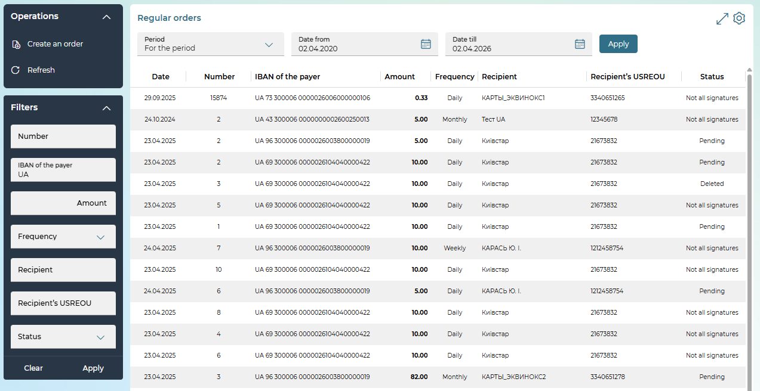
The following operations are available on the form:
- At the top of the form, you can select the period for displaying data: by date, for the previous day, for a month, for the period.
- You can set additional filters, sort data, configure the form (see "Settings on forms with lists").
- You can create a new order: click on the "Create an order" button (see "Creating a regular order").
Each line in the list is a link that you can use to go to the form to view or edit a document in detail, depending on its status and type.
For more information about the elements of the form, see "Creating a regular order".
On the detailed view form, depending on the status of the document, the following options may be available to you (the "Operations" block):
- creating a new document – the "Create new" button (see "Creation of a regular order");
- document editing (available for documents with "Not all signatures" statuses)
- signing – "Sign"/"Sign on behalf of another user" button (see "Signing documents");
- saving a document without a signature – the "Save without signature" button;
- creating a copy of the order – the "Copy" button;
- deleting a document – the "Delete" button;
- terminate the execution of the order - the "Stop" button;
- to resume the implementation of the current order;
- display and print the payment report - the "Payment report" button, by clicking on it, a report is generated with a list of payments that were created automatically under this order. Before generating a report, it is necessary to specify which payments should be included in the report.
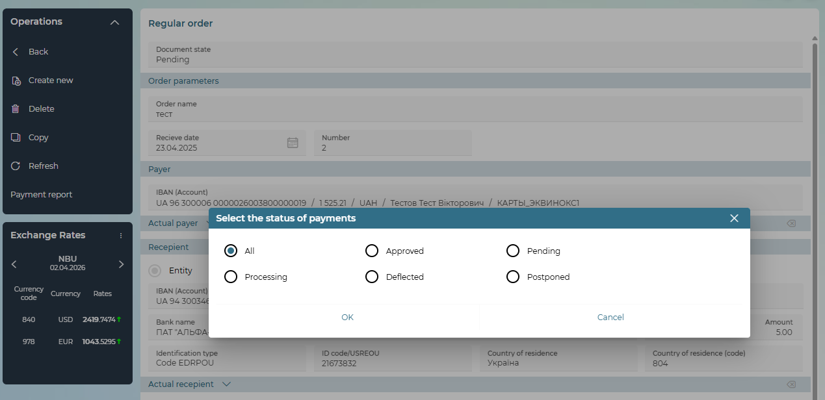
To cancel the changes and return to the form with the list of payments, click on the "Back" button.

Creating a Regular Order
To create a new order, select the Documents/Regular orders menu item and click on the "Create an order" button or click on the "Create new" button on the form for viewing detailed information about the order. Fill in the fields of the new form.
1. In the "Order parameters" section, fill in the following fields:
- Order name - enter the name of the order (maximum 100 characters).
- Date - select from the calendar or manually enter the date of creation of the order in the format DD.MM.YYYY (the date must be greater than or equal to the date of the ODB). The system automatically substitutes the current calendar date with the possibility of editing into this field.
- Priority - a field for entering the degree of priority of the document during processing (integer from 1 to 100, default value - 50). Please note: depending on the settings set by the bank, the field may not be editable or not displayed at all on the form.
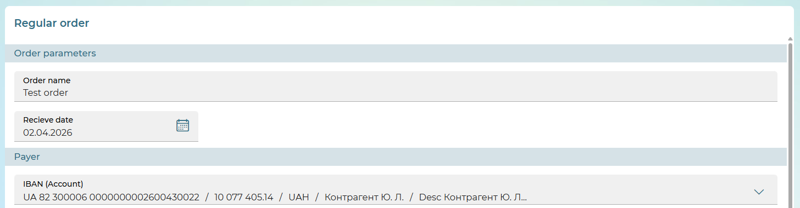
2. Fill in the fields of the sections "Payer", "Actual payer" (if necessary), "Recipient", "Actual recipient" (if necessary), "Budget" (if necessary), "Payment details".
The description and rules for filling in these fields are similar to the creation of a UAH document (see "Create a new payment").
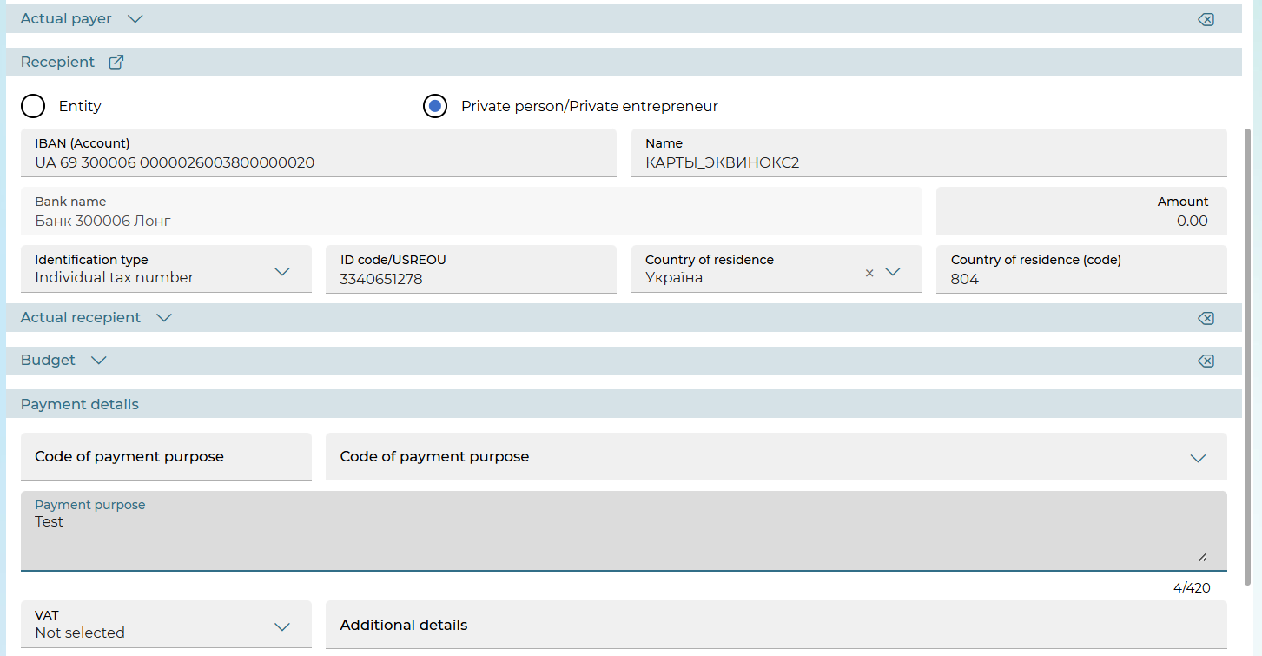

3. In the "Execution schedule" section, set the execution period of the order and select the frequency of execution from the drop-down list.
- If you have selected the daily execution of the order, no additional actions are required, the section will look like this:
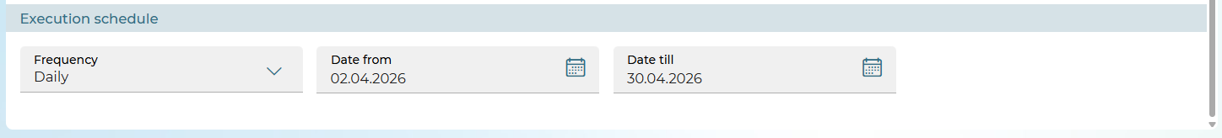
- If you have chosen to execute the order weekly, you need to specify the day of the week on which the order will be executed.
Depending on the settings set by the bank, you may have a choice of either only one day or several days a week.
Please note: the selected period must exceed one week (the interval from the selected day of the week ("Date from") to the same day of the following calendar week, e.g. from Tuesday to Tuesday inclusive).
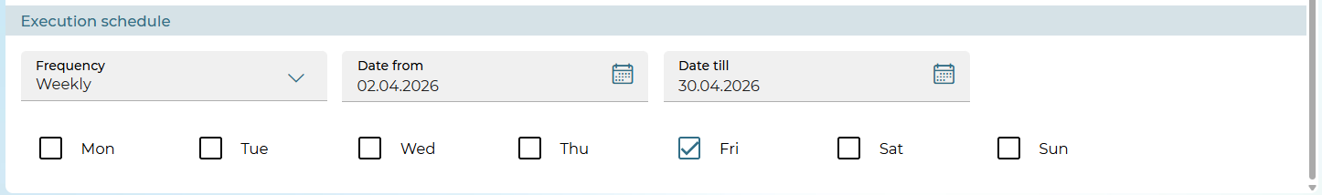
- If you have chosen to execute the order monthly, you need to click on the calendar icon in the Execution schedule field and specify the day on which the order will be executed.
Please note: if you choose at least one of the 29th, 30th, 31st days of the month, the system will warn you that the days you have chosen may fall on non-existent dates and the document for this date will be generated on the last day of the month. You can agree or choose another day.
Please note: the selected period must exceed one month (the interval from the selected date ("Date from") to the same date inclusive in the next calendar month).
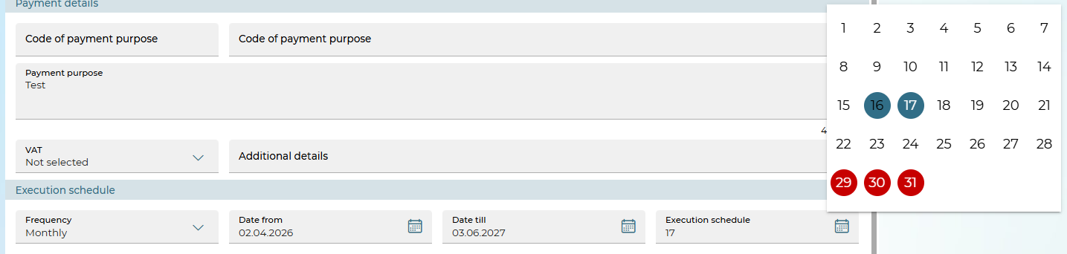
- If you have chosen to execute the order quarterly, you need to click on the calendar icon in the Execution schedule field and specify the day on which the order will be executed for each of the three months of the quarter. To move to the next month or return to the previous month, use the arrows. Depending on the settings set by the bank, you may be able to choose either only one day or several days in each month.
Please note: if you choose at least one of the 29th, 30th, 31st days of the month, the system will warn you that the days you have chosen may fall on non-existent dates and the document for this date will be generated on the last day of the month. You can agree or choose another day.
Please note: the selected period must exceed one quarter (the interval from the selected month date ("Date from") to the same date in 3 calendar months).
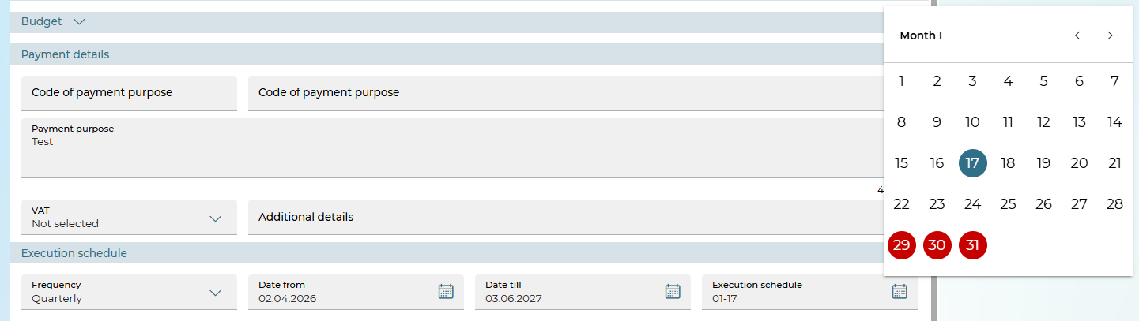
- if you have chosen the annual execution of the order, you need to click on the calendar icon in the Execution schedule field and for each of the months of the year specify the day on which the order will be executed. The calendar is displayed quarterly, to go to the next quarter or return to the previous one, use the arrows. To select a month, click on its name. Depending on the settings set by the bank, you may have a choice of either only one day or several days in each month.
Please note: if you choose at least one of the 29th, 30th, 31st days of the month, the system will warn you that the days you have chosen may fall on non-existent dates and the document for this date will be generated on the last day of the month. You can agree or choose another day. Please note: the selected period must exceed one year (the interval from the selected date of the month ("Date from") to the same date 12 calendar months inclusive).
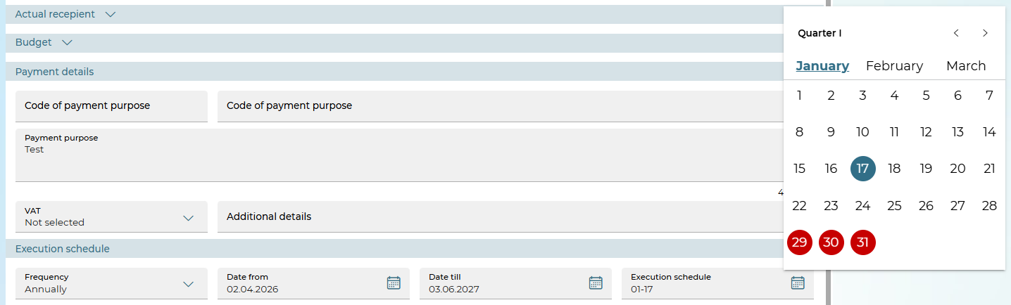
To save a payment without a signature, click on the "Save without signature" button.
To send a payment to the bank, sign the document (see "Signing documents"). If the document was successfully sent to the bank, a corresponding message will appear on the screen.
To return to the previous page unchanged, click on the "Back" button.

View payments created by regular orders
If you have the right to use the functionality of regular payments, the checkbox "Documents created by regular orders" is displayed on the list form of payments in the national currency (Documents/Payment Instructions). When this checkbox is enabled, the system will display only those payments that were created automatically when executing regular orders.
Further, on the list form, you have the same options as when viewing regular payments (see "Work with documents in national currency").
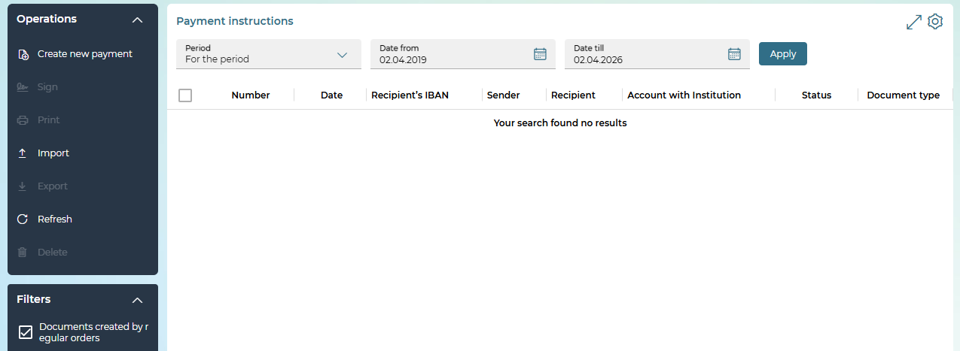
Each line of the list is a link where you can go to view detailed information on the document.
A payment that was created automatically according to a regular order opens on the payment details page in the national currency.
An additional operation “Regular order” will be available on such a payment to switch to the regular order form according to which this payment was automatically created. In this case, the operation “Back” on the standing order view form will return you to the payment view form from which you switched to the order.

Work with documents in foreign currency
The system allows the following transactions with foreign currency:
- work with foreign currency transfers within the bank (see "Currency transfer within the bank");
- work with requests for the foreign currency purchase (see "Request for currency purchase");
- work with requests for the foreign currency sale (see "Request for currency sale");
- work with currency conversion requests (see "Request for currency conversion");
- work with SWIFT documents (see "SWIFT currency payment orders").

Currency transfer within the bank
To view foreign currency payments, select the Documents/Currency transfer within the bank menu item.
At the top of the form, use the built-in calendar (the button ) to set the period for which the information will be displayed, click on the "Apply" button.
Note that by default, the display date corresponds to the current calendar date.
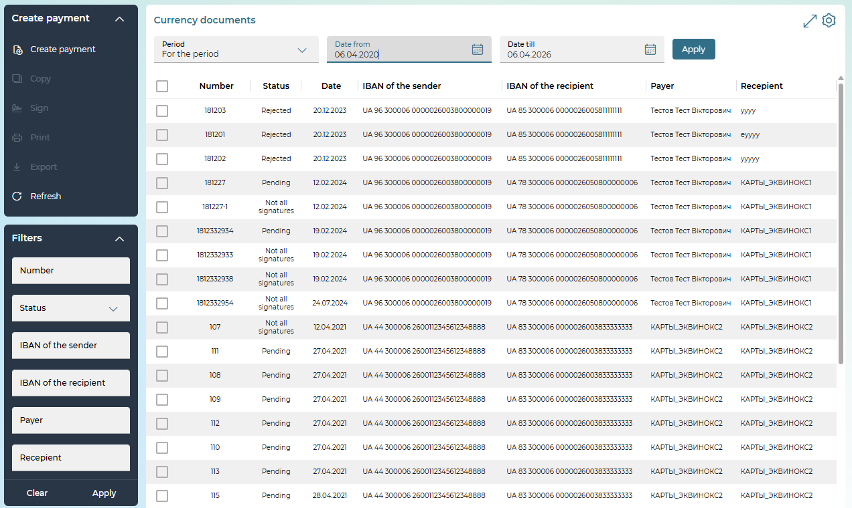
The following operations are available on the page:
- Creating a new foreign currency payment – the "Create payment" button (see "Creation of a new currency transfer within the bank").
- Signing the payment(s). To do this, set the checkboxes for payments in the "Not all signatures" status and click on the "Sign"/"Sign on behalf of another user" button (see "Signing documents").
Please note: mass signing of payments is available only using an electronic digital signature (EDS).
- Printing documents selected using checkboxes – the "Print" button.
- Export documents in XLS, XML formats – the "Export" button.
- Set additional filters, sort data, or customize the form (see "Settings on forms with lists").
Each line in the list is a link that you can use to go to the form to view or edit a document in detail, depending on its status and type.
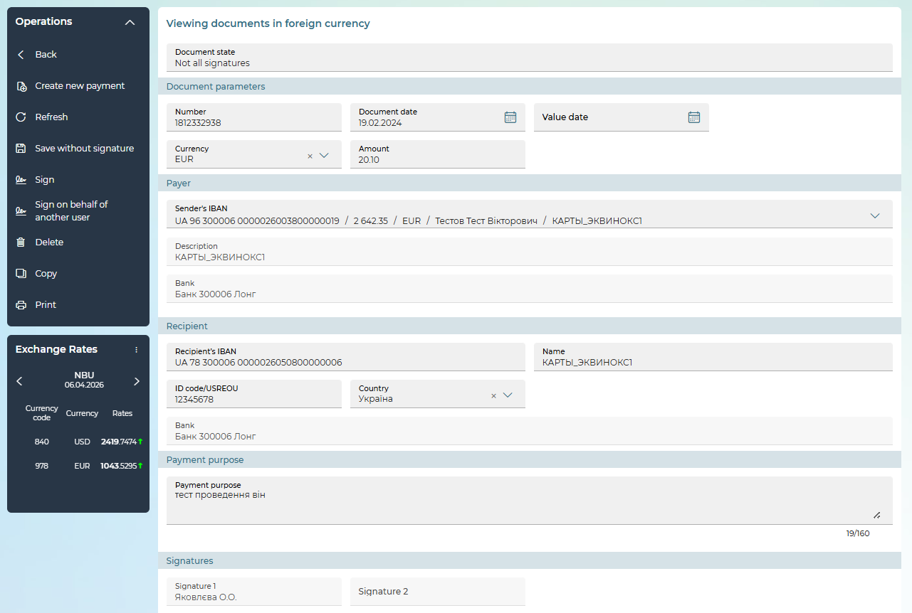
On the detailed view form, depending on the status of the document, you may have access to the following options in the "Operations" block:
- Creating a new document – the "Create New" button (see "Creation of a new currency transfer within the bank").
- Document editing (available for documents with the "Not all signatures", "Rejected" statuses).
- Signing – "Sign"/"Sign on behalf of another user" button (see "Signing documents");
- Save a document without a signature – the "Save without signature" button.
- Creating a copy of the payment – the "Copy" button.
- Printing a document – the "Print" button.
- Deleting a document – the "Delete" button.
For payments in the "Rejected" status, the reason for the rejection of the document is displayed at the top of the form.
To cancel the changes and return to the form with a list of payments, click on the "Back" button.

Creation of a new currency transfer within the bank
In order to create a new currency transfer within the bank, follow these steps:
1. On the form with the list of payments, click on the "Create payment" button or on the detailed payment view form, click on the "Create New" button.
2. A new form "Creating a currency document" will open.
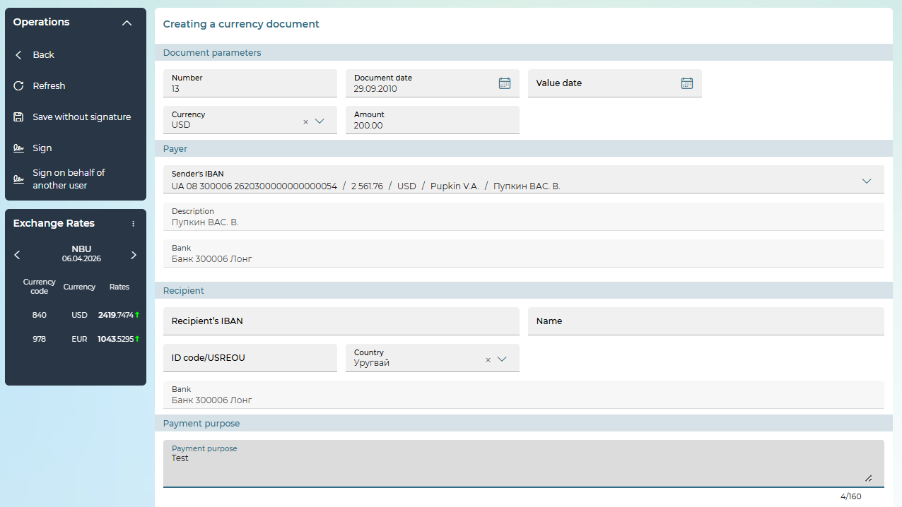
3. In the "Document parameters" section:
- Specify the document date and, if necessary, the value date.
- The document number will be assigned automatically after selecting the account from which the payment will be made. You can edit this field.
- If necessary, specify the priority of the document in the Priority field.
- Enter the amount of the currency transfer in the appropriate field.
- Select the payment currency from the drop-down list.
4. In the "Payer" section, from the list available in the Sender's IBAN field, select the account from which you plan to make the transfer. After selecting the account, the Description and Bank fields will be filled in by the system automatically.
5. In the "Recipient" section, enter the details of the counteragent.
6. Enter Payment purpose in the appropriate field.
7. To save a payment without a signature, click on the "Save without signature" button.
8. To send a payment to the bank, sign the document – the "Sign"/"Sign on behalf of another user" button (see "Signing documents").
If the document was successfully sent to the bank, a corresponding message will be displayed on the screen.
To return to the previous page unchanged, click on the „Back“ button.

Request for currency purchase
To view requests for the purchase of currency, select the menu item Documents/Currency purchase.
At the top of the form, use the built-in calendar (the button ) to set the period for which the information will be displayed, click on the "Apply" button.
Note that by default, the display date corresponds to the current calendar date.
To perform operations with the request, select the desired document(s) in the list – check the checkbox(es) in the first column.
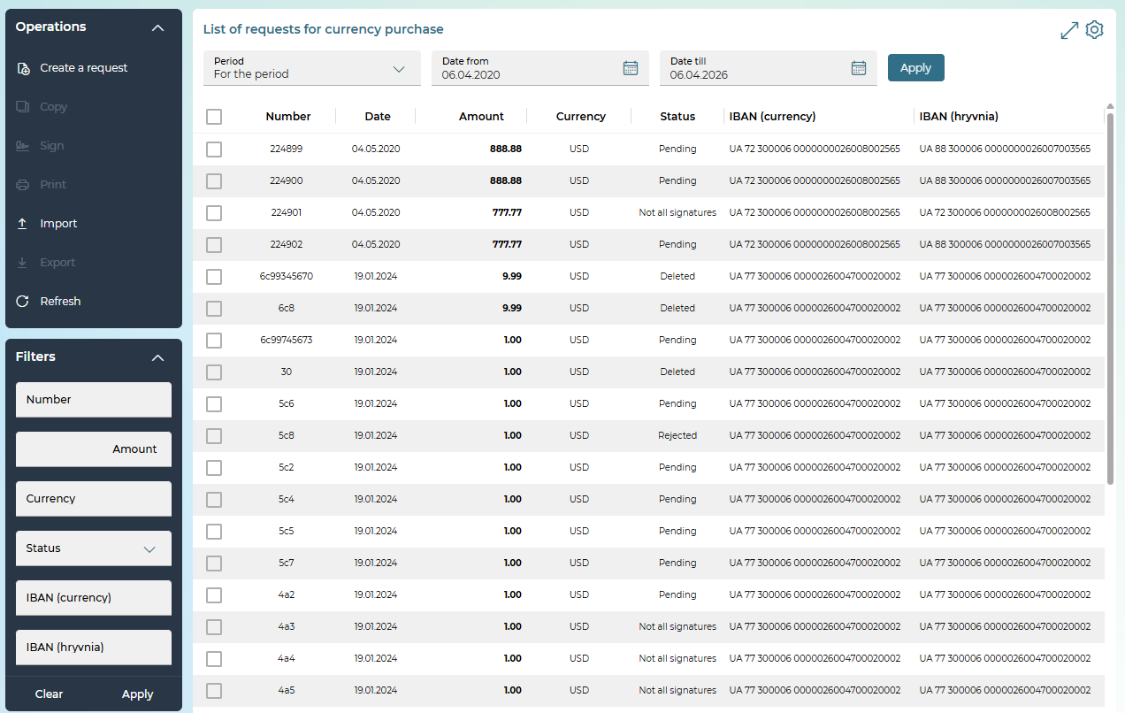
The following operations are available on the page:
- Creating a new request for the purchase of currency – the "Create a request" button (see "Creating a new request for the purchase of currency");
- Signing the request (requests) – the "Sign"/"Sign on behalf of another user" button (becomes active if the user checkboxes one or more documents in the status "Not all signatures"), see "Signing documents".
- Printing the selected document(s) – the "Print" button.
- Import of request (requests) in text format DAT, TXT – the "Import" button.
- Export of the request/requests in XLS, XML formats – the "Export" button.
- Set additional filters, sort data, or customize the form (see "Settings on forms with lists").
Each line in the list is a link that you can use to go to the form to view or edit a document in detail, depending on its status and type.
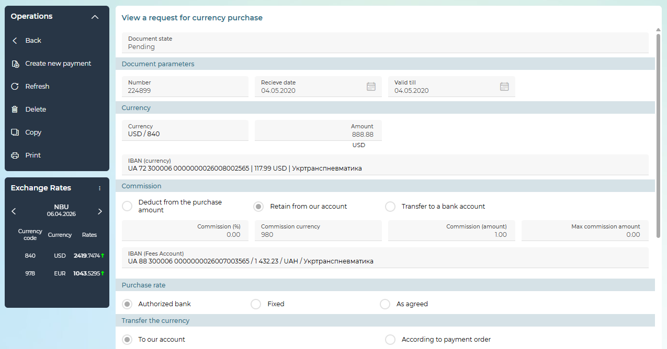
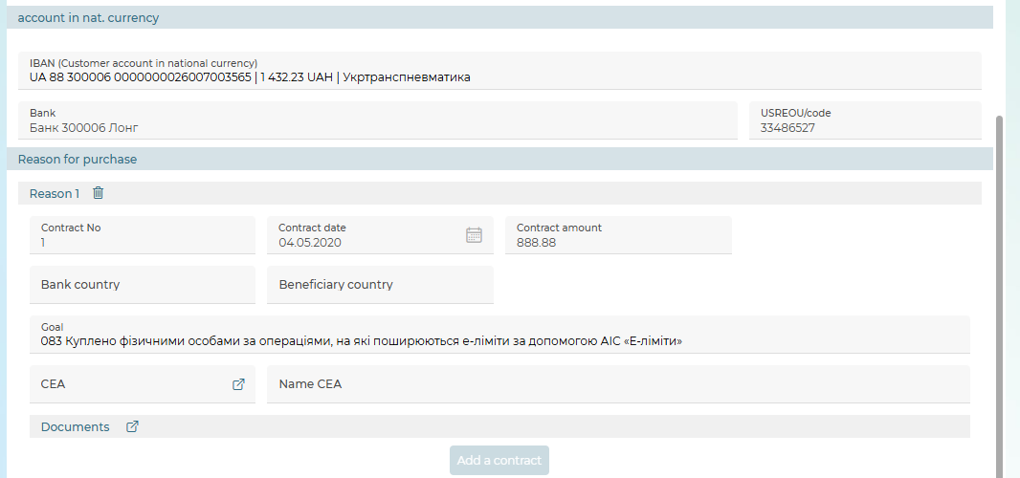
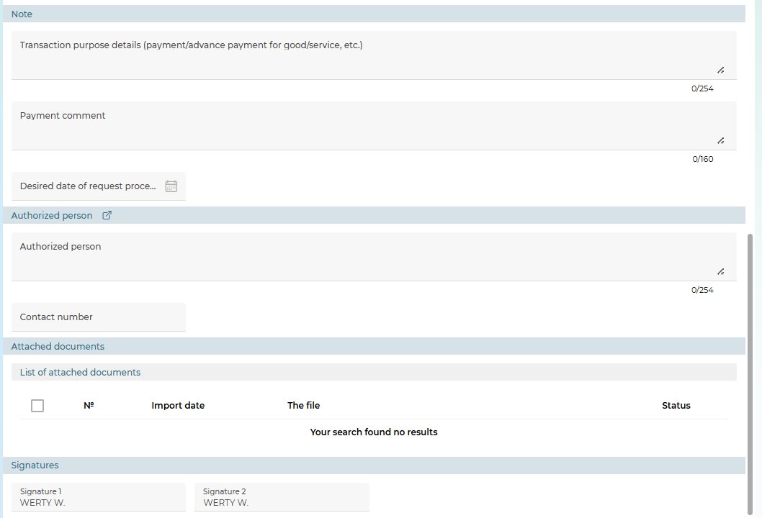
On the detailed view form, depending on the status of the document, you may have access to the following options in the "Operations" block:
- creating a new document – the "Create New" button (see "Creating a new request for the purchase of currency");
- document editing (available for documents with the status "Not all signatures", "Rejected");
- signing – "Sign"/"Sign on behalf of another user" button (see "Signing documents");
- saving a document without a signature – the "Save without signature" button;
- creating a copy of the payment – the "Copy" button;
- printing a document – the "Print" button;
- deleting a document – the "Delete" button.
For payments in the "Rejected" status, the reason for the rejection of the document is displayed at the top of the form.
To cancel the changes and return to the form with the list of payments, click on the „Back“ button.

Creating a new request for currency purchase
In order to create an order for the purchase of currency, follow these steps:
1. On the form with the list of payments, click on the "Create a request" button or on the detailed payment view form, click on the "Create new" button.
2. A new form "Creating a request for currency purchase" will open.
3. In the "Document parameters" section:
- Specify the date of the request (by default, the system substitutes the current date).
- The document number will be assigned automatically by the system with the possibility of editing.
- In the Valid till field, enter the cut-off date by which the request is considered valid and to be executed.
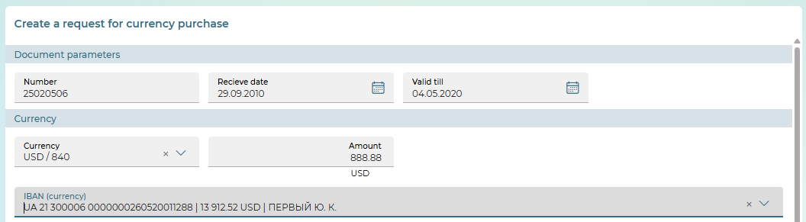
4. In the "Currency" section:
- Select a currency code from the reference book.
- If the amount is to be indicated in UAH, set the appropriate checkbox.
- Enter the purchase amount.
- In the IBAN (currency) field, select the account to which the currency will be credited from the list.
5. If the "Commission" section is displayed (depending on the bank's settings), select the type of commission accrual:
- "Deduct from the purchase amount",
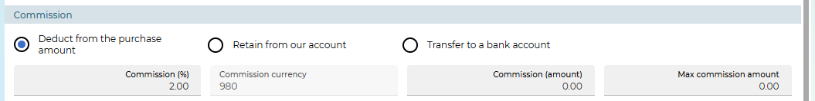
- "Retain from our account",
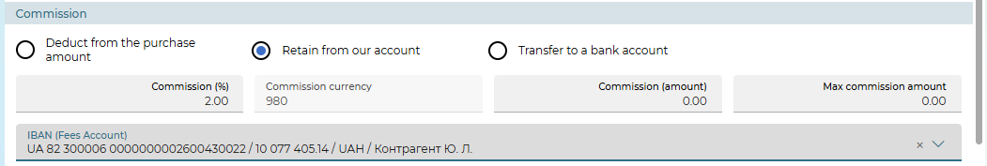
- "Transfer to a bank account".
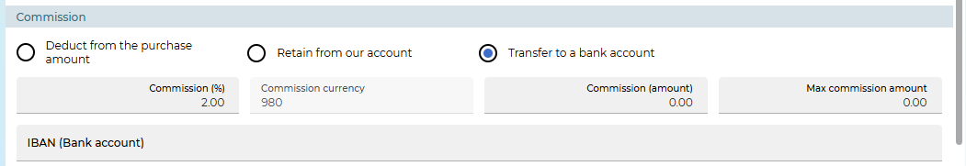
Depending on the selected type of commission, a certain set of fields will be available to the user to fill in:
- Commission (%) – the field is to enter the percentage of the commission fee for the sale of currency (if the commission is charged as a percentage).
- Commission currency – the commission currency is displayed in the field (according to the requirements of the NBU – national currency).
- Commission (amount) – the field is for entering the amount of the commission fee (if the commission is charged in the form of a fixed amount).
- Max. commission amount – the field is to enter the maximum amount of the commission fee.
- IBAN (Fees account) – the field is available for the "Retain from our account" fee type and is designed to select the account number from which the amount of commission will be debited (accounts in national currency, according to the requirements of the NBU).
- IBAN (Bank account) – the field is available for the "Transfer to a bank account" fee type and is designed to enter the account number to which the commission amount is to be transferred.
6. In the "Purchase rate" section, select the type of currency purchase rate: "Authorized bank" or "Market", "Fixed" or "As agreed".
When selecting the "Fixed" or "As agreed" rate types (if available), the Purchase rate field will open, in which you should specify the purchase rate.
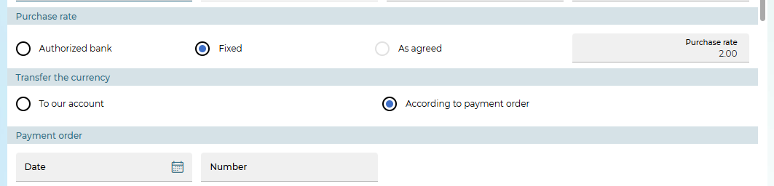
7. In the "Transfer the currency" section, use the switch to select one of the options:
- "To our account" – the purchased currency is credited to a pre-known account selected in the section "Account in the national. Currency"
- "According to payment order" – the purchased currency must be transferred according to the payment order.
Please note: when selecting this option, the user must fill in the Date and Number of the payment order fields in the "Payment order" section.
8. In the section "Account in national. currency" from the drop-down list in the IBAN (Customer account in national currency) field, select an account to write off the national currency for the purchase of foreign currency.
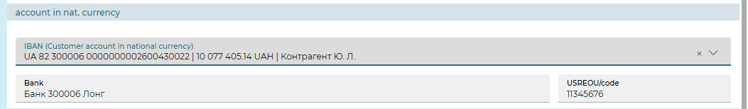
9. In the "Reason for purchase" section, you can add information about contracts and contract documents as a basis for buying currency:
- Click on the "Add a contract" button.
- Enter the contract number, contract amount, contract date, select the bank country and beneficiary country from the drop-down list.
- The Purpose field contains a list from which you need to select the purpose of purchasing currency.
- Using the button in the CEA field, the KVED reference book opens. Select the entry you need, and the field will be filled with data from the reference book.
- In the Product group name field, you must select an entry from the connected reference book.
- Also, in the Bank Name B010 field, you need to select an entry from the connected reference book.
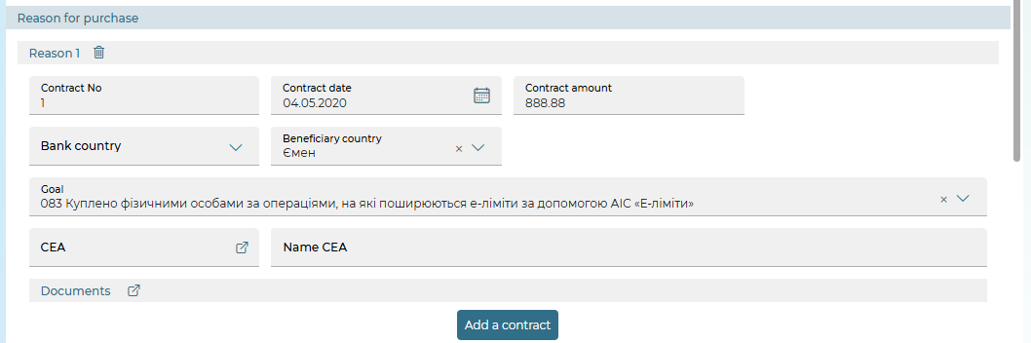
- With the help of the button in the "Documents" section, you will see the form of entering documents in the basis of the purchase of currency. The form contains fields for filling the number, date, amount. Select the type of document from the list: CD, ACT, INVOICE, ADVANCE PAYMENT. To add a document, click on the "Add" button. Entered documents are displayed in the form of a list. You can change or delete the selected document from the list.
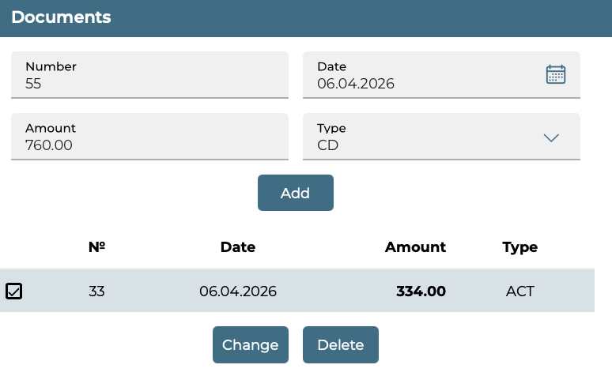
To delete a contract, use the button.
10. If necessary, in the "Note" section, enter additional information about the request and/or a comment on the payment.
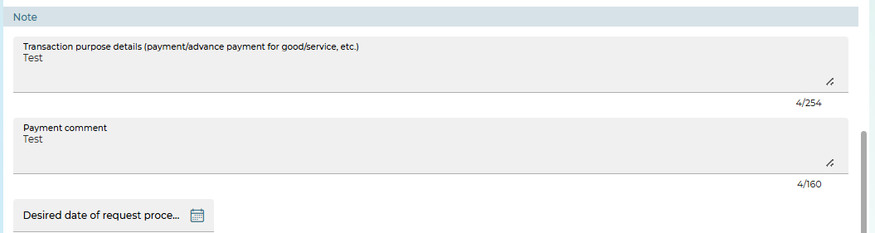
11. Indicate the desired date of request processing.
12. In the section "Authorized person" the employee authorized to resolve issues under the contract and his contact phone number are indicated. The data is selected from the reference book "Authorized persons" (the button).
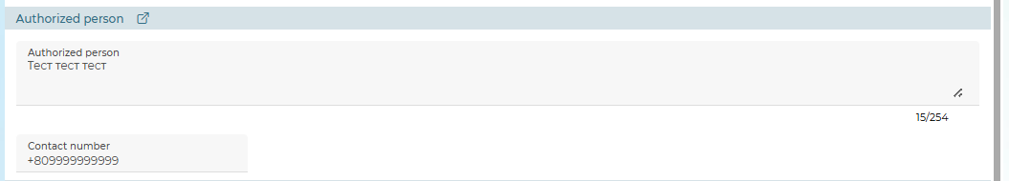
13. The section "Pension Fund" is intended to indicate the details of deductions to the pension fund. Its display depends on the bank's settings.
14. If the "Attached Documents" section is available on the form, you can add and link to the request files of supporting documents (for example, scanned copies of contracts, invoices, etc. "Linking a document to a request").
15. To save the request without a signature, click on the "Save without signature" button.
16. To send a request to the bank, sign the document – the "Sign"/"Sign on behalf of another user" button (see "Signing documents").
If the document was successfully sent to the bank, a corresponding message will appear on the screen.
To return to the previous page unchanged, click on the „Back“ button.

Request for currency sale
To view requests for the sale of currency, select the Documents/Sale of currency menu item.
At the top of the form, use the built-in calendar (the button ) to set the period for which the information will be displayed, click on the "Apply" button.
Note that by default, the display date corresponds to the current calendar date.
To perform operations with the request, select the necessary document(s) in the list – check the checkbox(es) in the first column.
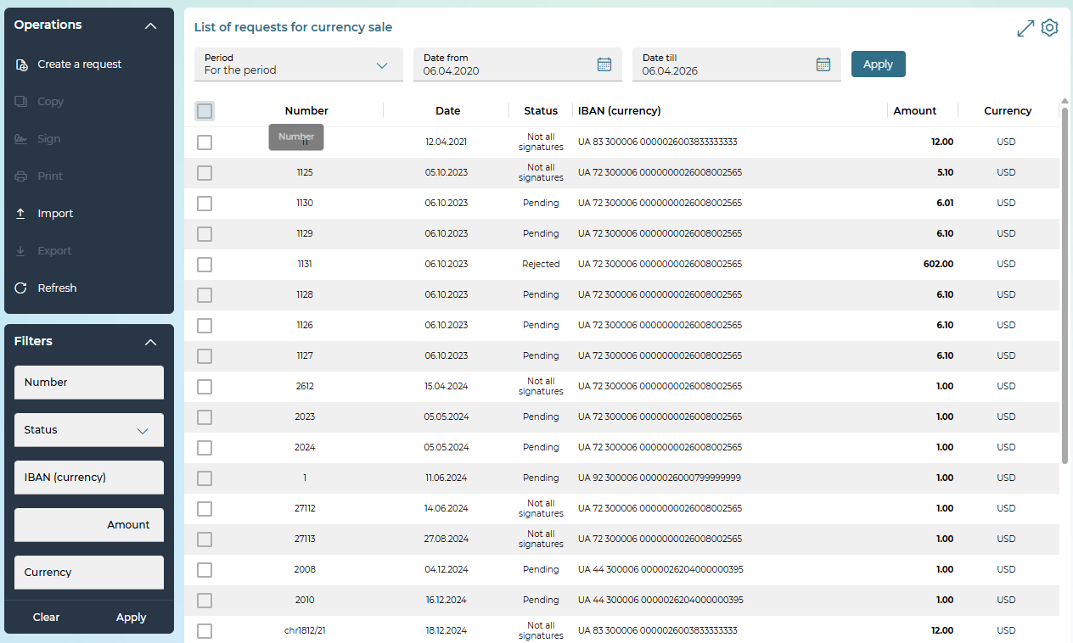
The following operations are available on the page:
- Creating a new order for the sale of currency – the "Create a request" button (see "Creating a new request for the sale of currency").
- Signing the request (requests) – the "Sign"/"Sign on behalf of another user" button (becomes active if the user checkboxes one or more documents in the status "Not all signatures"), see „Signing documents".
- Printing the selected document(s) – the "Print" button.
- Import of request (requests) in text format DAT, TXT – the "Import" button.
- Export of the request/requests in XLS, XML formats – the "Export" button.
- Set additional filters, sort data, or customize the form (see "Settings on forms with lists").
Each line in the list is a link to the form to view or edit a document in detail, depending on its status and type.
On the detailed view form, depending on the status of the document, you may have access to the following options in the "Operations" block:
- creating a new document – the "Create new" button (see "Creating a new request for the sale of currency");
- document editing (available for documents with the status "Not all signatures", "Rejected");
- signing – "Sign"/"Sign on behalf of another user" button (see "Signing documents");
- saving a document without a signature – the "Save without signature" button;
- creating a copy of the payment – the "Copy" button;
- printing a document – the "Print" button;
- deleting a document – the "Delete" button.
For payments in the "Rejected" status, the reason for the rejection of the document is displayed at the top of the form.
To cancel the changes and return to the form with a list of payments, click on the "Back" button.

Creating a new request for currency sale
In order to create a new order for the sale of currency, follow these steps:
1. On the form with the list of payments, click on the "Create a request" button or on the detailed payment view form, click on the "Create new" button.
2. A new form "Creating a request for currency sale" will open.
3. In the "Document parameters" section:
- Specify the date of the request (by default, the system substitutes the current date).
- The document number will be assigned automatically by the system with the possibility of editing.
- In the Valid till field, enter the cut-off date by which the request is considered valid and to be executed.
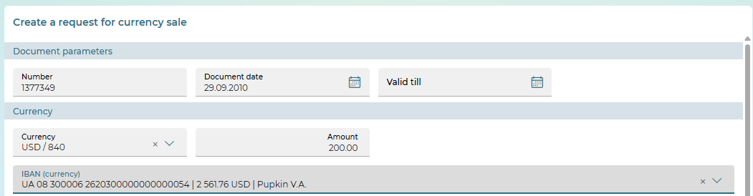
4. In the "Currency" section:
- Enter a currency or select it from the reference book.
- Enter the amount of the sale.
- In the IBAN (currency) field, select the account to which the currency will be credited from the list.
5. If the "Commission" section is displayed (depending on the bank's settings), select the type of commission accrual:
- "Deduct from the sale amount",
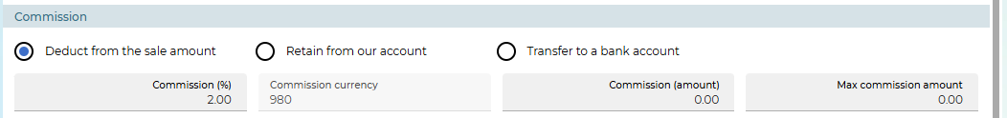
- "Retain from our account",
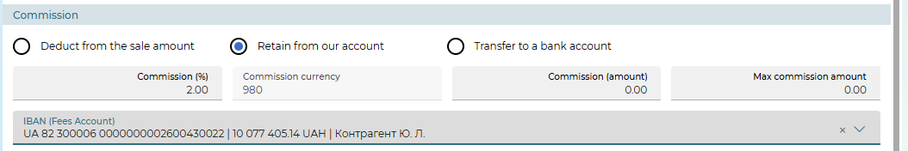
- "Transfer to a bank account".
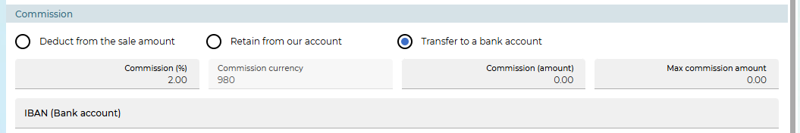
Depending on the selected type of commission, a certain set of fields will be available to the user to fill in:
- Commission (%) - the field is intended to enter the percentage of the commission fee for the sale of currency (if the commission is charged as a percentage).
- Commission currency – the commission currency is displayed in the field (according to the requirements of the NBU – national currency).
- Commission (amount) – the field is intended for entering the amount of the commission fee (if the commission is charged in the form of a fixed amount).
- Max. commission amount – the field is intended to enter the maximum amount of the commission fee.
- IBAN (Commission account) – the field is available for the "Retain from our account" fee type and is designed to select the account number from which the amount of commission will be debited (accounts in national currency, according to the requirements of the NBU).
- IBAN (Bank account) – the field is available for the "Transfer to a bank account" fee type and is designed to enter the account number to which the commission amount is to be transferred.
6. In the "Selling rate" section, select the sales rate: "Authorized bank" or "Market", "Fixed" or "As agreed". When selecting the "Fixed" or "As agreed" course types (if available), the "Selling rate" field will open, in which you need to specify the desired value.

7. In the section "Crediting nat. currency":
- Select the recipient: "To the account of the correspondent" or "To own account".
- When selecting the option "To the account of the correspondent", fill in the following fields: IBAN (Customer account in national currency), USREOU/code and correspondent's Name. In this case, the Bank field is automatically filled in by the system.
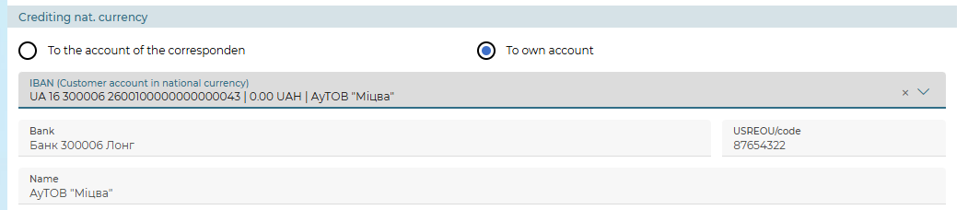
- When selecting the option "To own account" in the IBAN (Customer account in national currency) field from the drop-down list, select the required account.
8. In the "Reason for sale" section, you can add information about contracts as a basis for selling currency:
- Click on the "Add a contract" button.
- Enter the contract number, contract amount, contract date, select the bank country and beneficiary country from the drop-down list.
- The Purpose field contains a list from which you need to select the purpose of selling currency.
- Using the button in the CEA field, the CEA reference book opens. Select the entry you need, and the field will be filled with data from the reference book.
- In the Commodity group name field, you must select an entry from the connected reference book.
- Also, in the Bank name B010 field, you need to select an entry from the connected reference book.
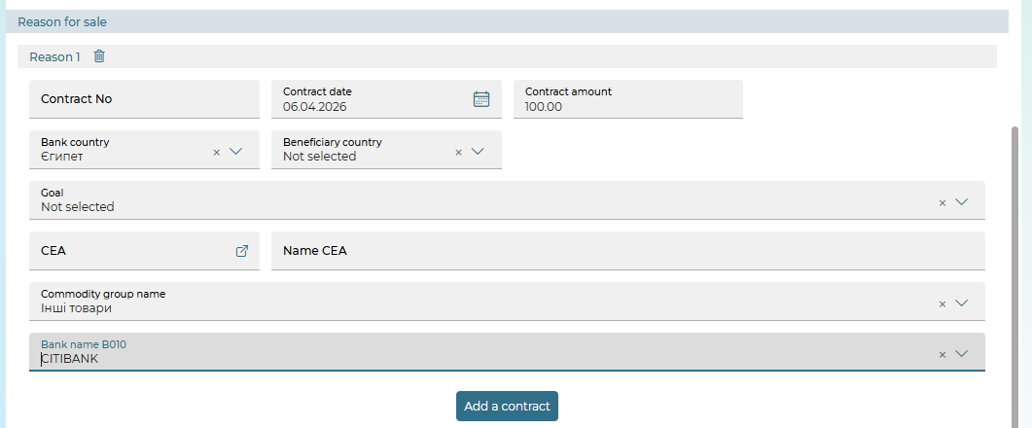
To delete a contract, use the button.

9. If necessary, in the "Note" section, enter additional information about the request and/or comment.
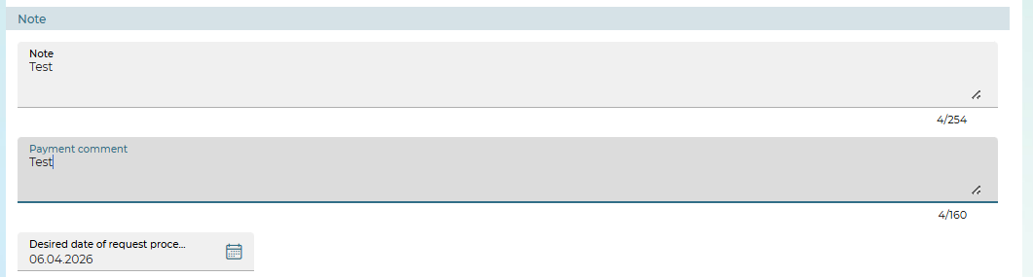
10. Indicate the desired date for processing the request.
11. In the section "Authorized person" the employee authorized to resolve issues under the contract and his/her contact phone number are indicated. The data is selected from the "Authorized persons" reference book (the button ).
12. To save the request without a signature, click on the "Save without signature" button.
13. If the "Attached Documents" section is available on the form, you can add and link to the request files of supporting documents (for example, scanned copies of contracts, invoices, etc. "Linking a document to a request").
14. To send a request to the bank, sign the document – the "Sign"/"Sign on behalf of another user" button (see "Signing documents").
If the document was successfully sent to the bank, a corresponding message will appear on the screen.
To return to the previous page without changes, click on the „Back“ button.

Request for currency conversion
To view currency conversion requests, select the Documents/Currency conversion menu item.
At the top of the form, use the built-in calendar (the button ) to set the period for which the information will be displayed, click on the "Apply" button.
Note that by default, the display date corresponds to the current calendar date.
To perform operations with the request, select the desired document(s) in the list – check the checkbox(es) in the first column.
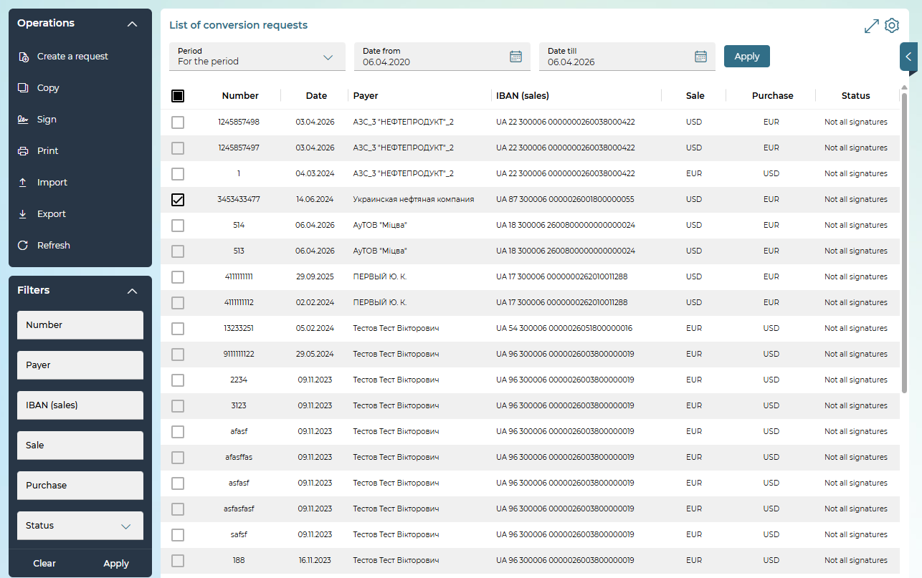
The following operations are available on the page:
- Creating a new currency conversion request – the "Create Request" button (see "Creating a new request for currency conversion").
- Signing the request (requests) – the "Sign"/"Sign on behalf of another user" button (becomes active if the user checkboxes one or more documents in the status "Not all signatures"), see „Signing documents").
- Printing the selected document(s) – the "Print" button.
- Import of request (requests) in text format DAT, TXT – the "Import" button.
- Export of the request/requests in XLS, XML formats – the "Export" button.
- Set additional filters, sort data, or customize the form (see "Settings on forms with lists").
Each line in the list is a link that you can use to go to the form to view or edit a document in detail, depending on its status and type.
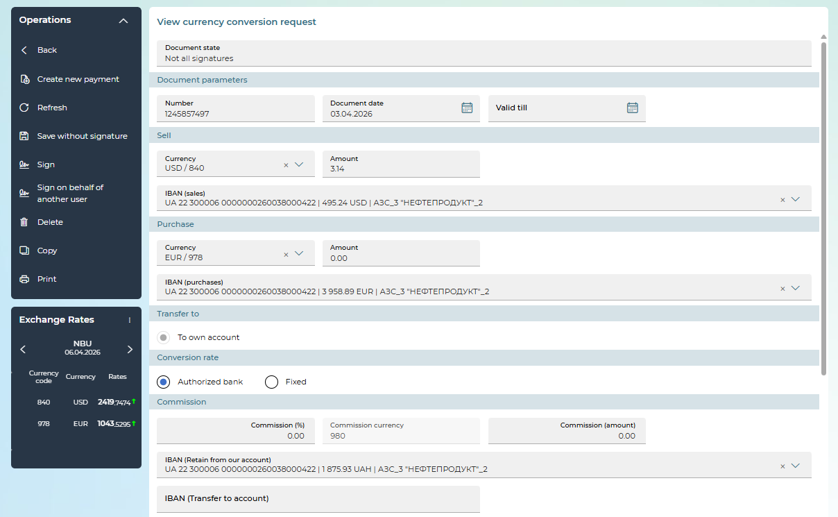
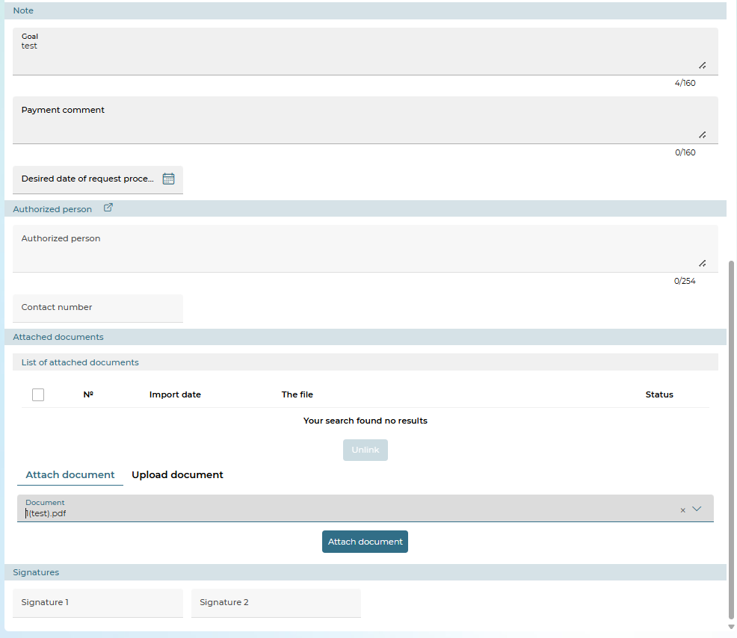
On the detailed view form, depending on the status of the document, you may have access to the following options in the "Operations" block:
- creating a new request – the "Create new payment" button (see the description below);
- document editing (available for documents with the "Not all signatures", "Rejected" statuses);
- signing – "Sign"/"Sign on behalf of another user" button (see "Signing documents");
- saving a document without a signature – the "Save without signature" button;
- creating a copy of the payment – the "Copy" button;
- printing a document – the "Print" button;
- deleting a document – the "Delete" button.
For payments in the "Rejected" status, the reason for the rejection of the document is displayed at the top of the form.
To cancel the changes and return to the form with the list of payments, click on the „Back“ button.

Creating a new request for currency conversion
In order to create a new request for currency conversion within the bank, follow these steps:
1. On the form with the list of payments, click on the "Create a request" button or on the detailed payment view form, click on the "Create new payment" button.
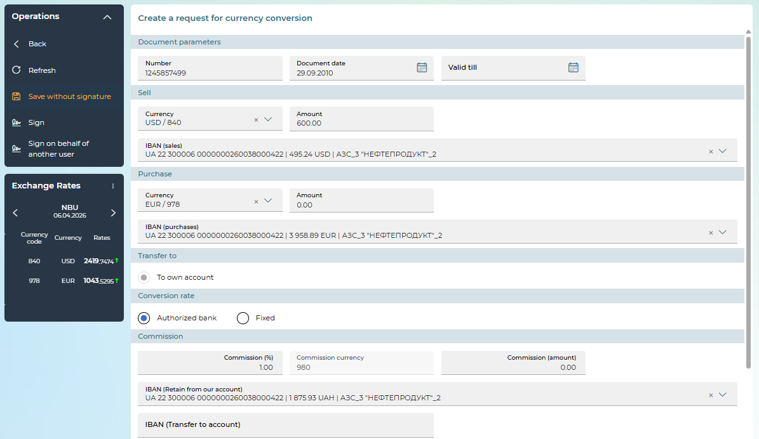
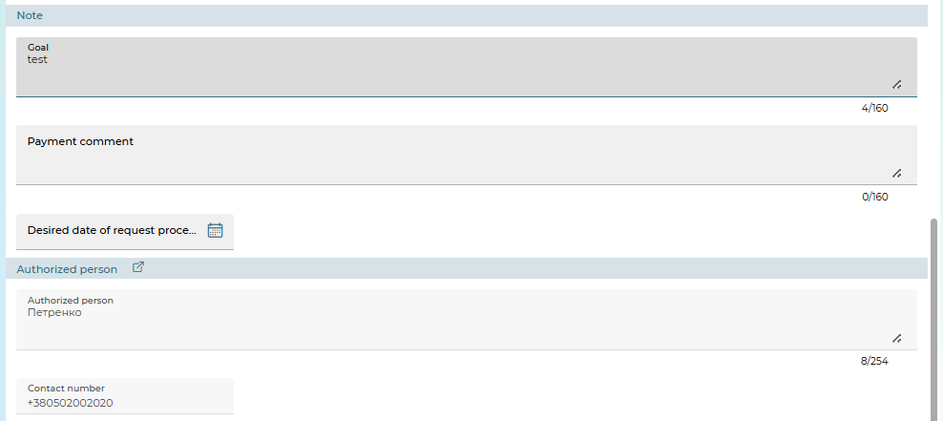
2. A new form "Creating a request for currency conversion" will open.
3. In the "Document parameters" section:
- Specify the date of the document (by default, the system substitutes the current date).
- The document number will be assigned automatically by the system with the possibility of editing.
- In the Valid till field, enter the cut-off date by which the request is considered valid and to be executed.
4. In the "Sales" section:
- Enter the currency of sale or select it from the reference book.
- Enter the amount of currency being sold.
Please note that the Amount field in the “Sell” section and the Amount field in the “Purchase” section are mutually exclusive. You can only fill in one of these two fields.
- In the IBAN (sales) field, select an account in the currency of sale from the list.
5. In the "Purchase" section:
- Enter a currency or select it from the reference book.
- Enter the amount of currency being purchased.
Please note that the Amount field in the "Buy" section and the Amount field in the "Sell" section are mutually exclusive. You can only fill in one of these two fields.
- In the IBAN (purchaseі) field, select the account in the currency of purchase from the list.
- In the "Transfer to" section, select one of two options: "To our account" or "According to the payment order". When selecting the "According to payment order" option, specify the number and date of the payment order.
6. In the "Conversion rate" section, select the type of currency conversion rate: "Market", "Fixed". When you select the "Fixed" course type (if available), the "Conversion rate" field will open, in which you must specify the conversion rate.
7. If the "Commission" section is displayed (depending on the bank's settings), select the type of commission accrual:
- Commission currency – the commission currency is displayed in the field (according to the requirements of the NBU – national currency).
- IBAN (Retain from our account) – the field is designed to select the account number from which the commission amount will be debited.
- IBAN (Transfer to account) – the field is intended for entering the account number to which the commission amount should be accrued.
- Commission (%) – the field is intended to enter the percentage of the commission fee for the purchase of currency (if the commission is charged as a percentage).
- Commission (Amount) – the field is intended for entering the amount of the commission fee (if the commission is charged in the form of a fixed amount).
8. In the Purpose field, you must enter the currency conversion purpose (maximum 160 characters).
9. In the Payment comment field, you can enter a comment (maximum 160 characters).
10. Indicate the desired date for processing the request.
11. In the "Authorized person" section the employee authorized to resolve issues under the contract and his/her contact phone number are indicated. The data is selected from the reference book "Authorized persons" (the button ).
12. To save the request without a signature, click on the "Save without signature" button.
13. If the "Attached documents" section is available on the form, you can add and link to the request files of supporting documents (for example, scanned copies of contracts, invoices, etc). See "Linking a document to a request").
14. To send a request to the bank, sign the document – the "Sign"/"Sign on behalf of another user" button (see "Signing documents").
If the document was successfully sent to the bank, a corresponding message will appear on the screen.
To return to the previous page without changes, click on the „Back“ button.

SWIFT currency payment orders
To view SWIFT currency documents, select the Documents/SWIFT menu item.
At the top of the form, use the built-in calendar (the button ) to set the period for which the information will be displayed, click on the "Apply" button.
Note that by default, the display date corresponds to the current calendar date.
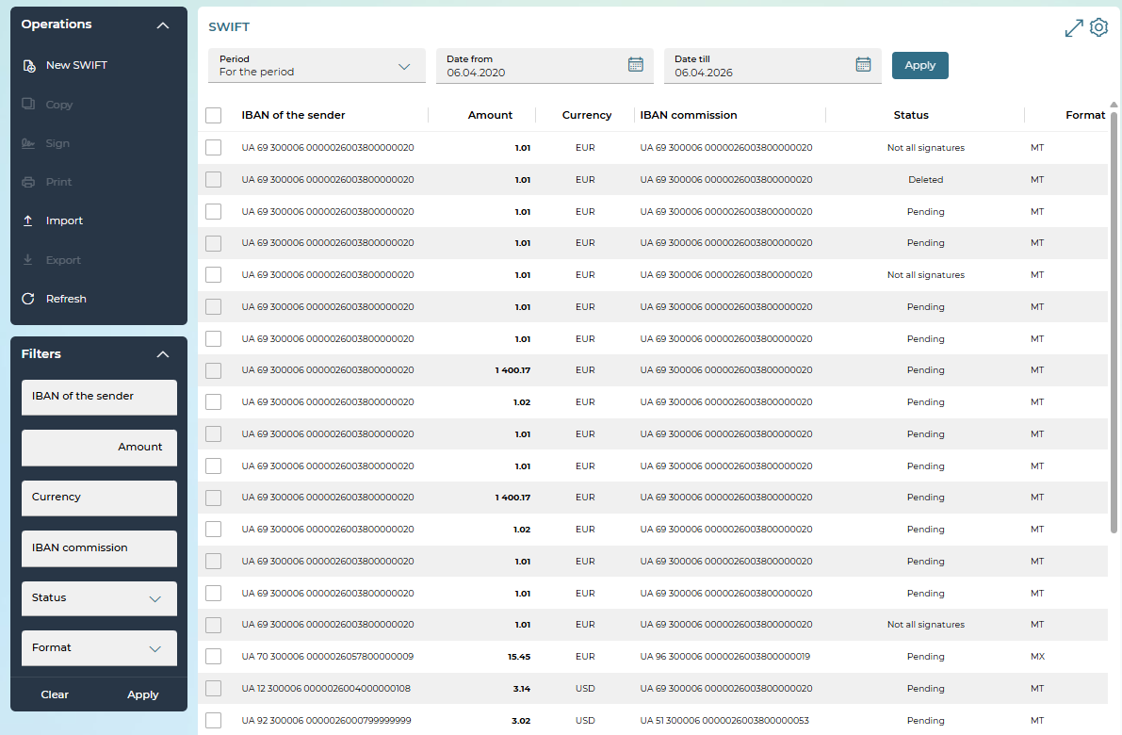
To perform operations with the request, select the necessary document(s) in the list – check the checkbox(es) in the first column.
At the same time, the following operations are available with the document(s):
- Signing a payment(s) – the "Sign"/"Sign on behalf of another user" button (becomes active if the user checkboxes one or more payments in the status "Not all signatures"). In order to sign an array of payments, mark all the necessary payments with a symbol and click on the "Sign"/"Sign on behalf of another user" button (see "Signing documents").
- Printing the selected document(s) – the "Print" button.
- Import SWIFT MT in TXT format, DAT – the "Import" button.
- Export of the request/requests in XLS, XML formats – the "Export" button.
- Create a new document - the "Create SWIFT" button.
- Set additional filters, sort data, or customize the form (see "Settings on forms with lists").
If you are configured to work with SWIFT MX payments, on the form with a list of documents:
- The Format field is available for filtering, where you can select the MT or MX format to be displayed.
- Available for import (the Import button) formats TXT, DAT, XML (pain.001). After importing, SWIFT MX payments are created.
If SWIFT MX document creation is available, then SWIFT MT document creation is no longer available. SWIFT MX payments, which were created earlier, are available only for viewing, printing, cloning.
Each line in the list is a link that you can use to go to the form to view or edit a document in detail, depending on its status and type.
On the detailed view form, depending on the status of the document, you may have access to the following options in the "Operations" block:
- creating a new SWIFT – the "Create new payment" button;
- document editing (available for documents with the status "Not all signatures", "Rejected");
- signing – "Sign"/"Sign on behalf of another user" button (see "Signing documents");
- saving a document without a signature – the "Save without signature" button;
- creating a copy of the payment – the "Copy" button;
- printing a document – the "Print" button;
- deleting a document – the "Delete" button.
For payments in the "Rejected" status, the reason for the rejection of the document is displayed at the top of the form.
To cancel the changes and return to the form with the list of payments, click on the „Back“ button.

SWIFT MT document
Allowed characters for a SWIFT MT document
Character category | Symbols
Latin characters | a b c d e f g h i j k l m n o p q r s t u v w x y z A B C D E F G H I J K L M N O P Q R S T U V W X Y Z
Numbers | 0 1 2 3 4 5 6 7 8 9
Other characters | / - ? : ( ) . , ' +  as well as Space and Carriage Return

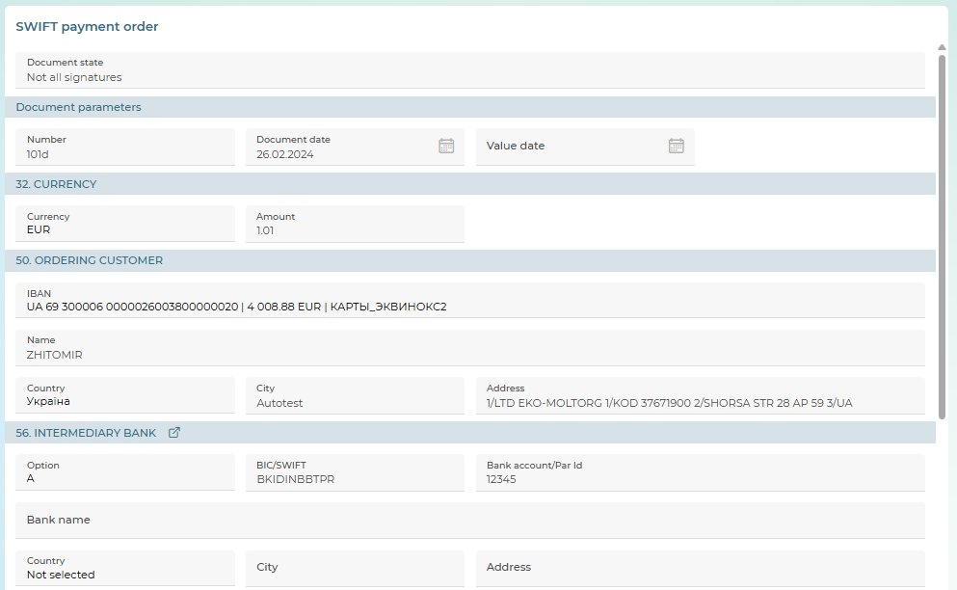
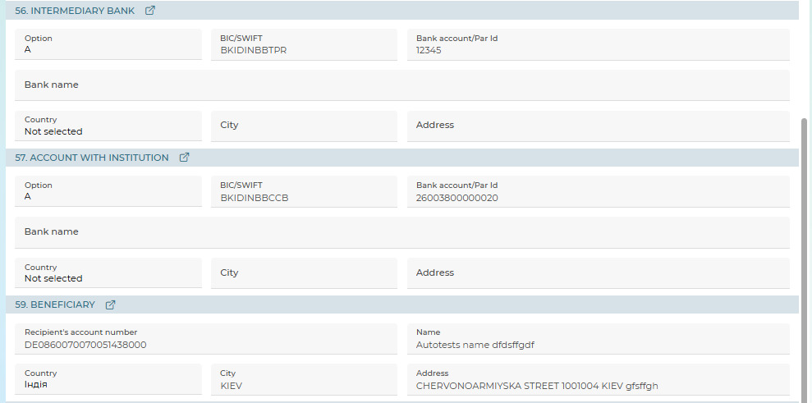
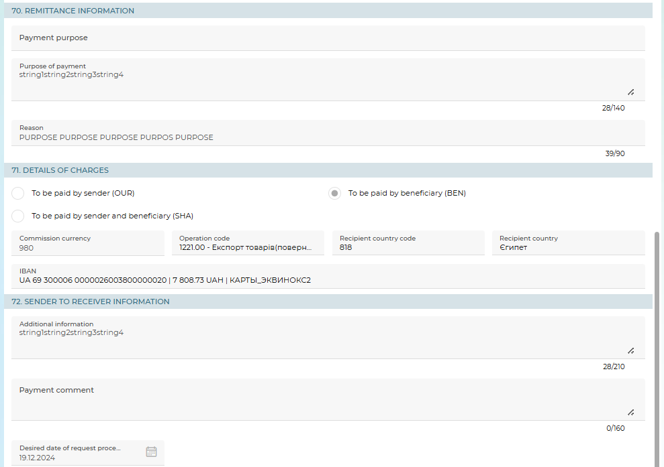
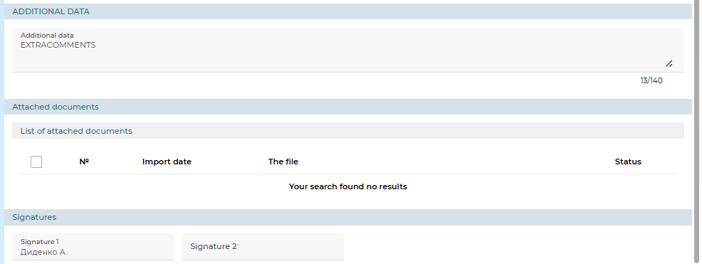
In order to create a SWIFT MT, on the "SWIFT payment order" form, follow these steps:
1. In the "Document parameters" section:
- Specify the payment date (by default, the system substitutes the current date).
- The document number will be assigned automatically by the system with the possibility of editing.
- Depending on the settings of customer seats, the Value date and Transfer procedure (regular or urgent) fields or the Urgency field (T+0 - today, T+1 - tomorrow, T+2 - the day after tomorrow) fields may be available in this section.
2. In the section "32. CURRENCY":
- Select a currency from the drop-down list.
- Enter the amount of the order.
3. In the section "50. ORDERING CUSTOMER":
- Select the payer's account number from the drop-down list.
- Enter the name and address of the payer in the appropriate fields.
4. In the section "56. INTERMEDIARY BANK" you must fill in the details of the intermediary bank:
- When option "A" is selected, you must enter the bank's BIC/SWIFT code.
- With option "D" selected, you must enter the name and address of the bank. At the same time, if you have entered the BIC/SWIFT code of the bank, the system checks whether it corresponds to the entry in the reference book of foreign banks. If there is such a record, the necessary fields will be filled in automatically, the data is available for editing.
- You can specify the bank account number.
Please note: you can enter the data manually or select from the reference book of foreign banks – the button .
5. In the section "57. ACCOUNT WITH INSTITUTION" you must fill in the details of the recipient bank:
- When option "A" is selected, you must enter the bank's BIC/SWIFT code.
- With option "D" selected, you must enter the name and address of the bank. At the same time, if you have entered the BIC/SWIFT code of the bank, the system checks whether it corresponds to the entry in the reference book of foreign banks. If there is such a record, the necessary fields will be filled in automatically, the data is available for editing.
- You can specify the bank account number.
Please note: you can enter the data manually or select from the reference book of foreign banks - button .
6. In the section "59. BENEFICIARY»:
- Enter the recipient's name and address in the appropriate fields.
- Enter the recipient's account number.
Please note: you can enter the data manually or select from the SWIFT Correspondents' reference book – the button .
7. In the section "70. REMITTANCE INFORMATION":
- Enter the payment purpose or select a value from the reference book.
- Enter the reason for the payment.
8. In the section "71. DETAILS OF CHARGES":
- Use the selector buttons to select the type of fee: to be paid by sender (OUR), to be paid by beneficiary (BEN), to be paid by sender and beneficiary (SHA), to be paid by sender with a guarantee of whole amount delivery (OUROUR/FULLPAY).
- The Commission currency field displays the commission currency – national currency according to the requirements of the NBU.
- Select the fee account from the drop-down list.
- Select the operation code for the payment order from the reference book.
- Select the country code of the recipient.
9. In the section "72. SENDER TO RECEIVER INFORMATION":
- In the Additional information field, you can enter additional information about the transfer (maximum 210 characters).
- In the Payment comment field, you can enter a comment on a currency order (maximum 160 characters).
- You can specify the desired date for processing the request.
10. To save the request without a signature, click on the "Save without signature" button.
11. To send a request to the bank, sign the document – the "Sign"/"Sign on behalf of another user" button (see "Signing documents").
If the document was successfully sent to the bank, a corresponding message will appear on the screen.
To return to the previous page without changes, click on the „Back“ button.

SWIFT MX Document
Allowed characters for SWIFT MX payment:
Character category | Symbols
Latin characters | a b c d e f g h i j k l m n o p q r s t u v w x y z A B C D E F G H I J K L M N O P Q R S T U VW X Y Z
Numbers | 0 1 2 3 4 5 6 7 8 9
Other characters | / - ? : ( ) . , ' +  as well as Space
Special symbols | ! # & % * = ^ _ { | } ~ " ; @ [ ] \ $ > <
Use the / buttons to expand/collapse the form sections.
Use the button to clear the section fields.
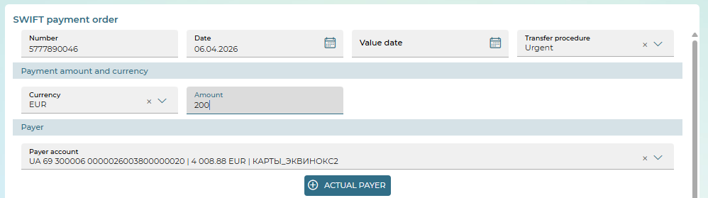
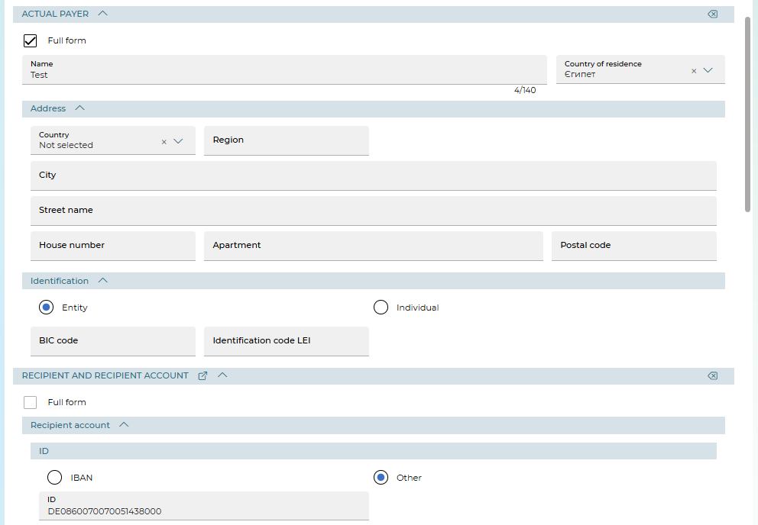
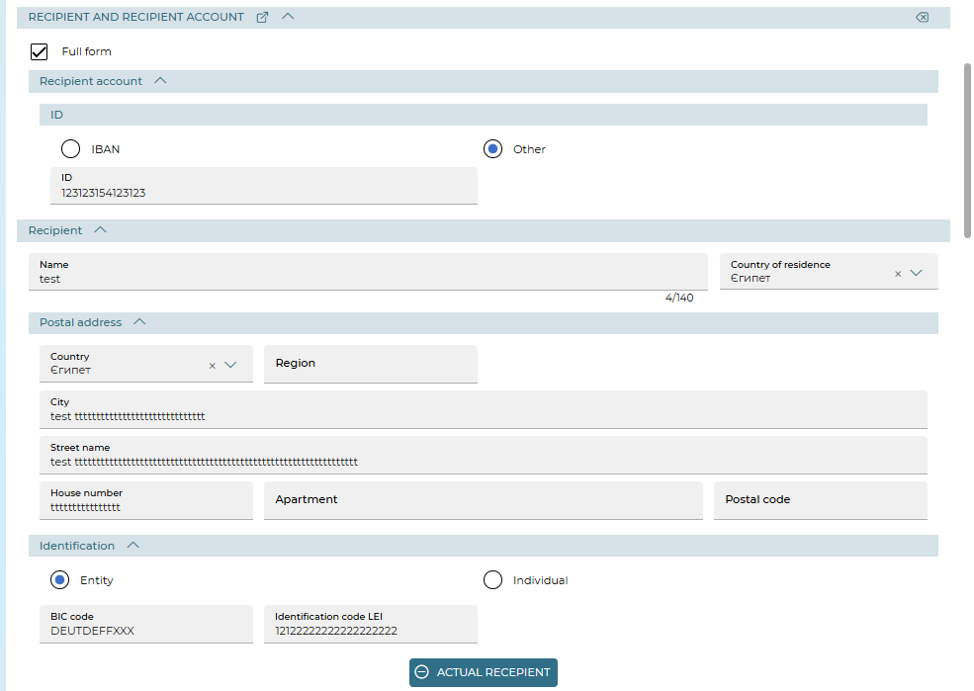
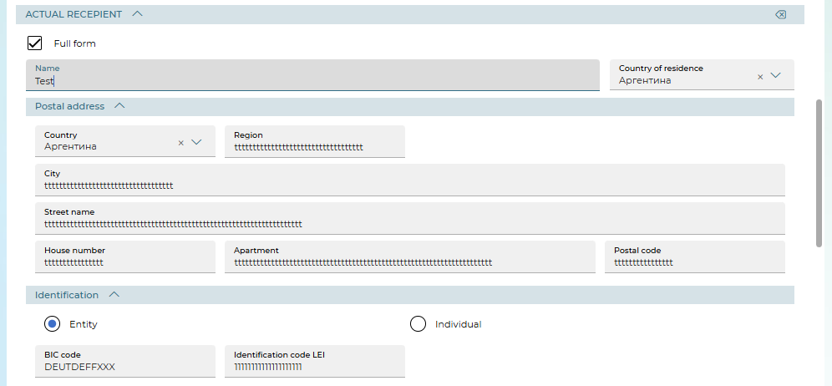
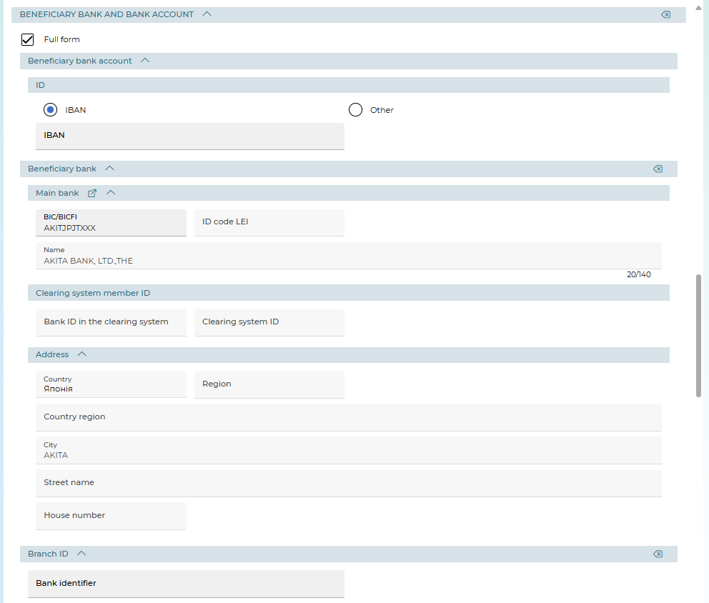
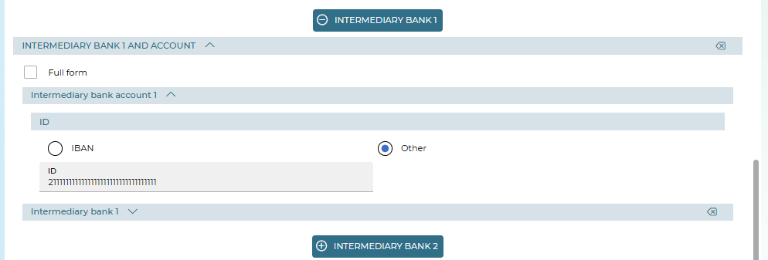
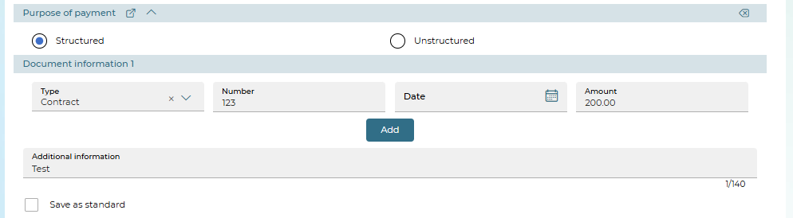
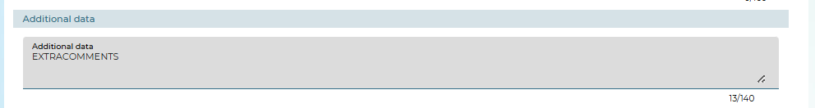
Description of elements
Element | Req. | Description
Section "Document parameters"
Number | + | The field is intended for entering the number of the currency order. The number is substituted automatically when creating a document, according to the numbering settings, but can be changed
Date | + | The field is for entering the payment date. By default, when creating, the system substitutes the current date into it. To enter the date, you can use the calendar
Value date | +/- | The field allows you to specify the date of value of the document. To enter the date, you can use the calendar.  The display of the field depends on the settings in the bank
Transfer procedure | +/- | The field allows you to determine the order of the transfer: ordinary (fixed) or urgent.  The display of the field depends on the settings in the bank
Urgency | +/- | With the help of switches, it is allowed to set the degree of urgency of conducting a currency payment order:  · T+0 – the document must be conducted "today" (the value date is equal to the date of the document). Default value;  · T+1 – the document can be conducted "tomorrow" (the value date can be set one day later than the date of the document);  · T+2 – the document can be conducted "the day after tomorrow" (the value date can be set two days later than the date of the document)  Depending on the settings in the bank, either the Value Date and Transfer Procedure fields or the "Urgency" section are displayed
Section "Payment amount and currency"
Currency | + | Field for specifying the currency of the document from the list (except for the national currency
Amount | + | Field for entering the amount of the order
Section "Payer"
Payer account | + | The field is used to select an account number from the list (in the selected currency). If the user has one account on monitoring, then it is automatically substituted
"Actual payer" is a button that is displayed when the setting is enabled in the bank. When you click on it, the "Actual payer" section opens. Filled in if necessary
The "Full form" checkbox | - | When the checkbox is displayed, additional tags and fields are displayed
Name | + | Field for entering the name of the actual payer
Country of residence | - | Field for entering the country of residence (selected from the reference book)
Address | +/- | The block for entering address data: Country (selected from the list), Region, City, Street name, House number, Apartment, Postal code
Identification | - | Block for entering identification data: select the legal status of the initiator using the "Entity" (default value) or "Individual" switches.  For legal entities. The following fields are displayed:  – BIC code is the business identification code of the organization. The BIC code of the organization is filled in if it is registered in ISO and is in the BIC reference book.  – Identification code - the identification code of the organization.  Note: If the "Entity" option is selected, at least one field must be filled in: BIC code, Identification code.  For individuals. person, fields with birth data are displayed:  – Date of birth – the date of birth is indicated.  – City of birth – the city of birth is indicated.  – Country of birth - the country of birth is indicated. The country is selected from the reference book.  Note: If the "Individual" option is selected, the fields Date of Birth, City of Birth, Country of Birth must be filled in
Section "Recipient and Recipient account". Data regarding the recipient is entered manually or from the reference book (including those created for SWIFT MT payments, the button )
Checkbox "Full form" | - | When the checkbox is displayed, additional tags and fields are displayed
Recipient Account/ID | + | Select the format in which the account will be indicated: "IBAN" or "Other", enter the identifier
Recipient | + | In the section, the name of the recipient is filled in, the country of residence is selected from the reference book
Postal address | +/- | Block for entering address data: Country (selected from the list), Region, City, Street name, House number, Apartment, Postal code
Identification | - | Block for entering identification data: select the legal status of the initiator using the "Entity" (default value) or "Individual" switches.  For legal entities. The following fields are displayed:  – BIC code - business identification code of the organization. The BIC code of the organization is filled in if it is registered in ISO and is in the BIC reference book. The format is either 8 or 11 characters.  – Identification code - the identification code of the organization.  Note: If the "Entity" option is selected, at least one field must be filled in: BIC code, Identification Code LEI.  For individual, fields with birth data are displayed:  – Birth date – the date of birth is indicated.  – City of birth – the city of birth is indicated.  – Country of birth - the country of birth is indicated. The country is selected from the reference book.  Note: If the "Individual" option is selected, the fields Birth date, City of Birth, Country of Birth must be filled in
"Actual recipient" | - | The button displayed when the setting is enabled in the bank. When you click on it, the "Actual recipient" section opens, which is filled in as needed
Section "Actual recipient"
The "Full form" checkbox | - | When the checkbox is enabled, additional tags and fields are displayed
Name | + | Field for entering the name of the actual recipient. Maximum 140 characters
Country of residence | - | Field for entering the country of residence (selected from the reference book)
Postal address | +/- | The block for entering address data: Country (selected from the list), Region, City, Street name, House number, Apartment, Postal code
Identification | - | Block for entering identification data: select the legal status of the initiator using the "Entity" (default value) or "Individual" switches.  For entities the following fields are displayed:  – BIC code is the business identification code of the organization. The BIC code of the organization is filled in if it is registered in ISO and is in the BIC reference book.  – Identification code/LEI – identification code of the organization.  Note: If the "Entity" option is selected, at least one field must be filled in: BIC code, Identification code.  For individuals, fields with birth data are displayed:  – Birth date – the date of birth is indicated.  – City of birth – the city of birth is indicated.  – Country of birth - the country of birth is indicated. The country is selected from the reference book.  Note: If the "Individual" option is selected, the fields Birth date, City of Birth, Country of Birth must be filled in
Section "Beneficiary Bank and Bank Account"
The "Full form" checkbox | - | When the checkbox is displayed, additional tags and fields are displayed
Beneficiary bank account/ID | - | Select the format in which the account will be indicated: "IBAN" or "Other", enter the identifier
Recipient bank/Main bank | + | The bank can be selected from the bank directory (the button ).  In addition, the section data can be filled in manually:  – BIC/BICFI bank code (if filled in, other identifiers cannot be filled in),  – Id code LEI - organization Id code,  – Name (required),  – Clearing system member identifier (Bank ID in the clearing system, clearing system ID).  – Address data (if filled in, BIC cannot be filled in):  – Country (selected from the list, required),  – Region (displayed on the full form),  – Country region (displayed on the full form),  – City (required),  – Street name,  – House number.  Either BIC or address data must be filled in.  If BIC is filled in, the Name and Address data fields are filled in automatically without the possibility of editing.  It is possible to simultaneously fill in data regarding the address and the clearing system member identifier.  It is possible to simultaneously fill in data regarding the address and the ID code LEI
Recipient Bank/Branch ID | - | The block with the field to enter the branch ID is displayed if the country Japan or the BIC of a Japanese bank is specified
"Intermediary bank 1 and account" | - | A button, when pressed, will open a section for entering data on the intermediary's bank. The fields of the section are identical to the fields of the " Beneficiary Bank and Bank Account" section. Fills in as needed
"Intermediary bank 2 and account" | - | The button displayed on the enabled setting in the bank. When you click on the button, a section will open for entering data regarding the second bank of the intermediary. The fields of the section are identical to the fields of the "Beneficiary Bank and Bank Account" section. To be filled in if necessary, after filling in the data on the intermediary bank 1
Section "Purpose of payment"
Purpose of payment | + | The data is selected from the bank reference book (the button ) or filled in manually.  Select the type of payment destination using the switches:  - "Unstructured" – this displays a single field for entering the purpose of the payment.  - "Structured" – at the same time, specify the information about the document(s): type (selected from the list), number, date, amount. To add a document, click on the "Add" button.  In addition, it is possible to enter additional information
The "Save as standard" checkbox |  | When the checkbox is enabled, the purpose of the payment is saved in the reference book
Section "Commission details"
Commission details | + | Use the toggles to select the type of commission:  · Commission charged to the payer (DEBT), by default;  · Commission charged to the recipient (CRED);  · Commission to the payer and recipient (SHAR);  · Commission charged according to the agreement of the parties (SLEV) - it is displayed when the setting is enabled in the bank;  · FullPay commission - displayed when the setting is enabled in the bank
Commission account | + | Field for selecting the account number to withdraw the commission. In addition, the commission currency is displayed
Section "Payment additional information"
Reason | + | Field for entering the reason for a foreign currency payment. The field is automatically filled in with the value from the "Document Information"/"Number" field when the "Structured" checkbox is selected and can be supplemented with information by the user
Operation code | + | The field allows you to select the transaction code for the payment order
Recipient country | + | The field allows you to select the country name of the recipient of the payment from the list. In addition, the recipient's country code will be displayed
Payment Comment | - | Field for entering a comment to a currency order
Preferred Request Processing Date | - | Field for entering the date of request processing
Section "Additional data"
Additional data | - | A field for entering additional payment instructions. The display of the field depends on the settings in the bank

Register of documents
The Documents/Documents approved by the bank menu section allows you to get information about all payment documents on account for the period:
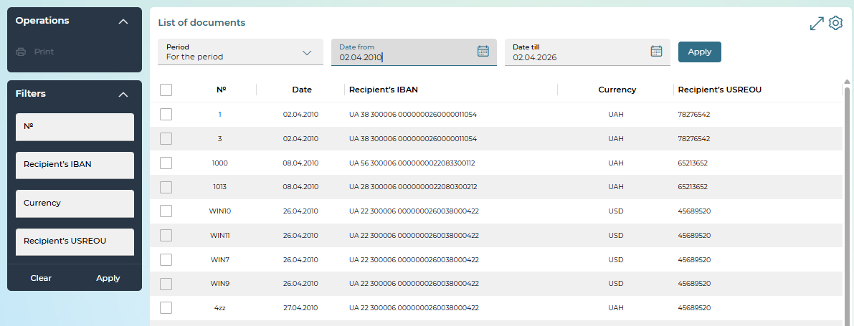
On the "List of documents" form, you can do the following:
- Select the period of display of documents – by date, for the previous day, for the month, for the period.
- For a more accurate search of the document, set additional filters or sort data, configure the display of columns on the form (see "Settings on forms with lists").
- Print the register of documents (select the necessary documents using the checkboxes and click on the "Print" button).
Each line is a link to go to the detail view form where you can print the data (the "Print" button).
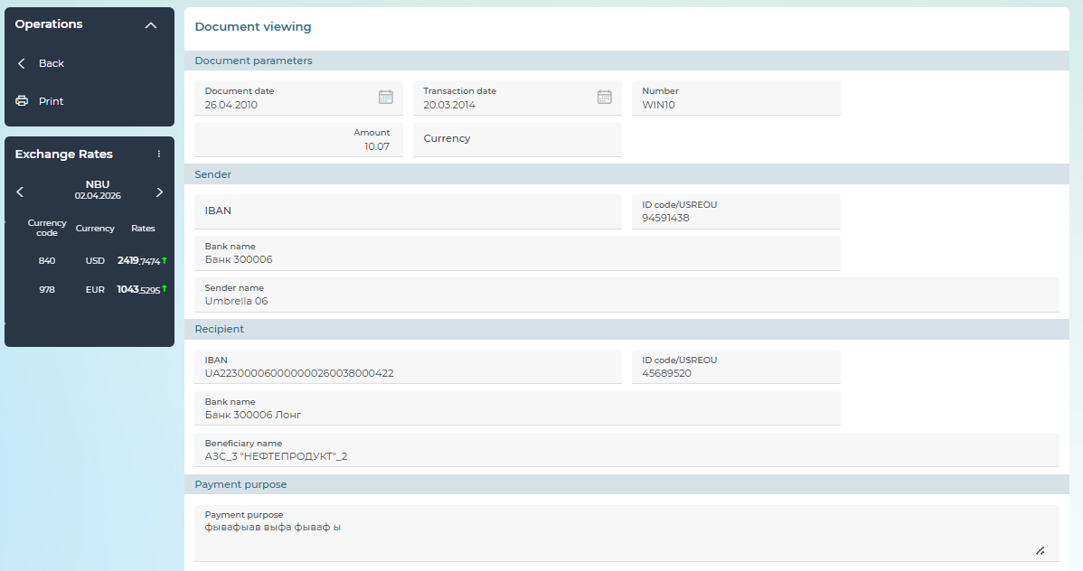
In addition, for documents in national currency, you can:
- Go to creating a payment (the "Payment" button). For the debit document, the system will create a copy of the document being viewed. For the credit document, the system will create a document in which the "Sender" section will be filled with the data of the recipient of the document being viewed, the "Recipient" section will be filled with the data of the payer of the document being viewed.
- "Detailed information about the document" is a button to view detailed information about the document. This will display a pdf form of the payment instruction, which can be downloaded or printed.
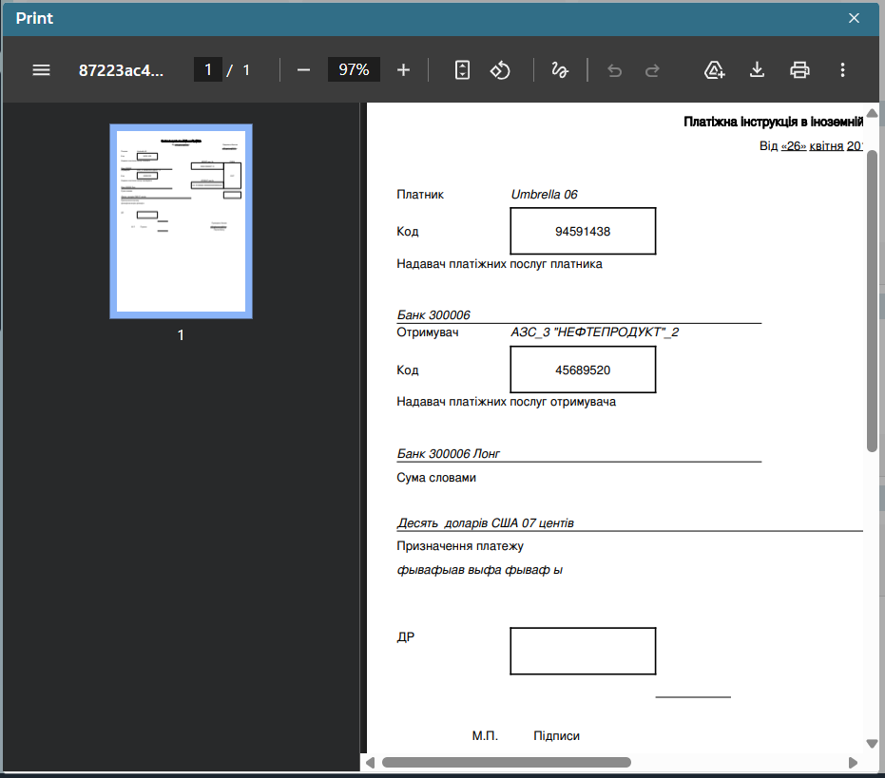
To return to the previous page, click on the „Back“ button.

Cards
You can view the list of card accounts and card information:
1. On the main page in the "Accounts" widget:
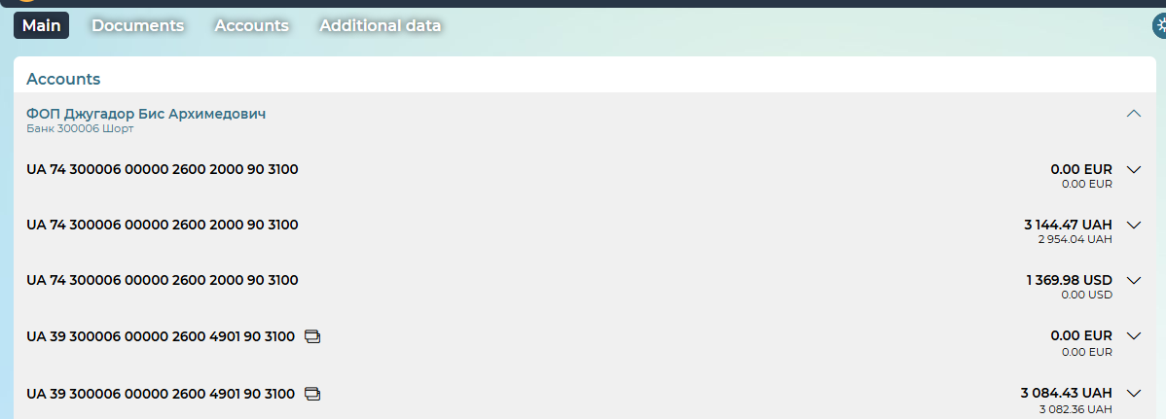
2. In the Accounts/All accounts menu item:
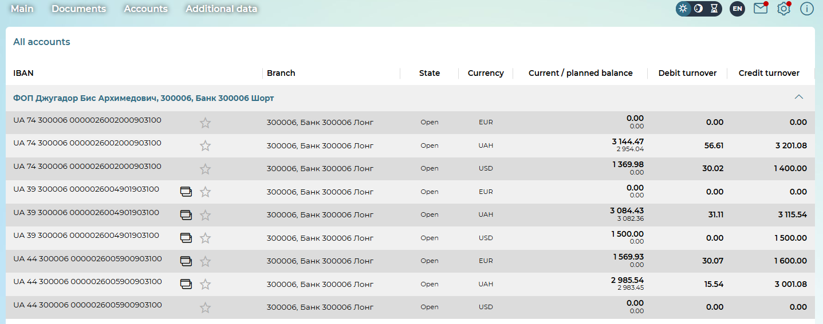
Please note: card accounts are marked in the lists with an icon .
In the "Accounts" widget, card accounts are displayed in a collapsed state. To view more detailed information on the card account, click on the button in the field with the necessary account.
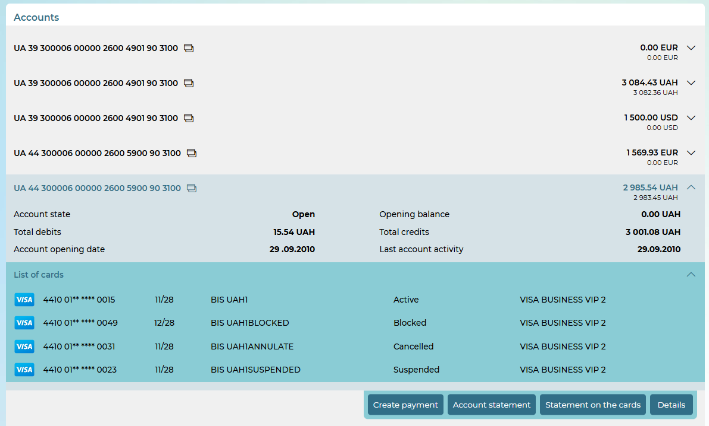
On the expanded form of the card account, you can perform the following actions:
- view basic information about the card account: account status, amount of debit/credit turnover, account opening date, balance at the beginning of the current day, last account activity;
- create a payment from the selected account – the "Create payment" button. By clicking, you will be taken to the form of creating a payment (hryvnia or intrabank currency) with the Payer Account field filled in;
- get an account statement – the "Account statement" button (see "Statement of accounts");
- get a card statement – the "Statement on the cards" button (see "Card statement");
- view/print account details – the "Details" button;
- view the list of cards linked to the account and detailed information for each card. To do this, in the "List of cards" line, click on the button , which will reveal the list of cards on this card account.

Click on the line with the necessary card to go to the form with detailed information.
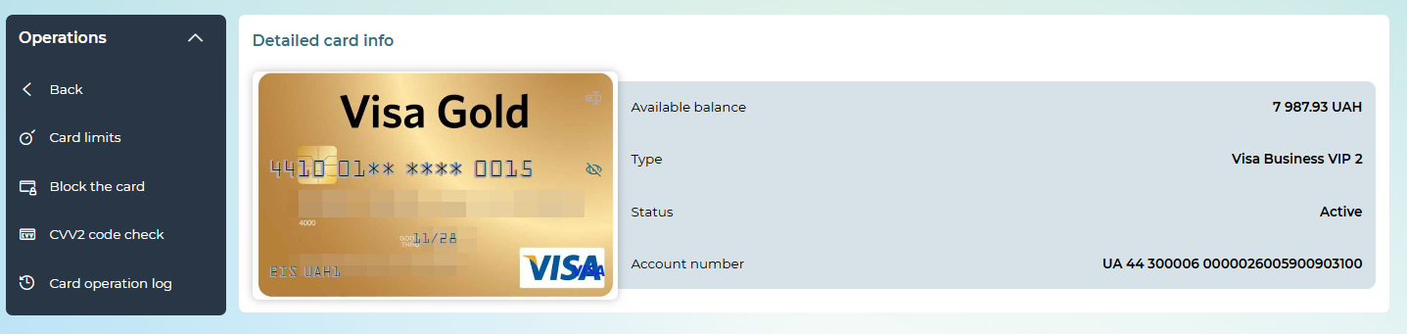
On the "Card details" form, you can:
- Change the nickname of the card. To do this, press the button , enter the name and press the button .
- View the full card number – click on the icon with the image of an eye. The displayed card number is available for copying. To get the number out again in a masked form, click on the icon with the image of the crossed-out eye.
- View the expiration date of the card, the embossed name on the card and the icon of the payment system.
- View available balance, account currency, card status, card type, card account number.
- perform non-financial transactions with the card (the available list of transactions is determined by card processing and the bank):

To return to the general list of cards on the account, click on the „Back“ button.
In the "Operations" menu, a list of non-financial transactions that you can perform with the card is available (please note: the availability of these transactions is determined by your bank):
- "Card limits" – takes you to the limit management form (available for cards in the "Active" status, see "Card limits").
- "Block the card" - go to the card blocking form (available for cards in the "Active" status, see "Card blocking").
- "Cancel the card" - go to the card cancellation form (available for cards in the status "Active", "Blocked" or "Suspended", see "Card Cancellation").
- "Card operation log" - go to the form for viewing the card transaction log (see "Personal settings").

Card statement
In order to receive a card account statement:
1. On the main page, in the "Accounts" widget, select the required card account, open the window with detailed information using the button and click on the "Card statement" button.
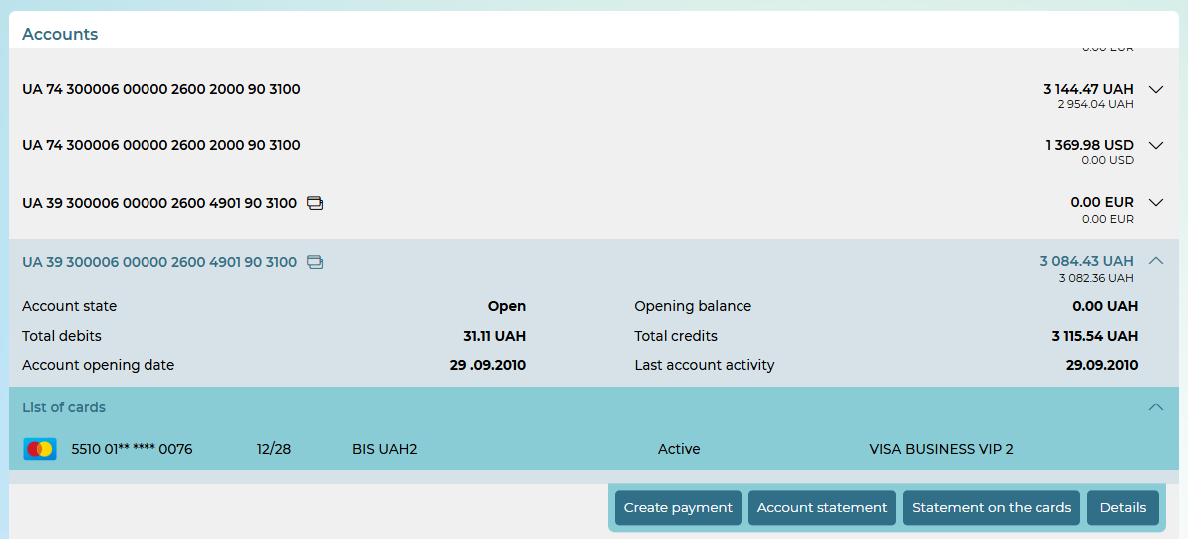
2. In a new window, please do the following:
- Select the statement period from the drop-down list: by date, by previous day, by month, for the period. Enter the date(s) manually or using the built-in calendar. By default, the current calendar date will be displayed.
- Check the "Bank stamp" checkbox if you want to put a bank seal.
- Click on the "Compose" button.
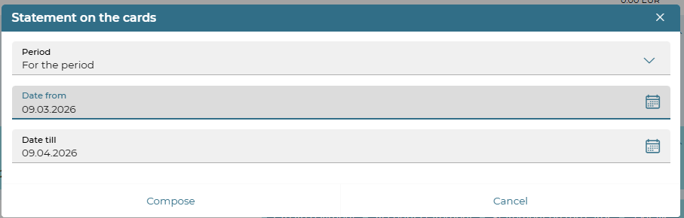
- When generating a statement, the system will display the following messages:
- The generated statement will be displayed on the screen, it can be printed using the browser tools.

Card cancellation
The card cancellation operation is available for cards in the statuses "Active", "Blocked", "Suspended".
After clicking the "Cancel card" button, you will receive a warning that the card will be canceled. Sign the document using EDS by clicking the "Sign" button.
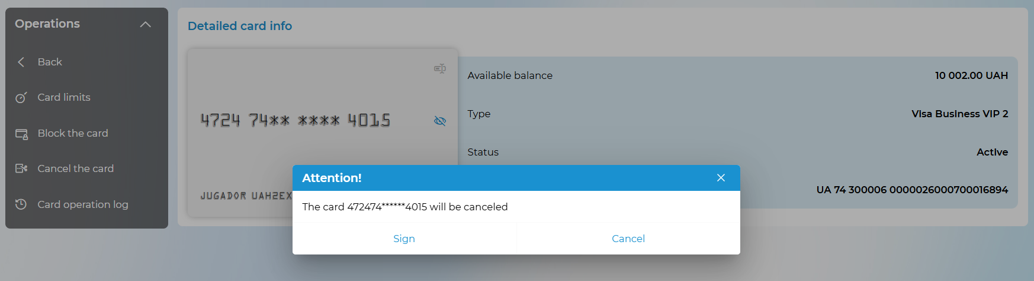
You can view the details of the transaction in the card transaction log (see "Personal settings").

Card blocking
The operation is available for cards in the "Active" status.
On the "Card details" form, click on the "Block the card" button, select the blocking status (stolen, lost, suspected of fraud, temporary blocking) from the drop-down list, specify a comment if necessary (if the Comment field is displayed on the form), click on the "Sign" button and sign the document using EDS.
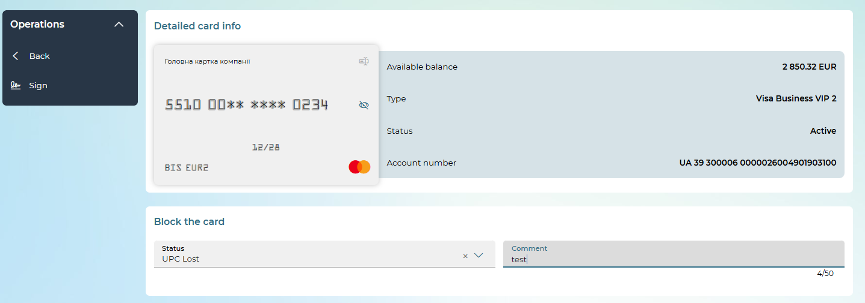
You can view the details of the transaction in the card transaction log (see "Personal settings").

Card limits
The operation is available for cards in the "Active" status.
On the "Card details" form, click on the "Card limits" button.
In the "Card limits" section, you can view the following information:
- the period of validity of card limits set by the bank (the period during which you can use limits with specified parameters for the amount and number of transactions) - the Cycle length field;
- the maximum amount and number of cash withdrawal operations - the Withdrawal field;
- the maximum amount and number of transactions for payment for goods and services - the Purchase field;
- the maximum amount and number of transactions on transactions on the Internet – the Internet field;
- the total amount and number of expenditure transactions for the established period on your card - the Total limits field.
You can make changes to the Amount and Number fields for expense transactions, transactions on the Internet, as well as change the total total limit. To do this:
- enter new values in the appropriate fields;
- click on the "Sign" button and sign the document using EDS.
To return to the "Card details" form, click on the „Back“ button.
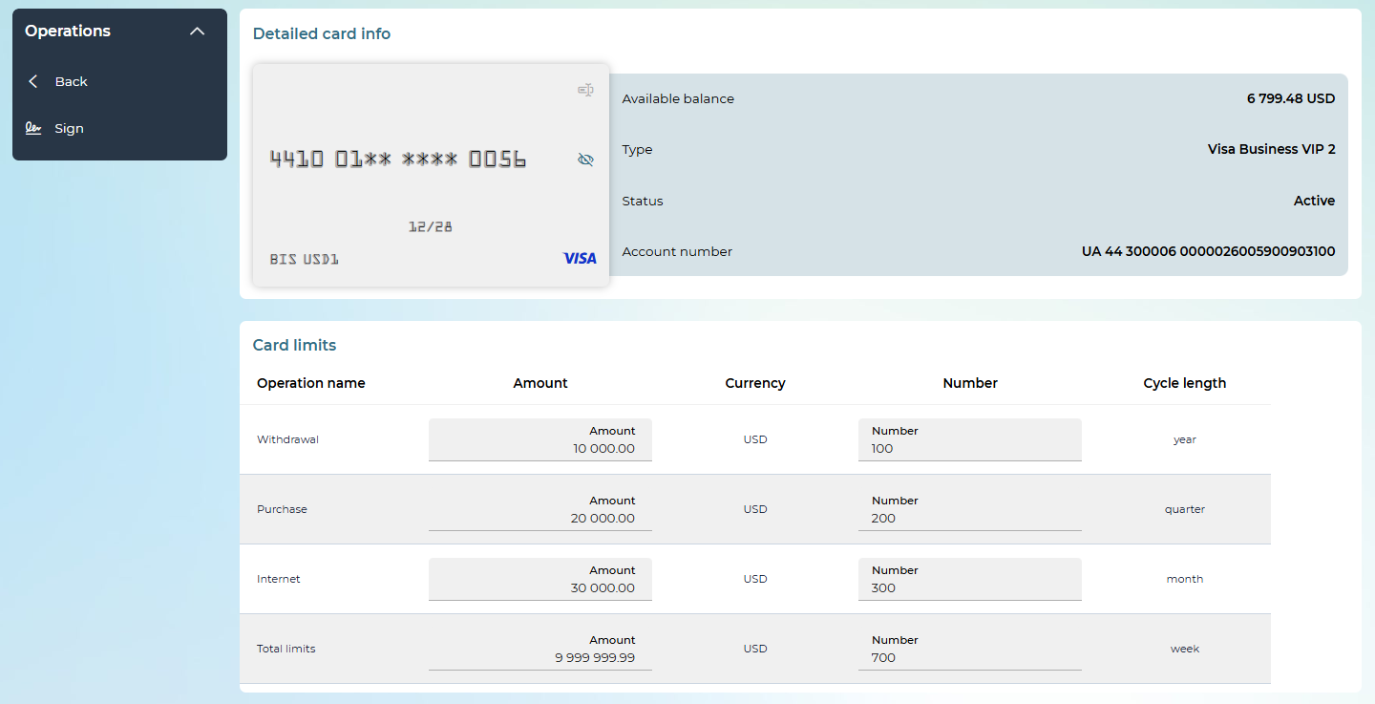
You can view the details of the transaction in the card transaction log (see "Personal settings").

Accounts
You can view the list of your current and card accounts with information on current and forecast balances by selecting the Accounts/All Accounts menu item.
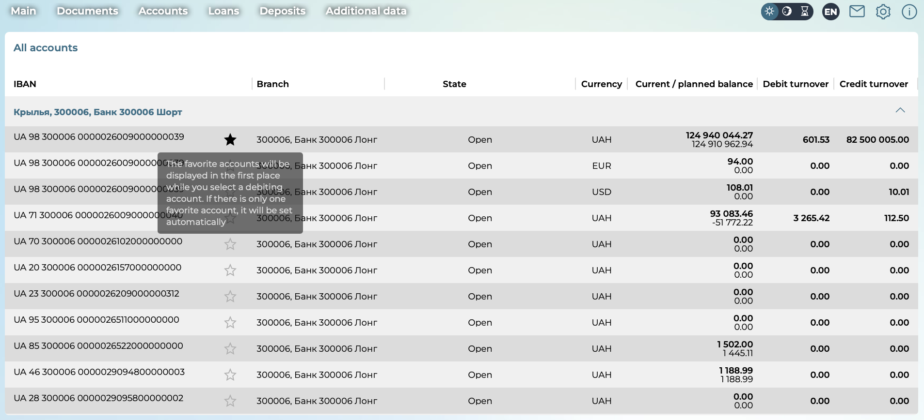
If the user has several accounts within one account under monitoring, then all accounts will be displayed according to the enterprise. By default, enterprises are located by name, and accounts of each enterprise are located by number. scroll-bookmark-42
On the “All accounts” page, you can do the following:
- In order to hide or display the list of counteragent cards/accounts, click on the arrow buttons ("Collapse" or "Expand").
- Mark the account as selected (click on the star icon). The selected accounts will be displayed first when you select a debit account.
- View information on current and planned balances, as well as debit and credit account turnovers.
- Copy the desired information – hover the cursor over the appropriate option and click on the copy icon in the pop-up window.

Statement of accounts
In order to receive an account statement:
- Go to the Accounts/Account statement menu item. In addition, it is possible to go to the statement from the main page by selecting the "Generate statement" menu in the "My statements" block.
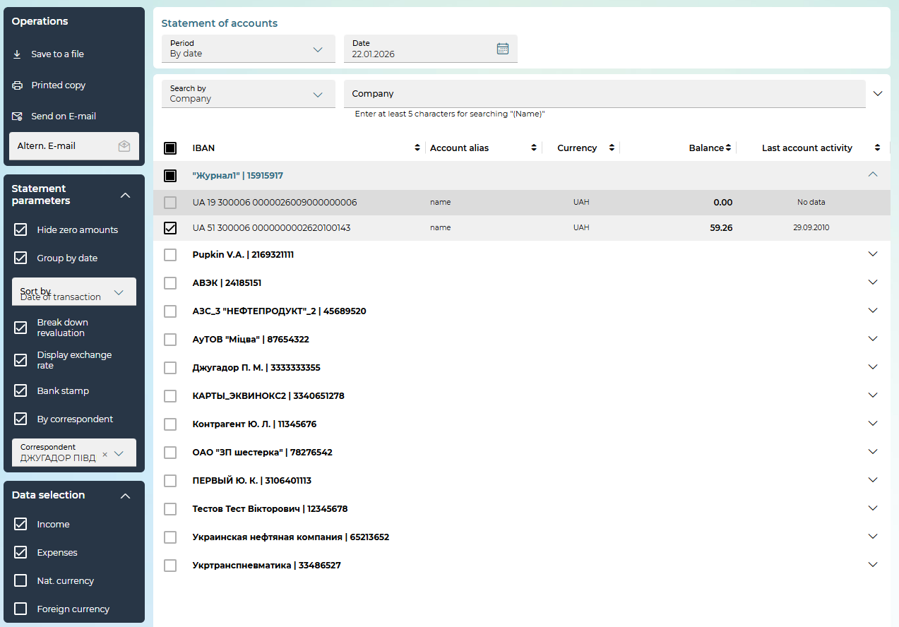
- On the form "Statement of accounts":
  - Select the check-out period from the drop-down list: for the previous day, for the month, for the period, or by date. If necessary, enter the date/dates manually or using the built-in calendar.
- You can search by company name or accounts by selecting the appropriate option. To search in the Company/Company accounts field, start typing the company name or account number.
  - In the "Data selection" block, use checkboxes to specify which documents should be included in the statement: income, expenses, payment documents in national or foreign currency.
- In the "Statement parameters" block:
  - "Hide zero amounts" – set this checkbox if you do not want the statement to display data with zero values (in the absence of transactions of a certain type (income/expense) on the account).
  - "Group by date" – set this checkbox if you want the statement data to be grouped not only by accounts, but also by dates.
  - Select from the drop-down list how to sort the documents in the statement: by date, by document number, by document amount. Documents will be sorted in ascending order.
  - "Break down revaluation" – set this checkbox so that the statement displays not only the revaluation values, but also the non-operating exchange rate difference.
  - "Display exchange rate" – set this checkbox so that the statement displays data indicating the exchange rate of each document.
  - "Bank stamp" – set this checkbox so that the printed form of the statement displays a facsimile of the bank (the availability of the option depends on the settings in the bank).
  - "By correspondent" – select this option to build a statement for the selected correspondent. Select the desired correspondent from the reference book from the drop-down list. Alternatively, you can search for a correspondent from the reference book by name or by ID number. In addition, it is possible to build a statement for a correspondent who is not in the reference book. To do this, enter the USREOU of the correspondent in the appropriate field and click on the "OK" button.

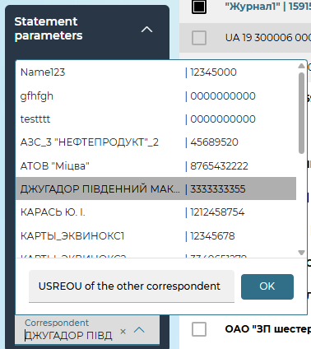

Please note: Menu items are displayed depending on the system configuration and the rights granted to you, so some of them may not be present in your version of the application
- In the list of accounts:
  - To expand/collapse the list of accounts by correspondent, use the / buttons to the right of the correspondent's name. To expand/collapse the list of all accounts, use the / buttons to the right of the search boxes.
  - You can sort accounts by the following parameters: account number (IBAN), account alias, currency, balance, last account movement. To do this, click to the right of the sort option. The or symbol to the right of the parameter name indicates that sorting by this parameter is in progress.
  - You can search by company or company accounts. To do this, select a search term from the drop-down list and enter a minimum of five characters of the company name or account number/alias in the appropriate search field.
  - Use checkboxes to mark the accounts for which the statement will be generated. To set checkboxes for all correspondent accounts, set the checkbox to the left of the correspondent's name.
After you have set all the necessary parameters, you can perform the following operations in the "Operations" block:
- Generate a statement and save it to the file system of your computer – the operation "Save to a file". When you click on the "Save to file" button, a window will open in which you should:
- select the export format (BOL, DAT, TXT, CSV, DBF, XLS, XML, PDF or CAMT.053). Please note: the CAMT.053 format is available only for accounts in national currency, and you can specify the period of issue and the type of documents, and all other statement parameters will not be available.
- choose the method of saving the file. If you have submitted a request for the generation of a statement for a certain period and have chosen any format, in addition to PDF or CAMT.053, you can save the statement as a single file or multiple files with file breakdown by date. To save the statement in several files, set the checkbox "Divide into separate files by dates of movement".
- click on the "Export documents" button.
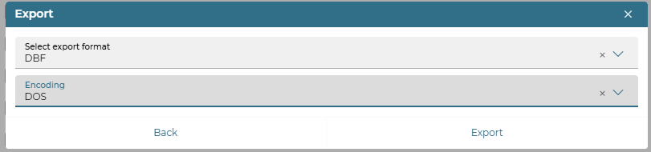

Please note: If you choose the DBF format, you also need to select the encoding (WIN/DOS) – Windows-1251 or DOS-866, respectively. If you choose the XML format, you also need to select the encoding (WIN/UTF) – Windows-1251 or UTF-8, respectively.
- View the statement on the screen of your monitor and print it – the operation "Printed form".
- Send the statement to e-mail – the operation "Send on E-mail". In this case, the system will send the statement file in PDF format to the address specified by you in the user settings (see "Personal settings"). If you want to receive a statement to a different e-mail address than the one specified in the user settings, enter an alternative E-mail, click on the  button.

Please note: current balances are calculated based on the results of work for the day, i.e. taking into account all documents generated by the client and carried out by the bank at the moment. At the same time, only the documents of the current day on the accounts of customers that have been received by the CBS, processed by the bank manager and delivered to the system at the time of the request for a statement by the user of the system are taken into account.
Attention! When generating a printed statement form, the amount of data processed may be limited by the bank's settings. If a message is displayed that the limit on the number of accounts or the number of records has been exceeded, close the message window, and then select a smaller number of accounts on the statement form, or shorten the request period, perform the statement generation operation again.

Account limits
If you have the right to work with the limit subsystem, then you will be able to perform the following actions:
- Set general and authorization limits on accounts (see below);
- Generate payment documents for accounts for which limits are set (see "Formation of payment documents");
- Sign payment documents with an authorization signature of the required level of authorization (see «Additional signing of documents»).

To view and configure account limits, select the Additional data/Limits by accounts section.
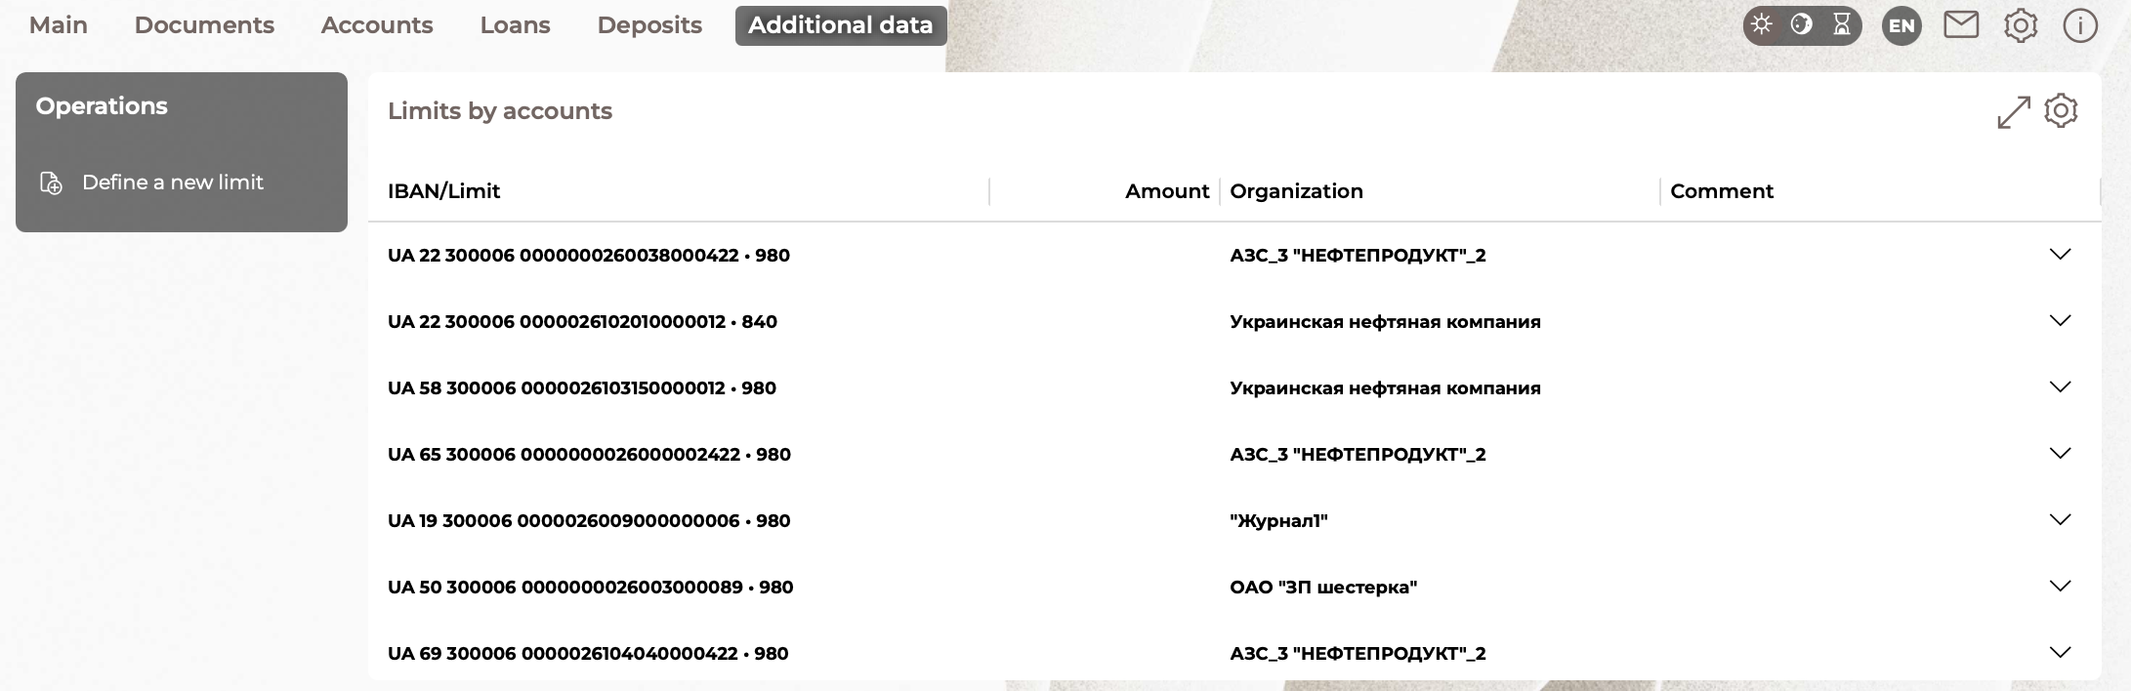

In the new form, you can do the following:
- View the list of accounts that have limits.
- View detailed information about the limits that are set for these accounts. Expand/collapse the section with detailed information using  the /  buttons.
- Set a new limit on the account - the "Define a new limit" button.
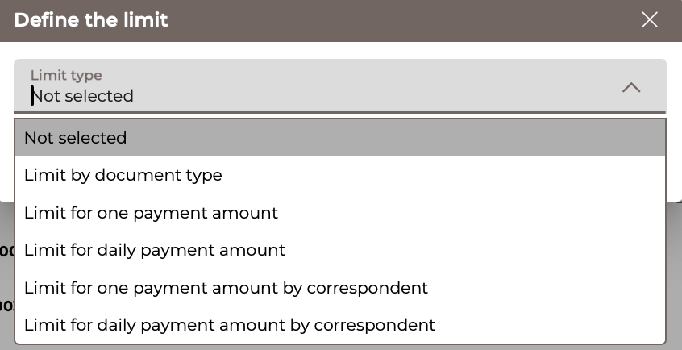
- Edit general or authorization limit – the button  (see "Editing and deleting limits").
- Delete general or authorization limit – the button (see ""Editing and deleting limits").

The subsystem implements a mechanism for determining the following types of account limits by the client:
- Limit by document type;
- Limit for one payment amount;
- Limit for daily payment amount;
- Limit for one payment amount by correspondent;
- Limit for daily payment amount by correspondent.

Limit by document type
To set a limit by document type, follow these steps:
- On the "Account limits" form, click on the "Define a new limit" button.
- Select the limit type: limit by document type.
- Select the account for which the limit will be set.
- Select the type of document for which the limit will be set (for accounts in UAH, document types are available: payment instruction, request for the currency purchase, payroll, for foreign currency accounts – a request for currency sale and a currency transfer within the bank).
- Specify the amount of the limit.
- Enter a comment (if necessary).
- Click on the "Save" button to save the limit.
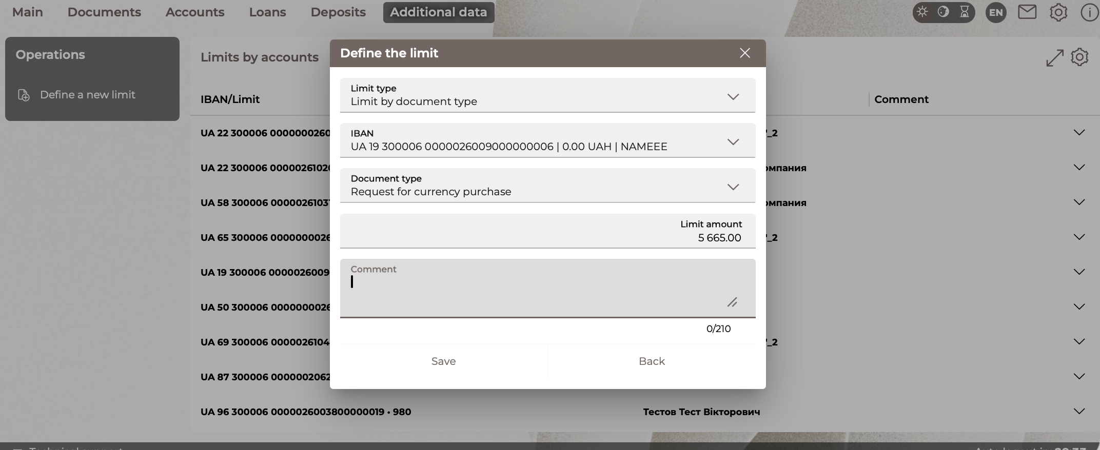

Limit for one payment amount
To set a limit for one payment amount, follow these steps:
- On the "Account limits" form, click on the "Define a new limit" button.
- Select the type of limit: limit for one payment amount.
- Select the account for which the limit will be set.
- Specify the amount of the limit.
- Enter a comment (if necessary).
- Click on the "Save" button to save the limit.
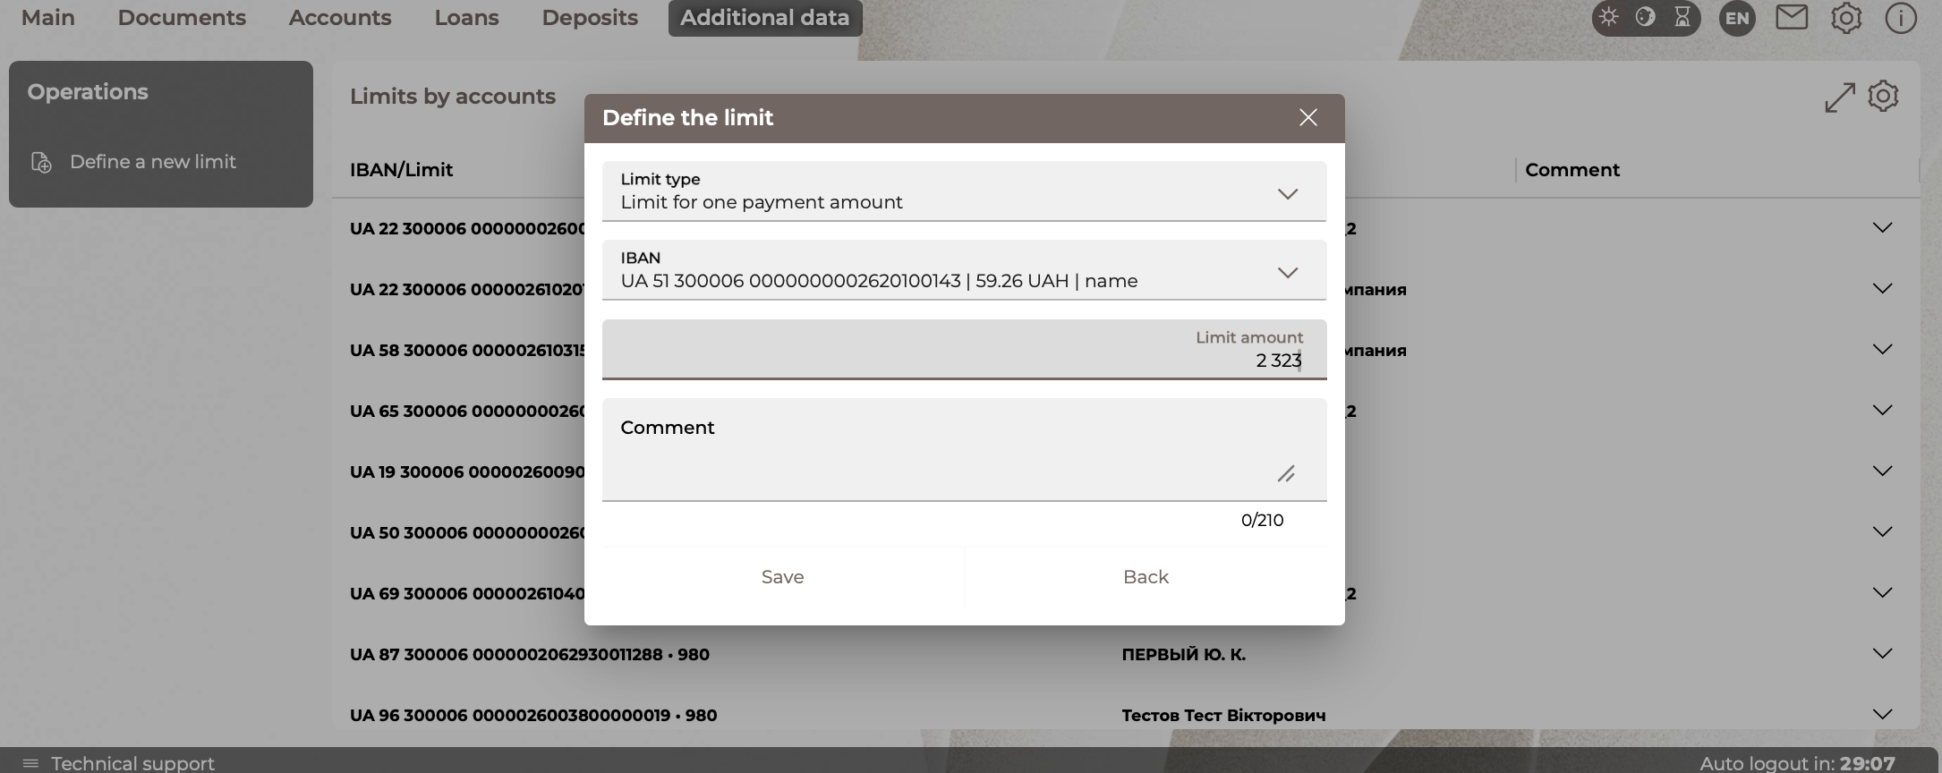

Limit for daily payment amount
To set a limit for daily payment amount, follow these steps:
- On the "Account limits" form, click on the "Define a new limit" button.
- Select the type of limit: limit for daily payment amount.
- Select the account for which the limit will be set.
- Specify the amount of the limit.
- Enter a comment (if necessary).
- Click on the "Save" button to save the limit.
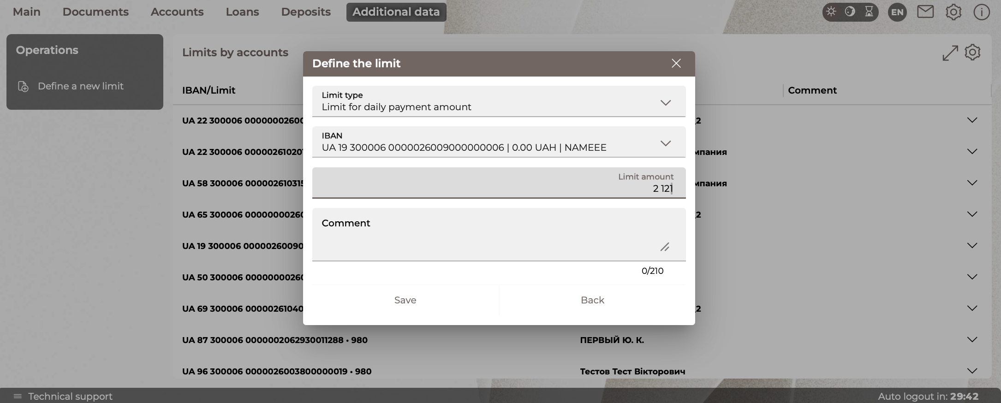

Limit for one payment amount by correspondent
To set a limit for one payment amount by correspondent, follow these steps:
- On the "Account limits" form, click on the "Define a new limit" button.
- Select the type of limit: limit for one payment amount by correspondent.
- Select the account for which the limit will be set.
- Indicate the identification code/USREOU of the correspondent.
- Specify the amount of the limit.
- Enter a comment (if necessary).
- Click on the "Save" button to save the limit.
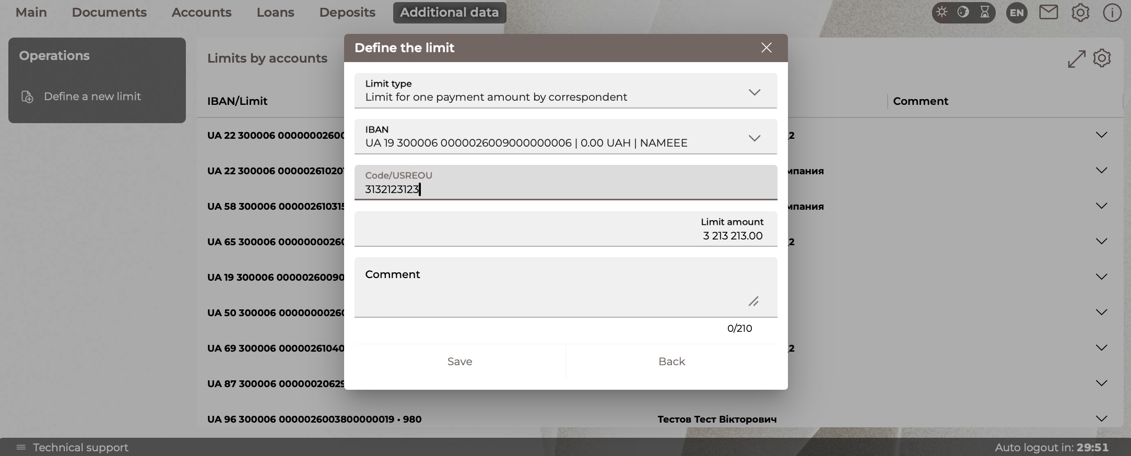

Limit for daily payment amount by correspondent
To set a limit for daily payment amount by correspondent, follow these steps:
- On the "Account limits" form, click on the "Define a new limit" button.
- Select the type of limit: limit for daily payment amount by correspondent.
- Select the account for which the limit will be set.
- Indicate the identification code/ USREOU code of the correspondent.
- Specify the amount of the limit.
- Enter a comment (if necessary).
- Click on the "Save" button to save the limit.
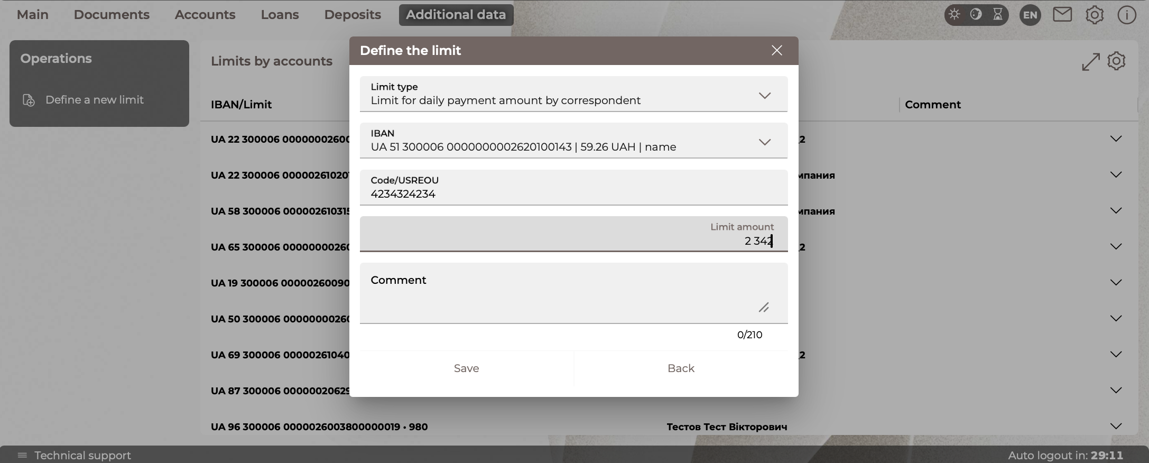

Setting authorization limits for an account
Authorization limits are configured separately for each of the above types of general limits (except for the limit by document type).
There are several levels of authorization limit in the subsystem:
- Authorization limit of the third level.
- Authorization limit of the fourth level.
- Authorization limit of the fifth level.
- Authorization limit of the sixth level.
To set an authorization limit, follow these steps:
- Go to the menu item Additional data/Account limits.
- On the form with a list of limits, select the line with the desired account and click on the button next to the limit for which you want to set an authorization limit.
- In a new form:
- select the type of limit: "Authorization limit ..." from the list;
- select the level of signing from the list;
- Specify the amount of the limit (taking into account the fact that the amounts of authorization limits should increase with the increase in the level of signature).
- Click on the "Save" button to save the limit.
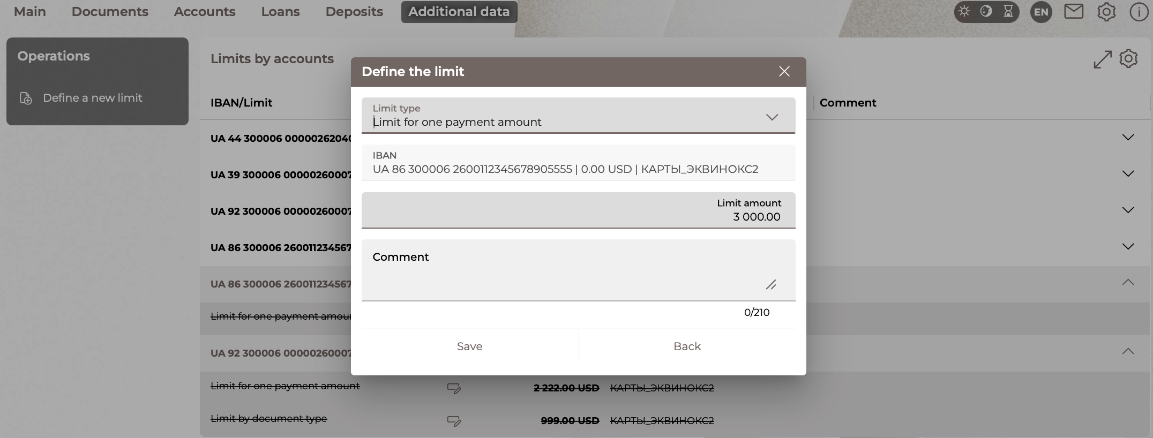
The auto-clearance limit is taken into account when processing documents in the system as follows: if the payment exceeds the established general limit, then the authorization limit will be searched, and if there is one, and the document does not exceed it, the document will be returned to the client for additional signature with an authorization signature of the required level.

Edit and delete limits
You can edit both the general and authorization limits that were previously set. To do this, follow these steps:
- Go to the menu item Additional data/Account limits.
- On the limit list form, select the line with the desired account and click on the button next to the limit you want to edit.
- Select the type of limit you want from the list.
- Make any necessary changes.
- Click on the "Save" button to save the changes.
Note: You cannot change your account number.
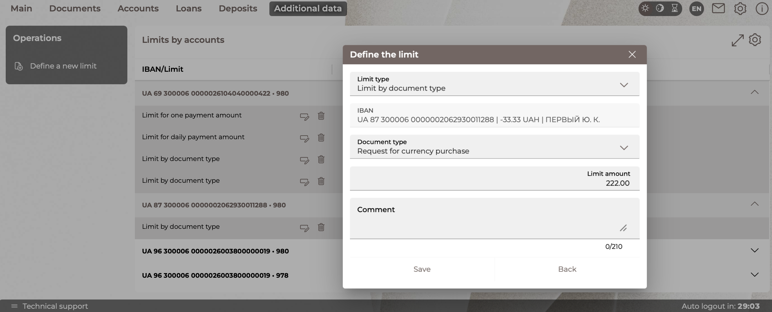

To remove a general or authorization limit, follow these steps:
- Select an account from the list.
- Click on the button next to the limit you want to delete.
- Click on the "Delete" button to confirm the deletion.
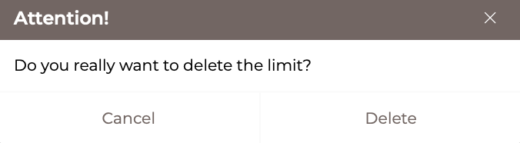
The remote limit will be displayed in a strikethrough font. You can set/edit the deleted limit by clicking the button.
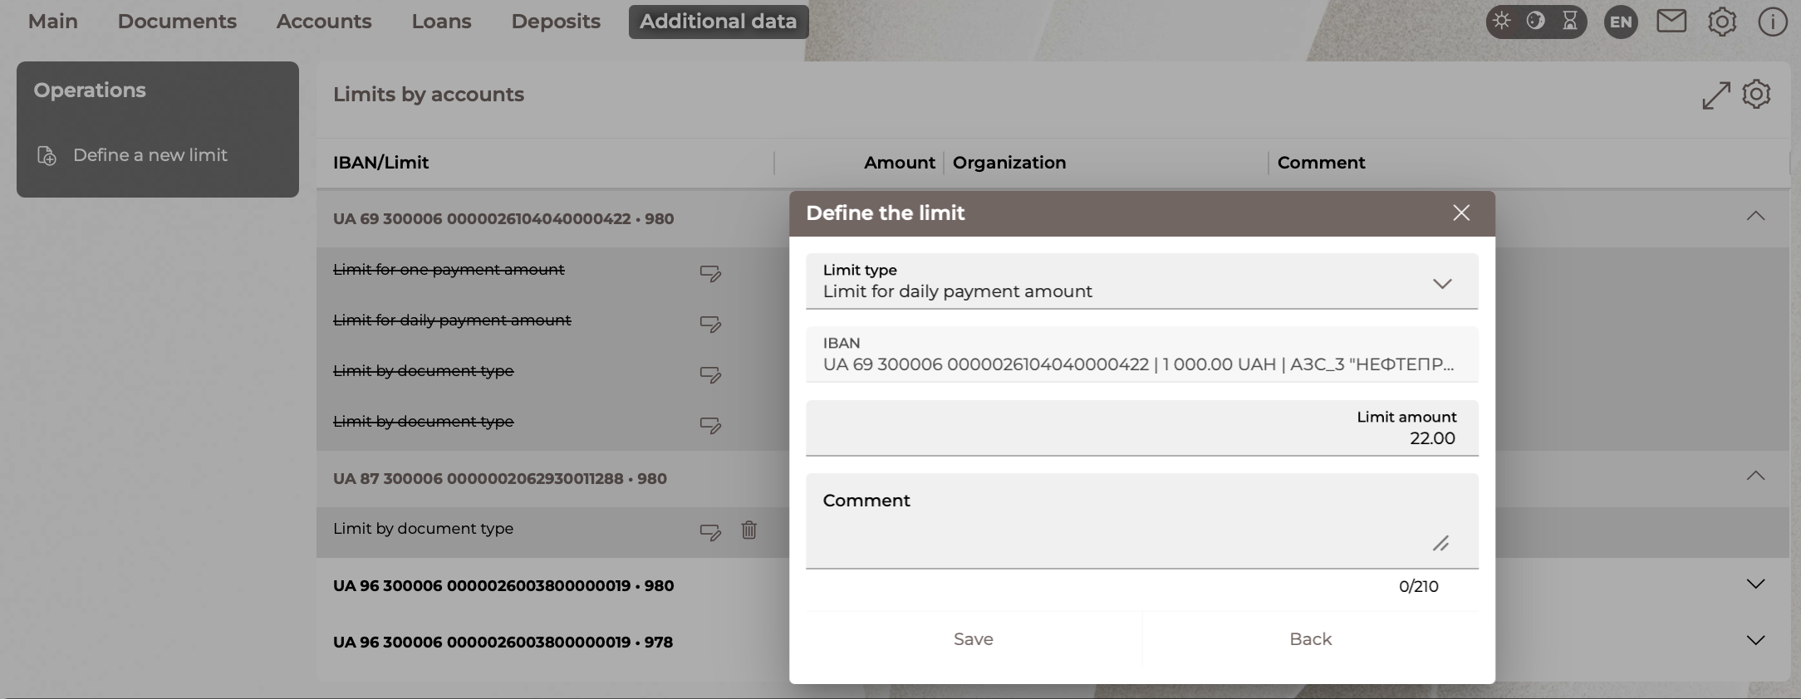
Please note: when you delete a limit on your account, its authorization limits are deleted automatically.

Formation of payment documents
In the Internet banking system, you can generate the following types of documents on the account for which limits have been set in the limit subsystem:
- payment documents in national currency;
- payment documents in foreign currency;
- requests for the purchase/sale of currency;
- payrolls.
For generated documents of the specified types, the checks described in the section "Rules for Processing Documents" are performed on the accounts for which limits have been determinedscroll-bookmark-111.

Additional signing of documents
If, after processing the payment document (see "Rules for Processing Documents") it turns out that the document requires authorization signatures of the third, fourth, fifth or sixth levels of signing, there is a possibility of its additional signing. The document will be moved to the "Not all signatures" state, indicating the number of signatures required.
Users with the right of authorization signature of the appropriate level can sign the document with a signature of the required level, after which it will be sent to the bank and posted.
Please note: you can only authorize for those accounts to which you have rights.

Document processing rules
Verification of documents in the system (taking into account the established limits) is carried out in the following order:
- Limit by document type;
- Limit for one payment amount;
- Limit for daily payment amount;
- Checking the limit for the amount of one payment by correspondent;
- Checking the limit for daily payment amount by correspondent.

Check the limit by document type
If the account is set a limit by the type of document, and the amount of the document exceeds it, then the document is rejected with a notification to the client about exceeding the established limit by the type of document.

Checking the limit for the amount of one payment
- If the account has a limit for one payment amount, and the amount on the document exceeds it, then the search for authorization limits for this total limit is carried out.
- If the amount of payment on the account exceeds the specified general limit, and there are no authorization limits, then the document is rejected. At the same time, the client is informed about exceeding the established general limit for one payment amount on the selected account.
- If there are authorization limits, then a check is performed to verify that the document amount complies with these limits. If the document does not exceed the maximum authorization limit in amount, then the document is returned to the client in the "Not all signatures" state, indicating the required level of signing.
- If there are authorization limits, and the document exceeds the maximum authorization limit, then the document is rejected. At the same time, the client is notified of exceeding the established authorization limits for the amount of one payment on the selected account.

Check the limit for daily payment amount
- If on the debit account there is a limit set on the amount of payments per day, and the amount of processed payments for the day, taking into account the current document, exceeds it, then the document is rejected. At the same time, the client receives a notification about exceeding the established limit on the amount of payments on the selected account.
- If a limit for daily payment amount is set on the debit account, and the amount of processed payments for the day, taking into account the current document, exceeds it, then the search for authorization limits for this general limit is carried out.
- If there are no authorization limits, then the document is rejected. At the same time, the client is informed about exceeding the established general limit for daily payment amount on the selected account.
- If there are authorization limits, then a check is carried out whether the amounts of processed payments for the day, taking into account the current document, correspond to these limits. If the amount of processed payments for the day, taking into account the current document, does not exceed the maximum authorization limit in amount, then the document is returned to the client in the state "Not all signatures" indicating the required level of signing;
- If there are authorization limits, and the amount of processed payments for the day, taking into account the current document, exceeds the maximum authorization limit, then the document is rejected. At the same time, the client is informed about exceeding the established authorization limits for the amount of payments per day on the selected account.

Checking the limit for the amount of one payment by correspondent
- If a limit for one payment amount is set on the write-off account and the correspondent of the document, and the amount on the document exceeds it, then the search for authorization limits for this total limit is carried out.
- If there are no authorization limits, then the document is rejected. At the same time, the client is notified of exceeding the established general limit for one payment amount by correspondent on the selected account.
- If there are authorization limits, then the document amount is checked for compliance with these limits. If the document does not exceed the maximum authorization limit in amount, then the document is returned to the client in the "Not all signatures" state, indicating the required level of signing.
- If there are authorization limits, and the document exceeds the maximum authorization limit, then the document is rejected. At the same time, the client is notified of exceeding the established authorization limits for the amount of one payment on the selected account and the payment correspondent.

Checking the limit for daily payment amount by correspondent
- If a limit for daily payment amount is set on the write-off account and the correspondent of the document, and the amount of processed payments and by the correspondent for the day, taking into account the current document, exceeds it, then the search for authorization limits for this total limit is carried out.
- If there are no authorization limits, then the document is rejected. At the same time, the client is notified about exceeding the established general limit for daily payment amount by correspondent on the selected account.
- If there are authorization limits, then a check is carried out for compliance of the amount of processed payments by the correspondent for the day, taking into account the current document with these limits. If the amount of documents posted on this correspondent account for the day, taking into account the current document, does not exceed the maximum authorization limit in amount, then the document is returned to the client in the state "Not all signatures" indicating the required level of signing.
- If there are authorization limits, and the amount of processed payments for the day, taking into account the current document, exceeds the maximum authorization limit, then the document is rejected. At the same time, the client is notified of exceeding the established authorization limits for the amount of payments per day on the selected account and by the payment correspondent.

Checking the limit on the payroll
Calculation of payroll document amounts is carried out according to the following principle:
- if the documents on the payroll have not yet been posted in CBS B2 - the total amount is used;
- if the documents are posted on the side of B2 CBS – the value of the amount of accruals is used. In a particular case, it coincides with the total amount.

Salary
The Extra/Salary menu item allows you to go to the following sections:
- Salary projects
- Employee applications
- Payroll

Salary projects
To switch to working with salary projects, select the menu item Additional data/Salary/Salary projects.
The form will display a list of the user's enterprises and their salary projects for which they are serviced by the bank.
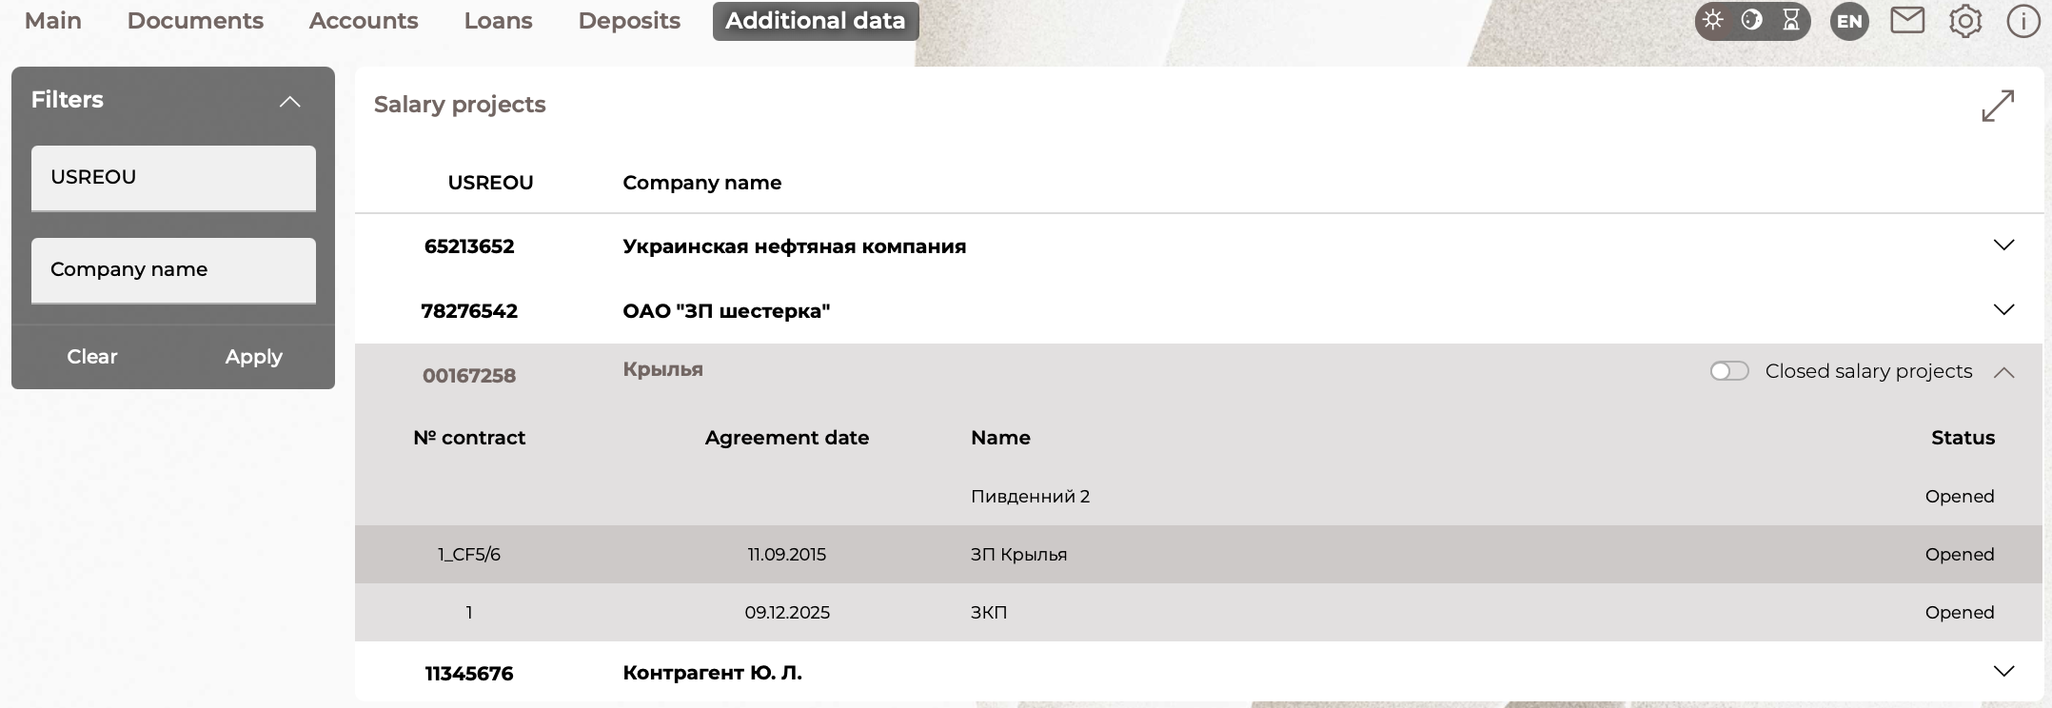
You can find the desired project by the USREOU and/or the name of the company using filters.
To collapse/expand the section with the list of accounts, use the / buttons.
In order to display closed salary projects in the list, use the "Closed salary projects" switch (disabled by default).
Each line of the salary project list is a link that you can follow to the list of salary project employees.
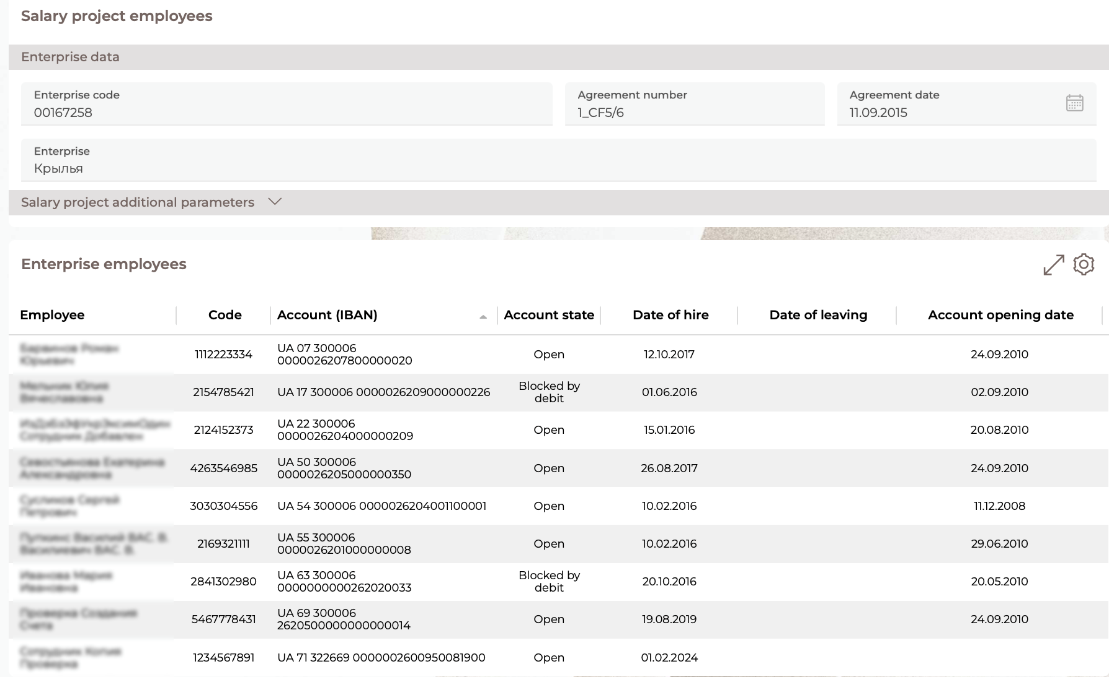
The form "Salary project employees" displays detailed data on the selected salary project.
The "Enterprise Data" section displays the Enterprise code and the name of the enterprise, as well as the number of the salary card project agreement and the date of the agreement.
The "Enterprise employees" section displays the following elements:
- Employee: last name, first name, patronymic of the employee.
- Employee ID code.
- Employee's account for the selected salary card project.
- Account state.
- Date of hire.
- Date of leaving.
- A sign of dismissal.
You can set additional filters, sort the data, or customize the form (see "Settings on forms with lists").
To display the dismissed employees, set the appropriate checkbox in the filter block.
You can export a list of employee accounts (in CSV or DBF formats). To do this, click on the "Accounts export" button.
To return to the "Salary projects" form, click on the „Back“ button.

Employee applications
To view information about employees of salary projects, go to the Additional data/Salary/Employee applications menu item:
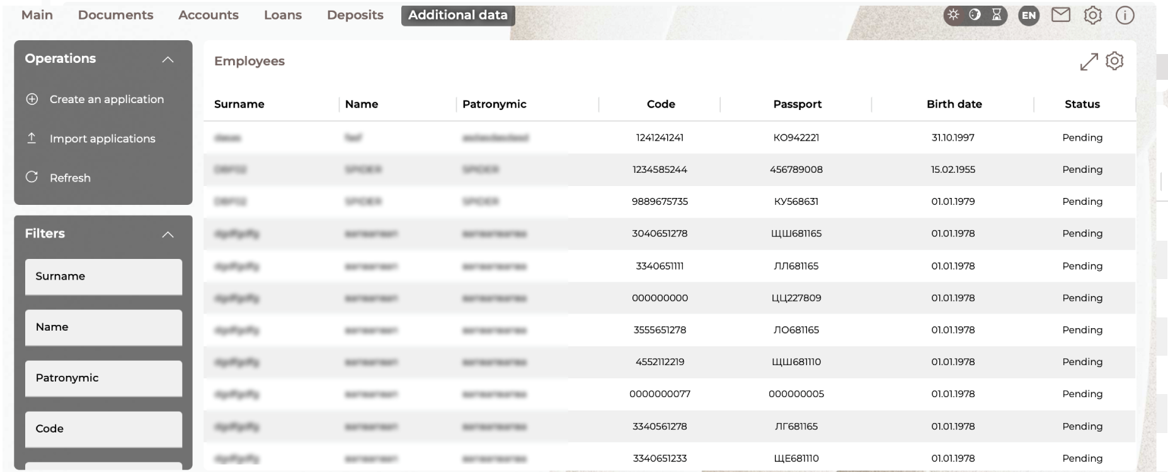
You can set additional filters, sort the data, or customize the form (see "Settings on forms with lists").
The following operations are available on this page:
- creating a new application – the "Create an application" button (see "Creating a new employee application");
- import of employee applications from XML, DBF, XLS format files – the "Import applications" button. This will open a new form, where you need to select an enterprise, a salary project from the drop-down lists.
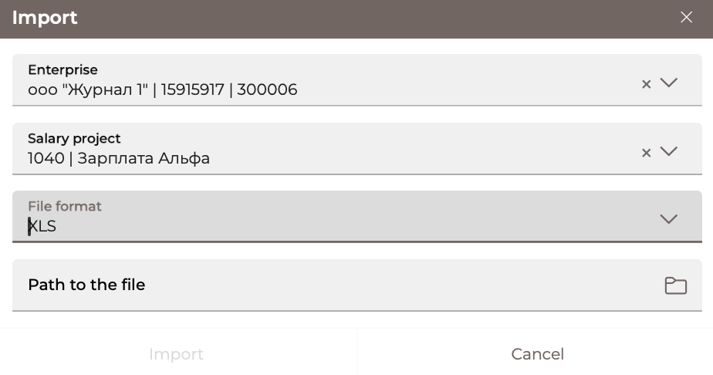
Each line of the list on the "Employees" form is a link that can be used to go to the form for viewing the application data. For a detailed description of the form fields, see the item "Creating a new employee application".
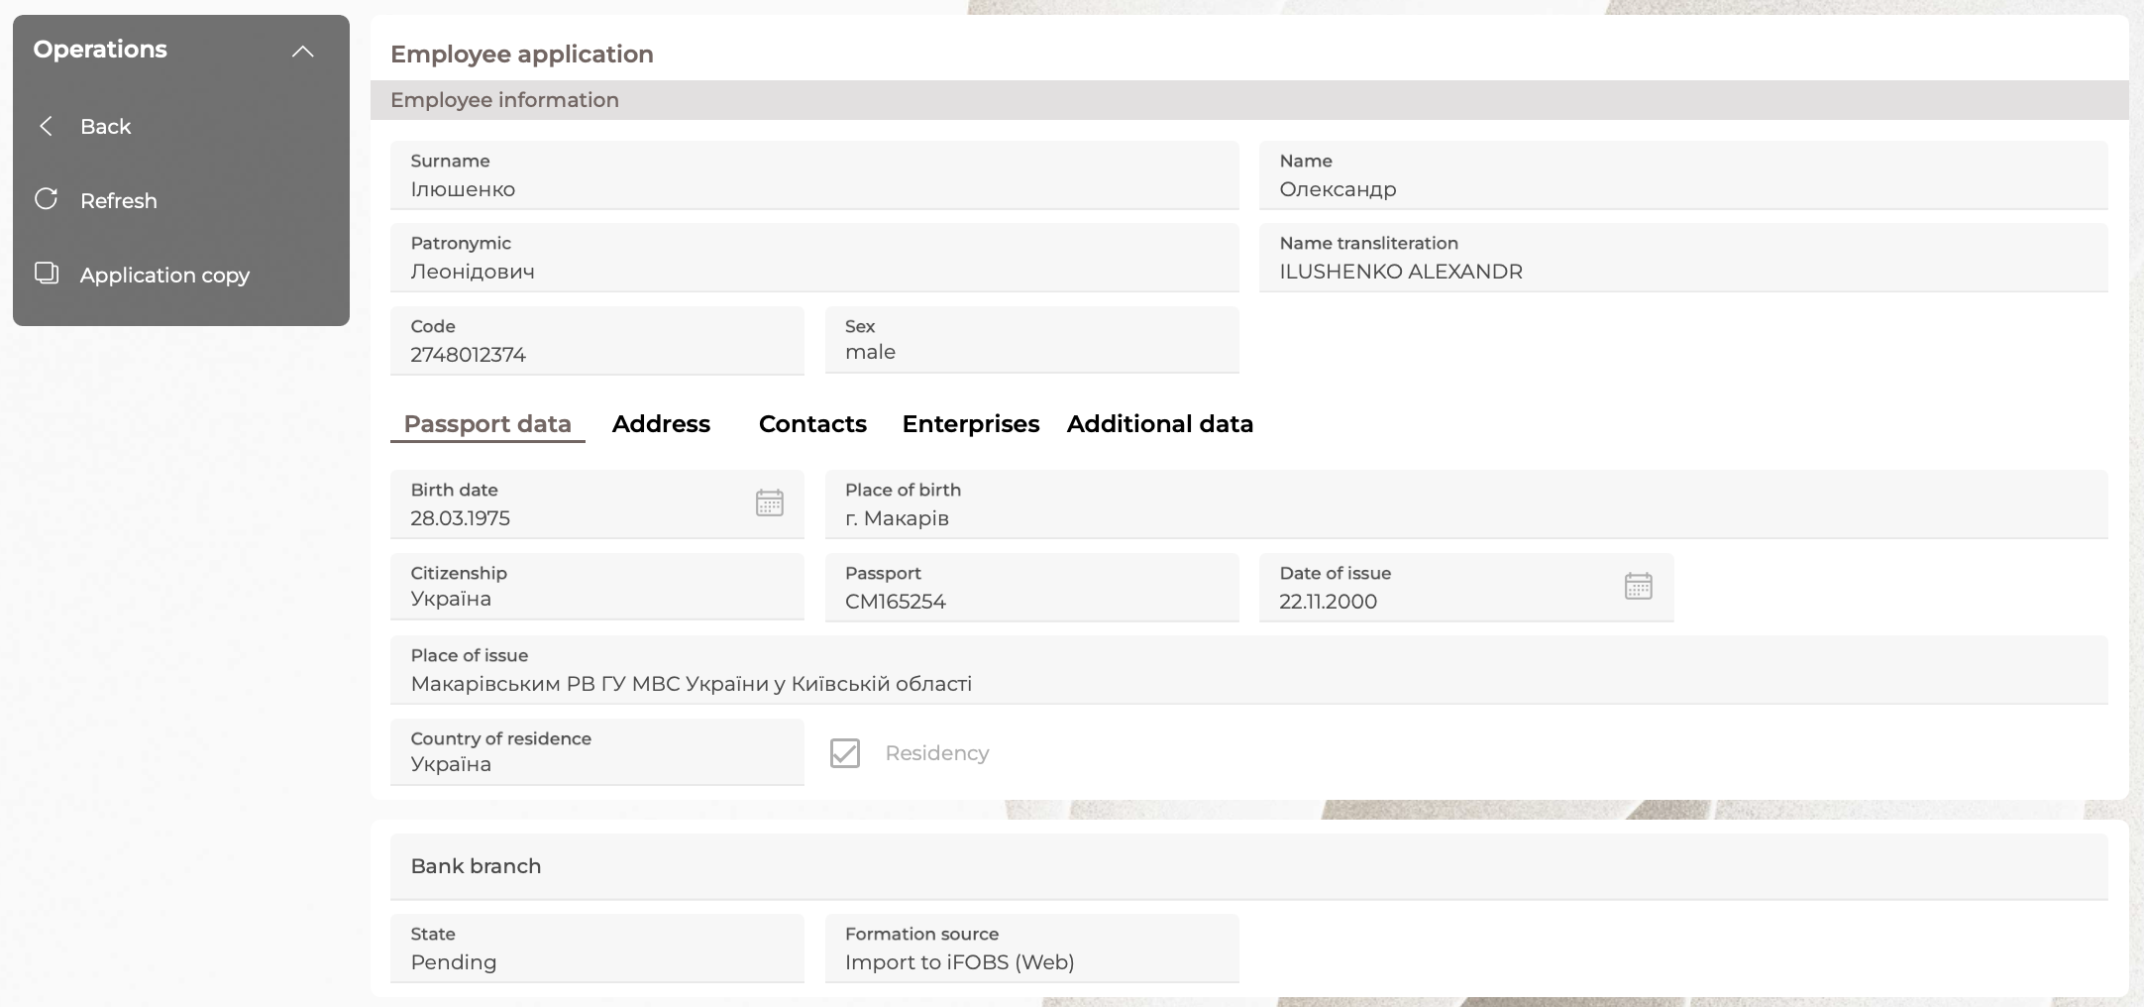

Creating a new employee application
To create a new application on the "Employees" form, click on the "Create an application" button and fill in the fields below:
1. In the "Employee Information" section, enter the following data:
- Surname, name, patronymic.
- Transliteration of the name. If you want to generate a name automatically, click on the button .
- The employee's identification code (for non-residents, as well as for residents who refused to assign an identification code, is filled in with the value "0000000000").
- Sex of the employee.
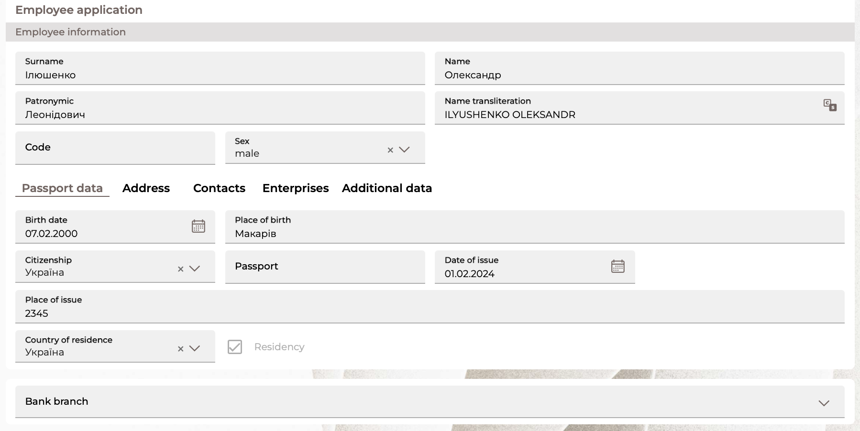
2. On the "Passport Data" tab, enter the following data:
- Date of birth, place of birth, citizenship of the employee.
- Number, date and place of issuance of the passport. If the Ukrainian passport is in the form of an ID card, enter the record number and the date until which the document is valid.
- Country of residence is the name of the country of residence of which the employee is a resident.
- Residency is a sign (checkbox) of whether an employee is a resident (if a value that differs from "Ukraine" is specified in the Country of residence field, the checkbox is automatically disabled).
- Bank branch.
Note: the following fields are available on the form for viewing an already created application: Status, Source of formation: the value is determined automatically (adding, importing, copying).
3. On the "Address" tab, specify the employee's address.
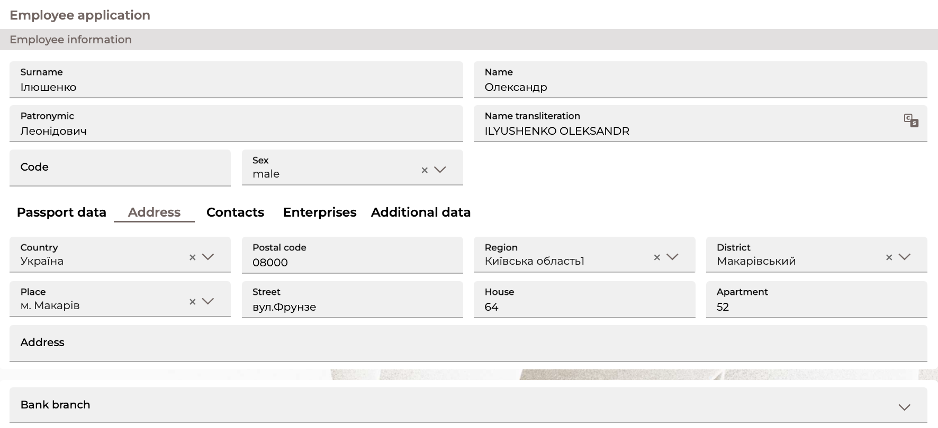
4. On the "Contacts" tab, enter the following data: home, business, mobile phone (in this case, filling in at least one phone number is mandatory), email of the employee.
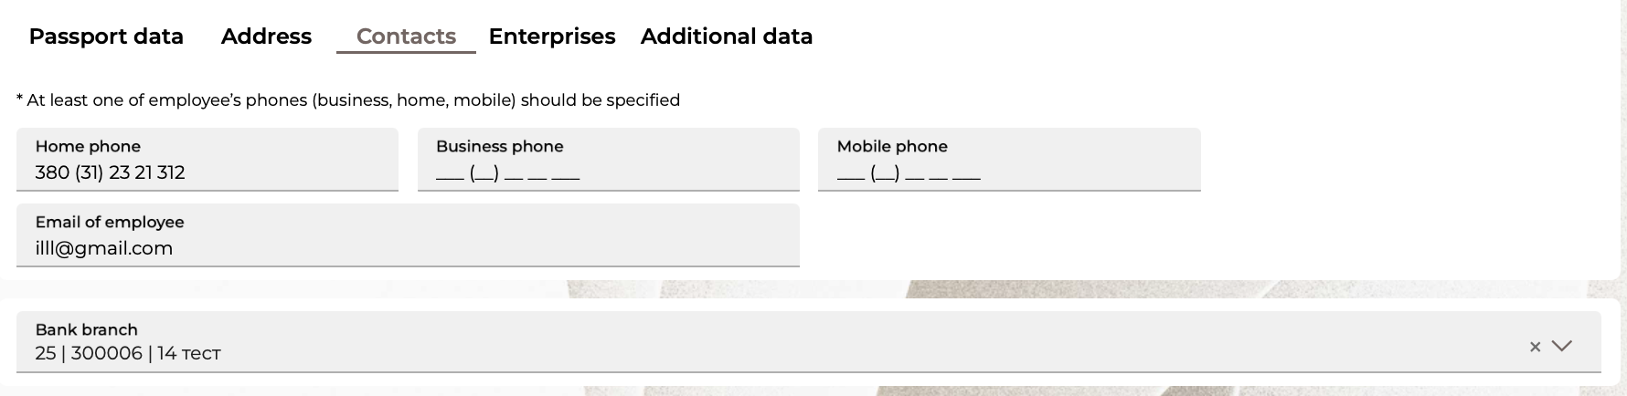
5. The data on the "Enterprise" tab is a list of enterprises and salary projects to which the employee is linked.
The "Add connection to enterprise" button – to add a new binding of an employee to the enterprise and the salary project. When clicked, a pop-up window opens to perform binding (see "Binding an employee to the enterprise").
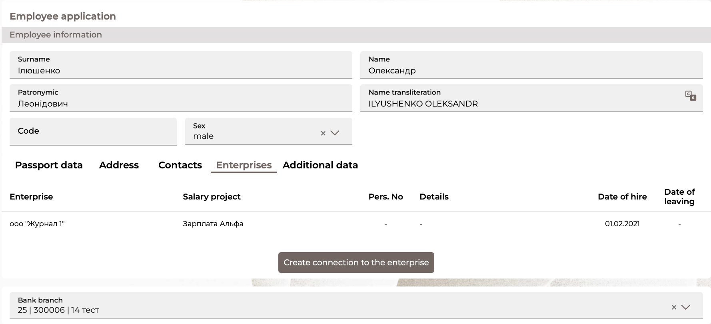
- Each line is a link to go to viewing the record on the form "Enterprise-employee relationship" with the ability to edit.
6. The "Additional data" tab displays a secret word that can be used to identify the employee.
You can use the checkbox to indicate that the employee is a related person.
To send a card to an employee at your home address, select the appropriate checkbox.
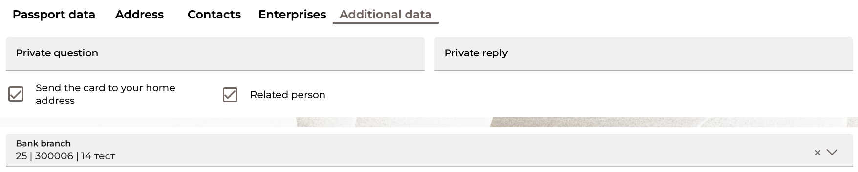
After filling in the required data, click on the "Save" button. If the application is saved successfully, the following operations are available to the user: "Back" – return back to the "Employees" form, "Create a new one" – go to the form of creating a new application.
To return from creating an application to the previous page without saving the application, click on the „Back“ button.

Linking an employee to the enterprise
In order to link an employee to the enterprise:
- On the "Enterprise" tab, click on the "Add connection to the enterprise" button.
- The Employee field displays the employee's full name. The field is not editable.
- In the Enterprise field, from the drop-down list of the client's enterprises working on salary projects, select the required one. If there is only one enterprise in the list, it is filled in automatically.
- The bank code is filled in automatically after selecting a company.
- If necessary, indicate the employee's personnel number.
- Fill in the date of hiring an employee at the enterprise under the salary project manually or using the built-in calendar.
- If necessary, fill in the date of dismissal of the employee from the enterprise.
- In the Payroll project field, select the required one from the drop-down list of the company's payroll. The field is available after selecting the company. If there is only one payroll in the list, the field is filled in automatically.
- After selecting the salary project, additional salary project parameters may be available for filling.
- If the account is opened in another bank, select the appropriate checkbox, enter the account in IBAN format in the displayed field.
- In the Details field, you can specify additional data (for example, the position of an employee).
To save the link, click on the "Save" button.
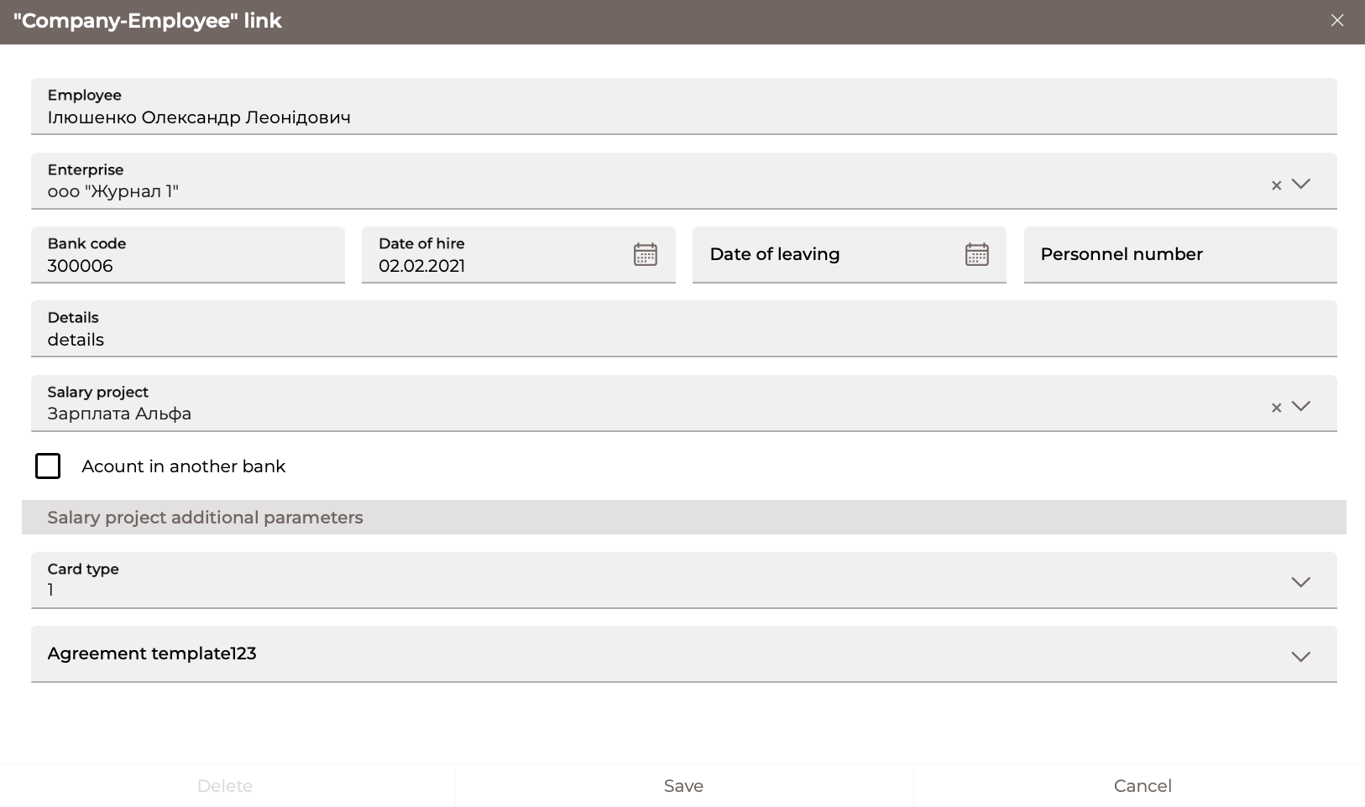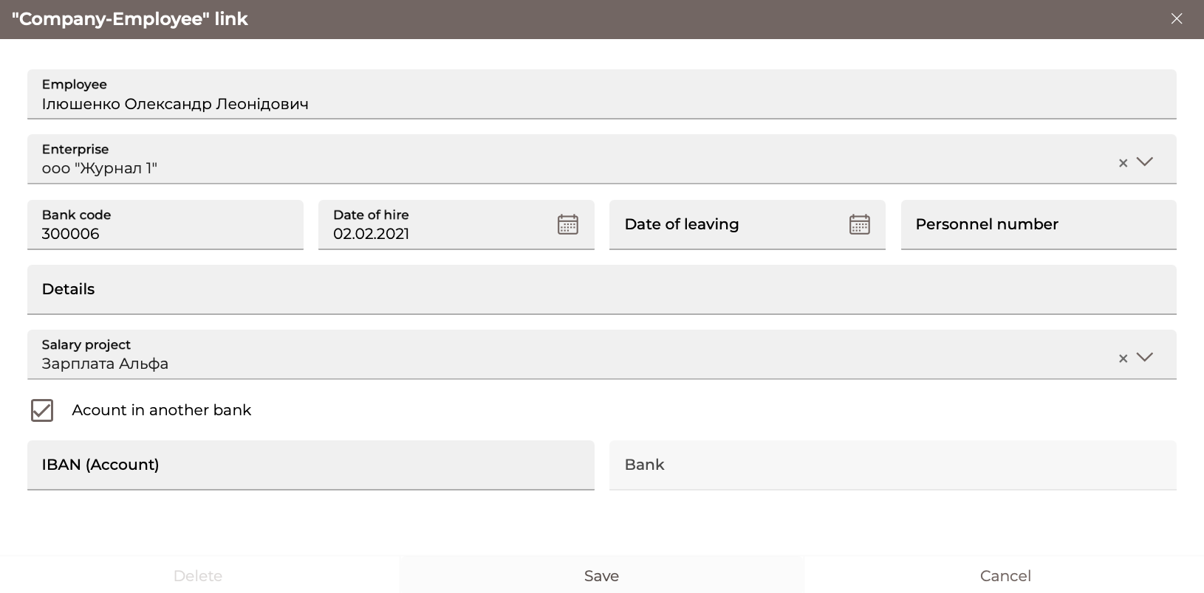

Payroll
The system allows you to view, sign, create, and import payroll. To view the list of payrolls, go to the Salary/Payroll menu section – a list of all created payrolls will appear on the form:
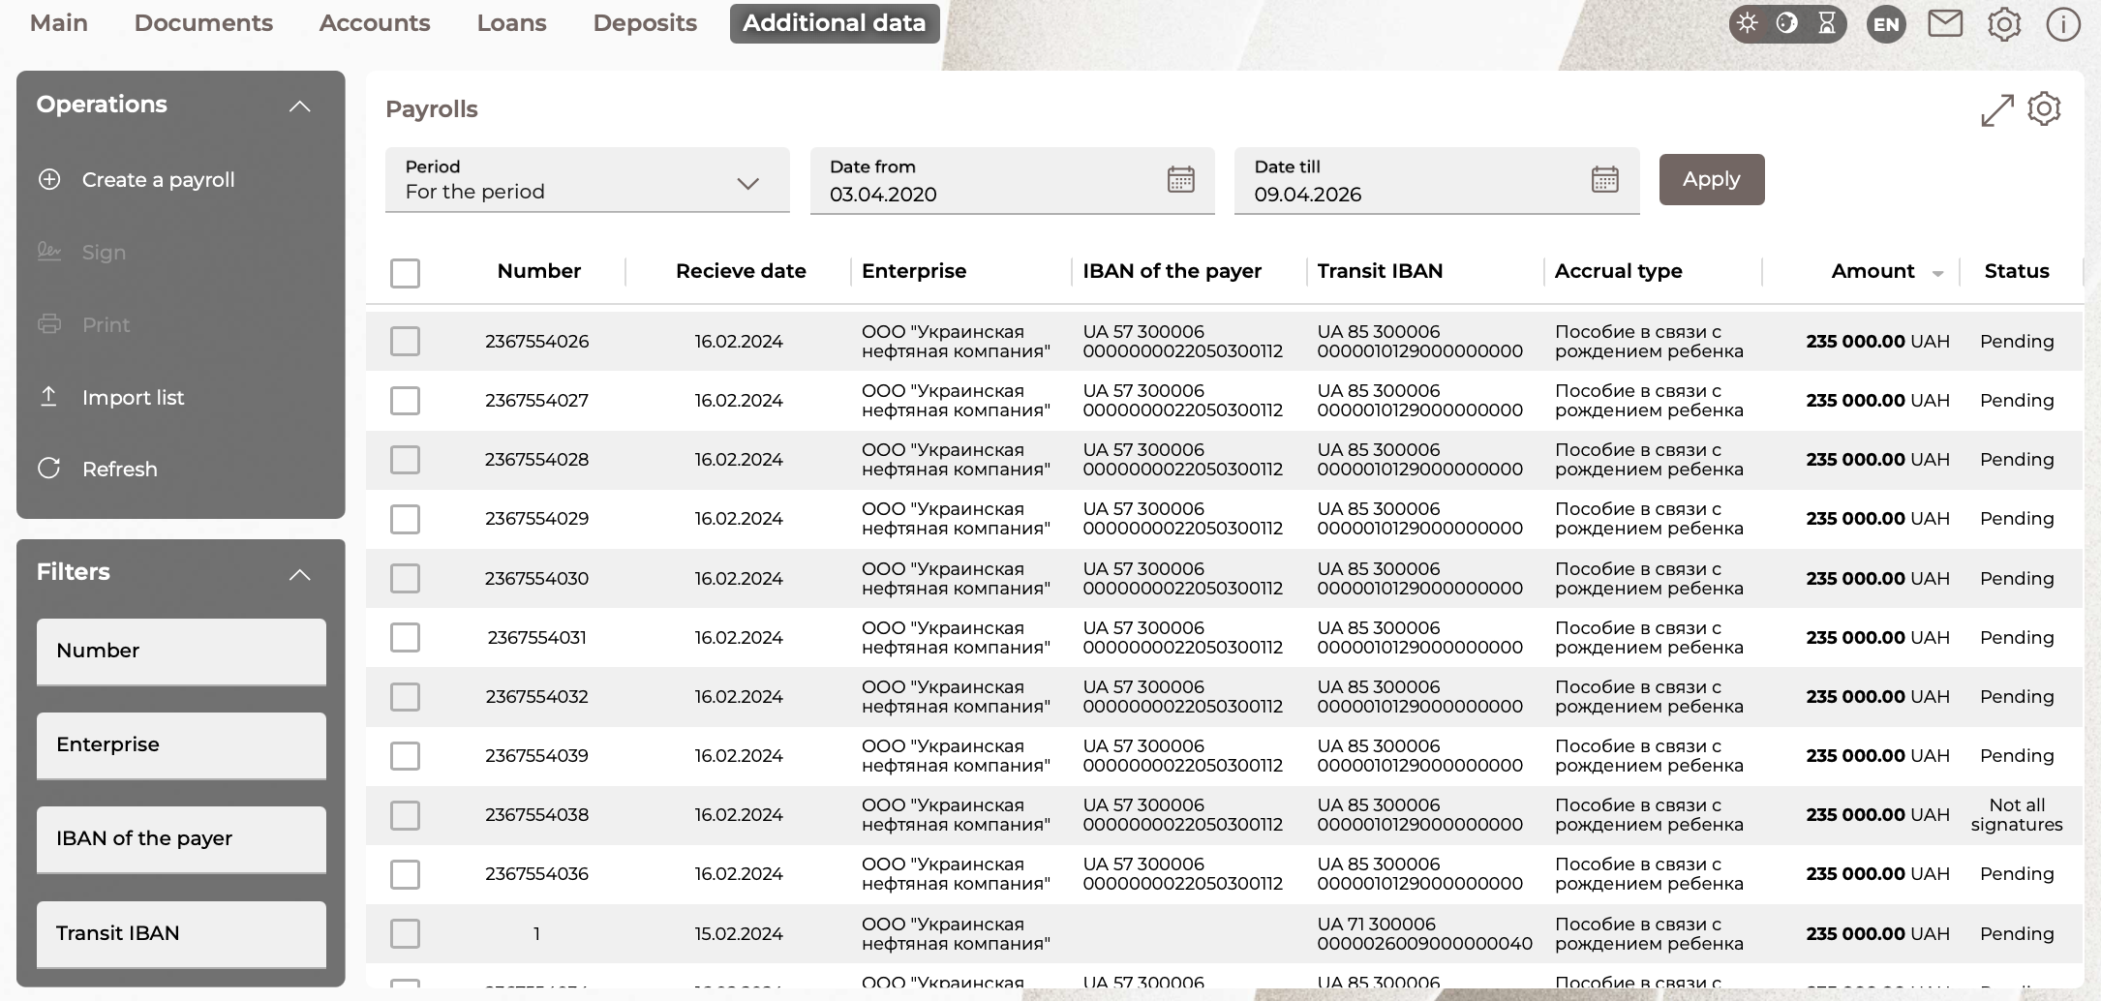
On the form with a list of payrolls, you can:
1. Set additional filters, sort the data or customize the form (see "Settings on forms with lists").
2. Sign the required statement (information). To do this, check the lines with the required information, see "Signing documents").
3. Print the desired statement (information). To do this, check the boxes in the lines with the required information, click on the "Print" button.
4. Import payroll in XML, DBF, XLS format – "Import list" button.
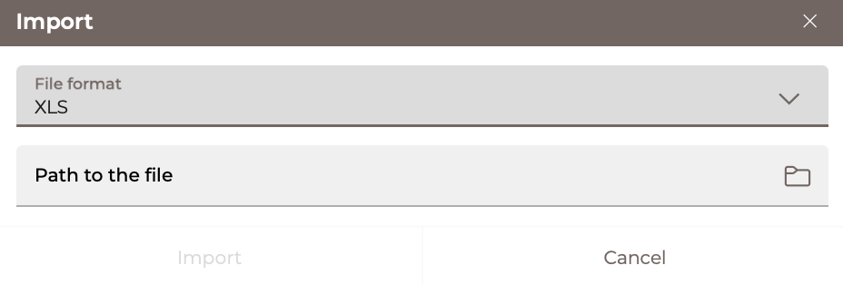
This will open a new window where you have to select the type of file from the drop-down list, specify the path to the file with the information and click on the "Import" button.
Note: for XML and XLS formats, the user must specify the path to the file with the statement. For the DBF format, the user must specify the path to the file with the statement and the path to the file with accruals separately.
- Create a new payroll (see below).
- Go to the form with detailed information on the selected document, where, depending on the status of the document, you will be able to: save the document after making changes – the "Save" button, copy to a new form – the "Copy" button, print – the "Print" button, sign the statement (see "Signing documents"), exit without saving changes – the „Back“ button, delete the statement – the "Delete" button.

Creating a new payroll
To create a new payroll, follow these steps:
1. Click on the "Create a payroll" button. Or to create a payroll with filled in details, click on the "Copy" button on the payroll view form.
Please note: when copying the payroll in a new one the number and date are automatically updated, the value date is cleared; accruals are transferred (except for rejected and deleted); in such a statement, it is impossible to change the company and the salary project and it cannot be saved without accruals.
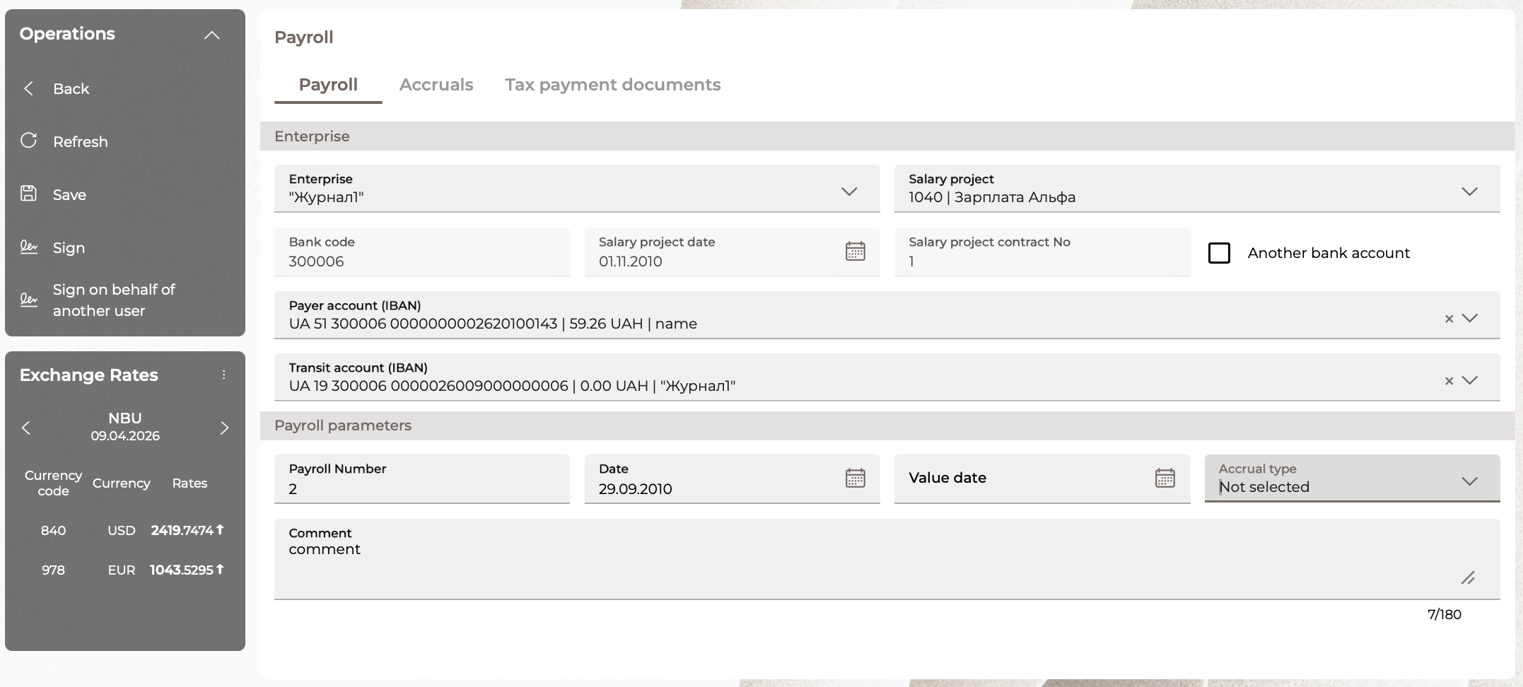
2. On the "Payroll" tab in the "Enterprise" section:
- In the Enterprise field, select from the drop-down list of enterprises of users served by salary projects. If the user has one enterprise, it will be automatically substituted in the field.
- In the Salary project field, select the payroll project of the selected enterprise from the list. The list of projects becomes available after selecting an enterprise. If the selected enterprise has only one payroll, it is inserted into the field automatically.
- The bank code, date and number of the salary project agreement are filled in automatically without the possibility of editing.
- In the Payer Account (IBAN) field, select the required account from the drop-down list.
- Check the "Another bank account" checkbox if the funds will be transferred from an account in another bank. By default, the checkbox is disabled. The checkbox becomes available after selecting a salary project. If the checkbox is enabled, the Payer account field is cleared.
- Select the transit account (IBAN) from the drop-down list.
3. On the "Payroll" tab in the "Payroll parameters" section:
- The field Payroll No. is filled in automatically after selecting the company and account. The field is available for editing.
- The Date field is filled in automatically with the date of the bank's current business day. The field is editable.
- In the Value date field, you can specify the date manually or select using the built-in calendar.
Please note: when copying a document with the Value date field filled in in the new payroll, it is cleared.
- Select the type of charges from the drop-down list.
- In the "Comment" section, you can add a comment to your payroll (maximum 180 characters).
4. The "Accruals" tab is available only after filling in the mandatory data on the "Payroll" tab. On this tab, you can create a list of accruals for a salary project. You can add (the button ), delete (the button ) and edit accruals. Each line of the list of accruals is a link that opens a form with detailed information on the selected accrual.
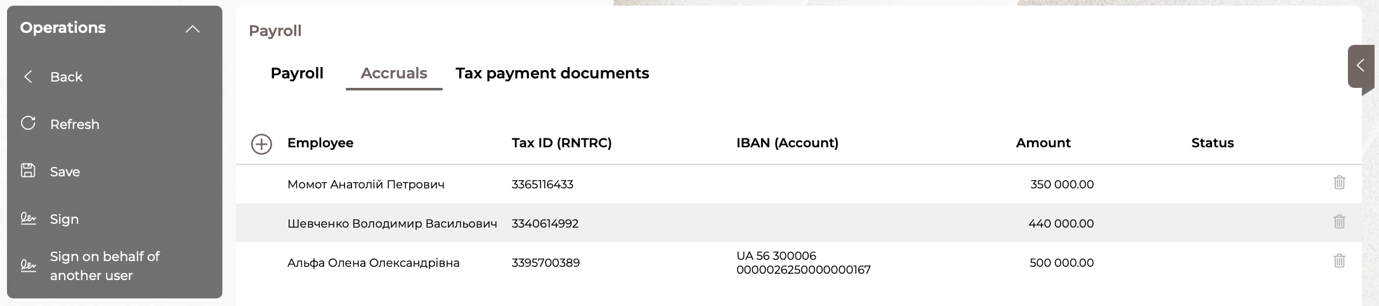

To add a new accrual to the list:
- Click on the button .
- In the new form, to create an accrual, select the employee's full name or his code from the list.
- Select an employee account if necessary.
- In the Amount field, enter the required accrual amount for the selected employee.
- To save the accrual, click on the "Save" button. After that, the accrual for the employee will be added to the general list. In addition, the following buttons are available:
- "Cancel" - to close the form with information about the accrual;
- "Create new" - to create a new accrual.
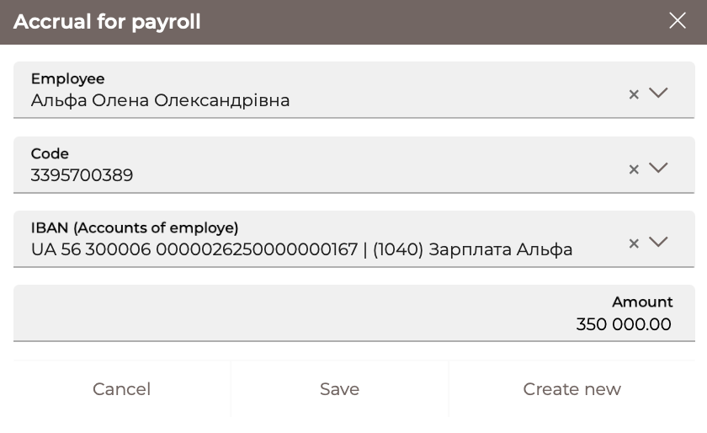
Note: The following fields are available on the form for viewing an already created payroll: Status, Formation source of the payroll: the value is determined automatically (input, import, copy).
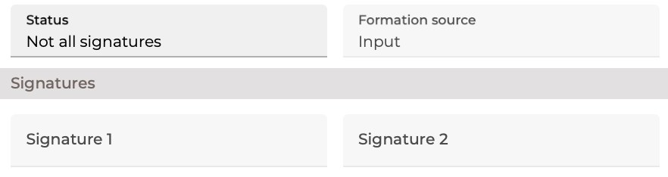
5. Depending on the bank's settings, the "Tax payment documents" tab may be displayed on the form. The tab is available only after filling in the mandatory data on the "Payroll" tab. On this tab, you can add (the button ), delete (the button ) and edit the binding of tax documents for the payroll. Each line of the list of linked documents is a link that opens a form with detailed information on linking.
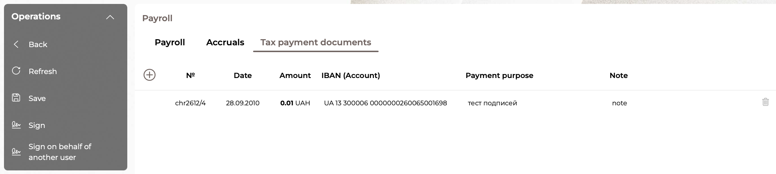
To link a new document:
- Click on the button .
- Select Document Type: payment instruction, conducted document, file.
- Click on the "Select Document" button and select the desired document from the list in the new form (the fields of the "Document Information" form will be filled in) or specify the path to the file.
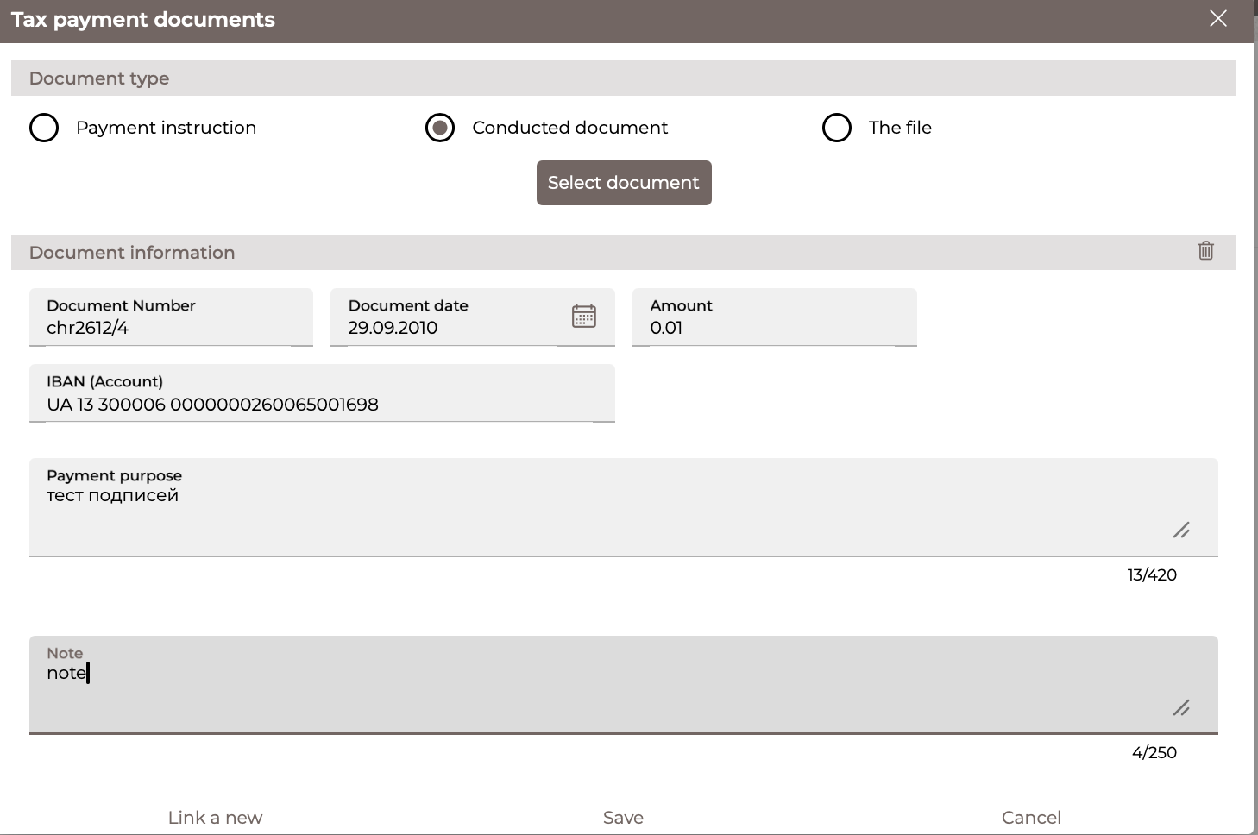
- In the Note field, you can add/edit additional information about the document. Maximum 250 characters.
- To save the binding, click on the "Save" button. After that, the binding will be added to the general list. In addition, buttons are available: "Cancel" - to close the form with information about the tax payment document; "Link a new" - to create a new binding.
After filling in the required payroll data, click on the "Save" button.
To return to the previous page without saving the information, click on the „Back“ button.

Loans
To view a list of your loans, select the Loans/Loan Agreements menu item.
You can set additional filters, sort the data, or customize the form (see "Settings on forms with lists").
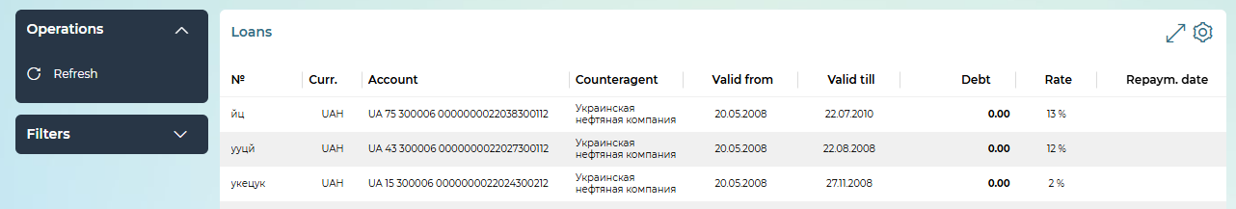
Each line of the list is a link to the form for viewing information on the selected loan agreement.
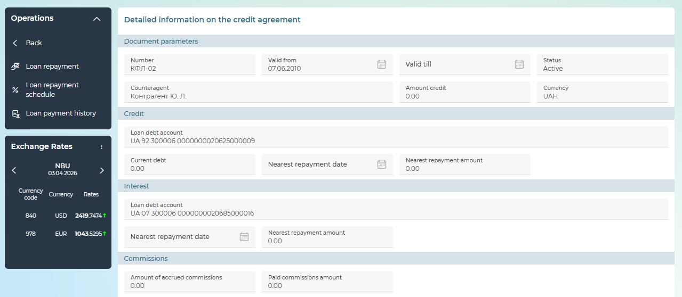
The data is only available in view mode. You can follow these steps:
- To repay the loan, click on the "Loan repayment" button (see "Operations with loans. Loan repayment").
- To get information on scheduled payments for loan repayment, click on the "Loan repayment schedule" button on the form for viewing detailed information on the loan.
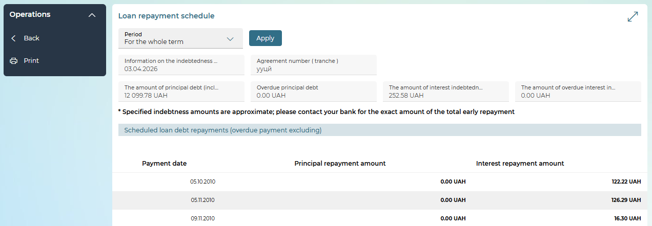
For obtaining information, specify the period: for the whole term or for the selected period (then and specify the start and end dates manually or using the built-in calendar). Click on the "Apply" button.
The amounts of debts on the displayed date and a list of future (expected) loan payments will be displayed. If necessary, you can print the received data – the "Print" button. To return to the deposit agreement review form, click on the „Back“ button.
- To view the history of loan payments, click on the "Loan payment history" button on the loan details view form.
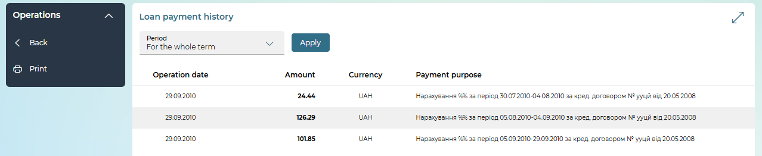
To get information, set the data display period: for the whole term or for the period (then specify the start and end dates manually or using the built-in calendar). Click on the "Apply" button.
The dates and amounts of transactions will be displayed. If necessary, you can print the received data – the "Print" button. To return to the deposit agreement review form, click on the „Back“ button.
- To return from the form for viewing detailed information on the loan to the list of loan agreements, click on the „Back“ button.

Operations with loans. Loan repayment
In order to view the list of documents for loan repayment, go to the Loans/Repayment of loans menu item.
In the Period list, select the necessary option. If necessary, enter the start and end dates manually or using the built-in calendar. After that, the corresponding documents appear in the list.
You can set additional filters, sort the data, or customize the form (see "Settings on forms with lists").
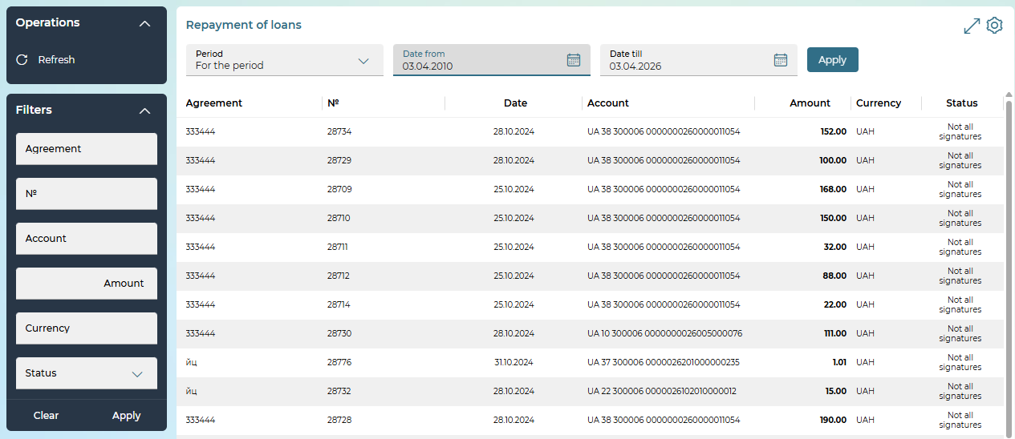
Each line in the list is a link to the detailed view or edit form of the document, depending on its status.
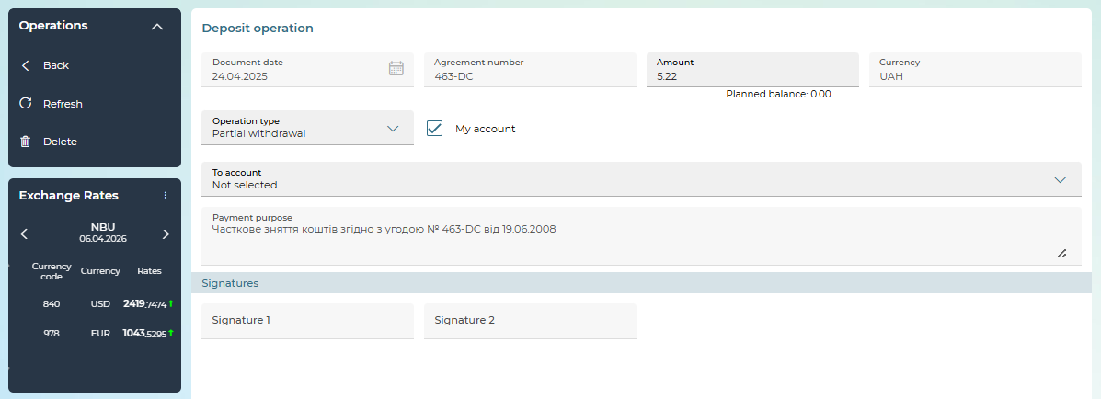
On the detailed view form, depending on the status of the document, the following options may be available to you:
- document editing;
- signing (see "Signing documents");
- saving a document without a signature – the "Save without signature" button;
- deleting a document – the "Delete" button.
For documents in the "Rejected" status, the reason for the rejection is displayed at the top of the form.
To cancel the changes and return to the form with the list of documents for loan repayment, click on the „Back“ button.

Loan repayment
In order to repay the loan, follow these steps:
- On the form with loans list click on the necessary line. A form for a detailed view of information on the selected loan agreement will open.
- Click on the "Loan repayment" button. In the new form, the purpose of the payment will be filled in automatically.
- Specify the date of the document (by default, the system substitutes the current date).
- The agreement number is filled in automatically by the system and corresponds to the number of the loan agreement from which the transition to this form took place.
- In the Amount field, specify the amount to be repaid.
- In the IBAN field, select the account from which the funds will be transferred.
- To save the application without a signature, click on the "Save without signature" button.
- To send an application to the bank, sign the document (see "Signing documents").
To return to the previous page unchanged, click on the „Back“ button.
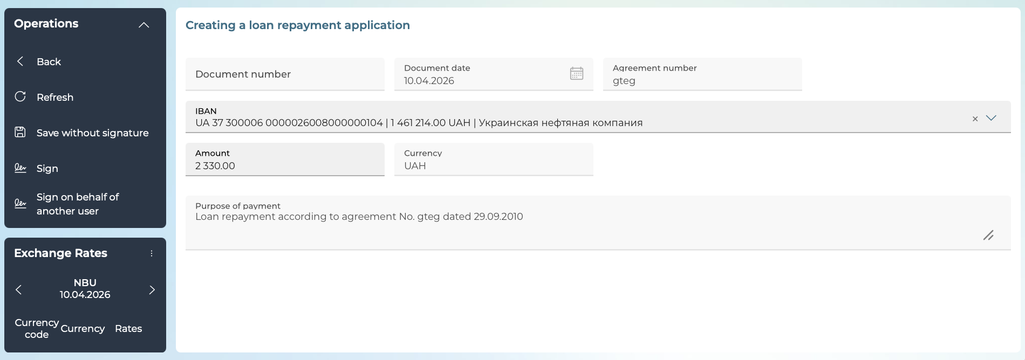
You can see the list of documents for loan repayment on the page "Repayment of loans"

Deposits
To view a list of your deposits, select the Deposits/Deposit Agreements menu item.
You can set additional filters, sort the data, or customize the form (see "Settings on forms with lists").
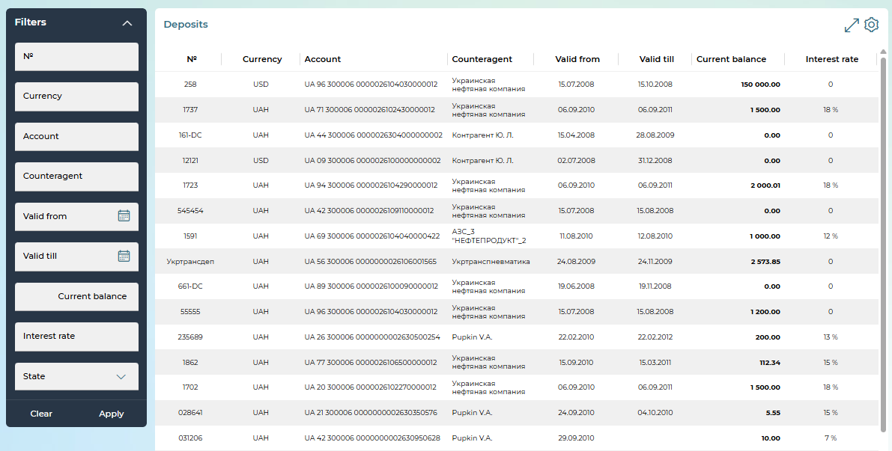
Each line of the list is a link to the form for viewing information on the selected deposit.
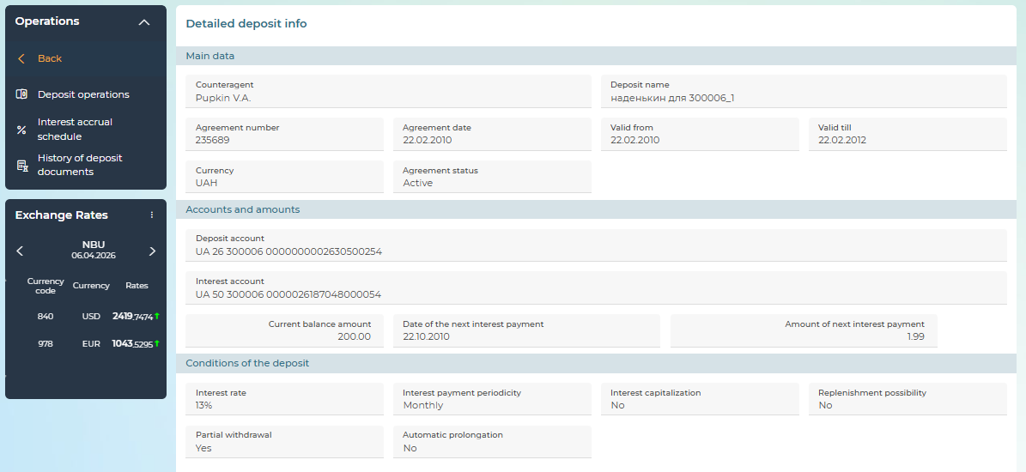
On the deposit review form, you can view the following information:
- The "Main data" section: information about the counteragent; the name of the deposit; number and date of the transaction; the currency of the transaction, the start and end dates of the deposit period; agreement status.
- The "Accounts and Amounts" section: deposit and interest account numbers, current balance amount, amount and date of the next interest payment.
- The "Conditions of the deposit" section: interest rate, interest payment periodicity, possibility of capitalization, replenishment, partial withdrawal, automatic prolongation.
The following options are available on the detailed view form:
- To replenish or partially withdraw funds – the "Deposit operations" button (see "Creating a New Deposit Transaction").
- To view the interest accrual schedule (see "Interest Accrual Schedule").
- To view the history of deposit documents (see "").
To return to the list of deposits, click on the „Back“ button.

History of deposit documents
In order to view the archive of documents on deposit:
- Click on the "History of deposit documents" button on the deposit agreement review form (see "Deposits").
- Select the period for which you want to receive data: for the whole term or for a specific period (use the built-in calendar to enter the start and end dates).
- Click on the "Perform the request" button.
- A statement will be displayed, which can be printed or downloaded.
To return to the deposit agreement review form, click on the "Back" button.
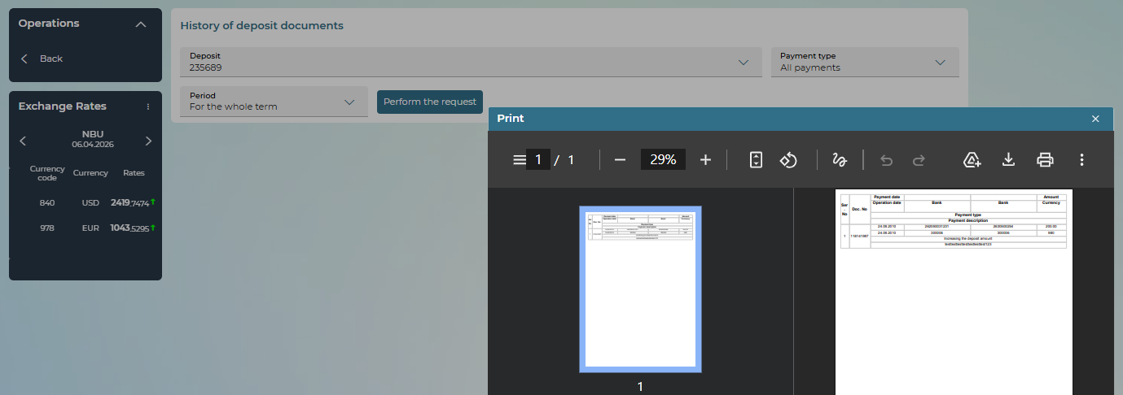

Interest accrual schedule
In order to view the schedule of accrual of interest on the deposit.
- Click on the "Interest accrual schedule" button on the deposit agreement revision form (see "Deposits").
- Select the period for which you want to receive data: for the whole term or for a specific period (use the built-in calendar to enter the start and end dates).
- Click on the "Perform the request" button.
A statement will be displayed, which can be printed or downloaded.
To return to the deposit agreement review form, click on the „Back“ button.
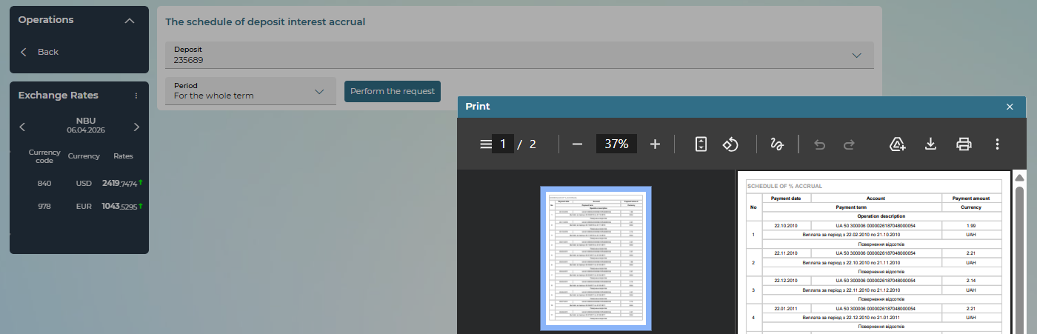

Operations with deposits. Creating a new deposit transaction
In order to view deposit transactions, go to the Deposits/Deposit operations menu item.
In the Period field, select a period: by date, by previous day, per month, for the period. When selecting a period, enter the start and end dates manually or using the built-in calendar. Click "Apply" – and the system will display the corresponding documents.
You can set additional filters, sort the data, or customize the form (see "Settings on forms with lists").
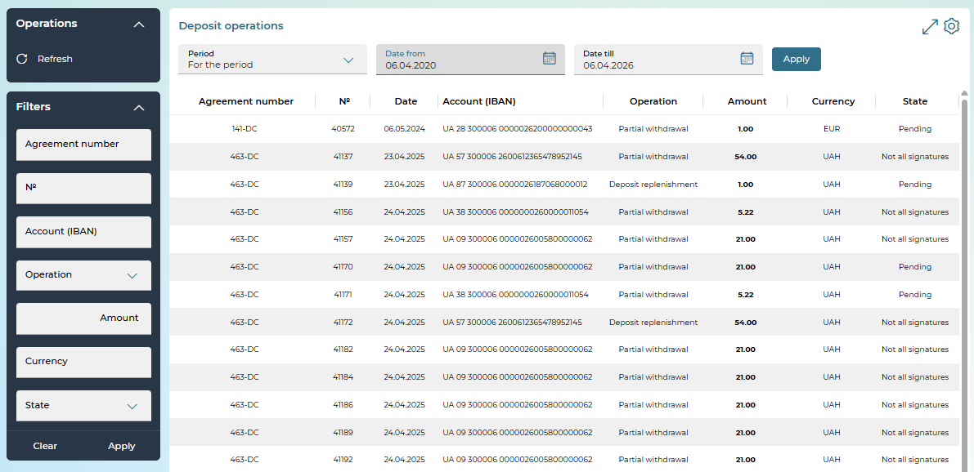
Each row in the list is a link to the detailed view or edit form of the document, depending on its status.
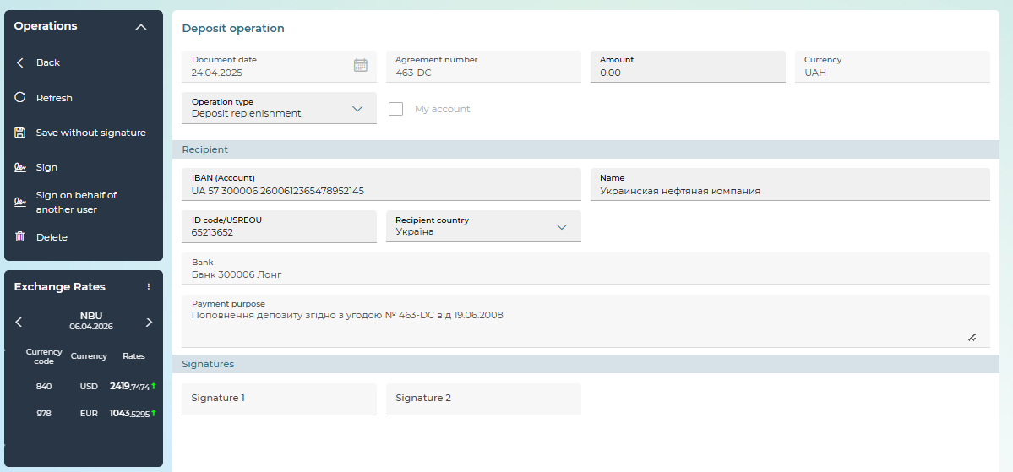
On the detailed view form, depending on the status of the document, the following options may be available to you:
- document editing;
- signing – the "Sign" button (see "Signing documents");
- saving a document without a signature – the "Save without signature" button;
- deleting a document – the "Delete" button.
For documents in the "Rejected" status, the reason for the rejection is displayed at the top of the form.
To cancel the changes and return to the form with the list of documents for loan repayment, click on the „Back“ button.

Creating a new deposit transaction
Deposit transactions are available if the terms of the deposit agreement allow for replenishment or partial withdrawal of the deposit.
In order to create a new transaction with a deposit – replenish it or partially withdraw funds, follow these steps:
- On the form for viewing detailed information on the deposit, click on the "Deposit operations" button.
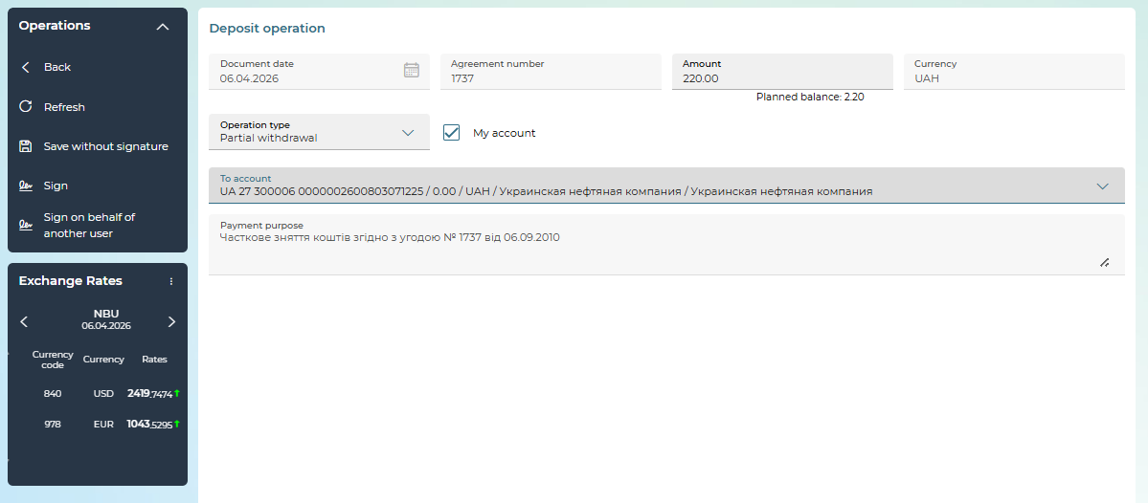

- In the new form, in the Amount field, specify the amount of the transaction.
- Set the date of the document (by default, the system substitutes the current date).
- The Currency field contains the symbolic code of the trade currency.
- The agreement number is filled in automatically by the system and corresponds to the number of the deposit agreement from which the transition to this form took place.
- In the Operation type field, select (if available) the required operation from the list: deposit replenishment or partial withdrawal.
- The "My account" mark is available for the withdrawal operation. If there is a checkbox, the user can select one of their own accounts from the drop-down list; if there is no checkbox, fill in the recipient's details in the "Recipient" section.
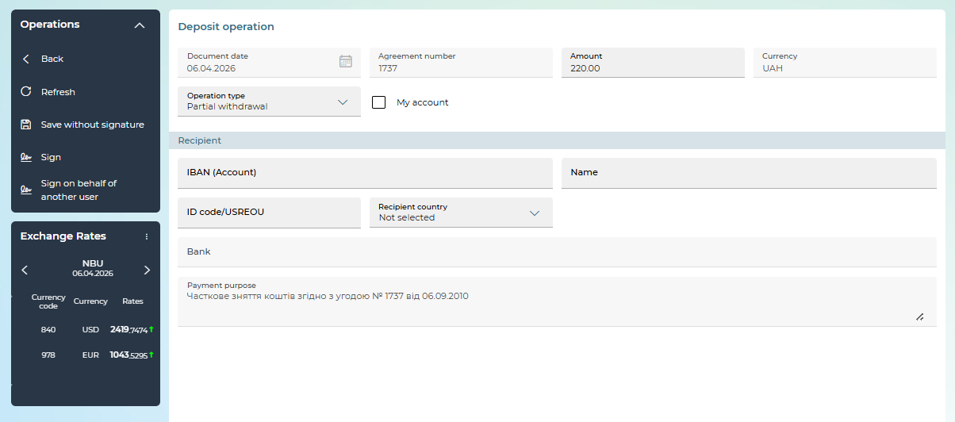
- The purpose of the payment will be displayed automatically without the possibility of editing.
- To save a document without a signature, click on the "Save without signature" button.
- To send the document to the bank, sign the document (see "Signing documents").
To return to the previous page unchanged, click on the „Back“ button.

Requests for opening deposits

Please note: This section describes the additional functionality of the system

To work with deposit opening requests, select the Deposits/Requests for depositing money menu section.
The "Requests for depositing money" form displays a list of previously created deposit requests.
You can set the date/period for displaying requests, set additional filters, sort data, or customize the form.
The form has the ability to sort by non-reference fields (Number, Date, IBAN, Counteragent, Amount, Currency, Deposit name, Deposit term, USREOU). The State and Operation fields are reference, without the possibility of sorting.
The Operation field displays the type of operation: "All operations", "Prolongation", "Opening".
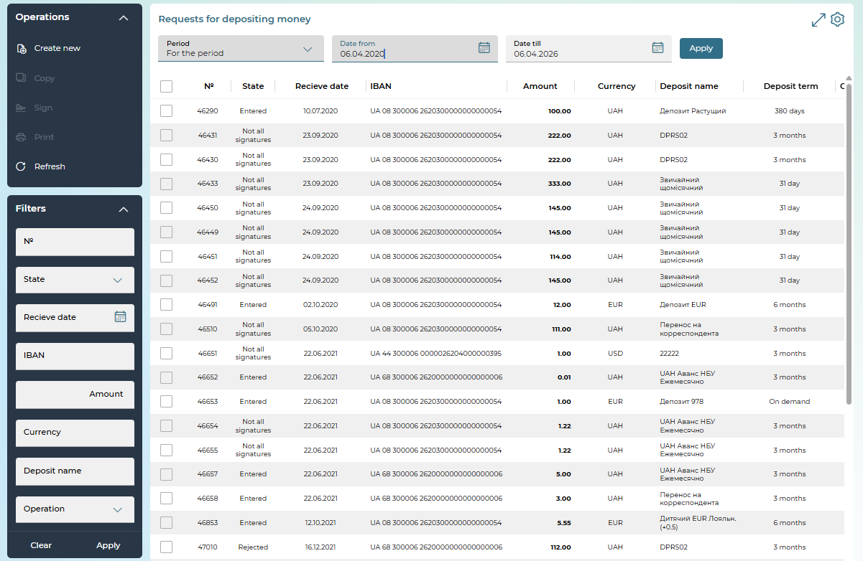
The following operations are available on the page:
- Go to the form of creating a new request for opening a deposit – the "Create new" button, see "Creating a request for deposit opening").
- Signing the document(s) – the "Sign" button, which is active only for the document(s) in the "Not all signatures" state.
- Printing the selected document(s) – the "Print" button.
- Update the information on the form – the "Refresh" button.
Each line in the list is a link to the form to view or edit a document in detail, depending on its status and type.
On the detailed view form, depending on the status of the document, the following options may be available to you:
- document editing;
- creating a new request – the "Create new" button;
- updating information on the form – the "Refresh" button;
- saving a document without a signature – the "Save without signature" button;
- signing the request – the "Sign" and "Sign on behalf of another user" buttons;
- deleting a document – the "Delete" button;
- copying the request – the "Copy" button;
- print the request – the "Print" button.
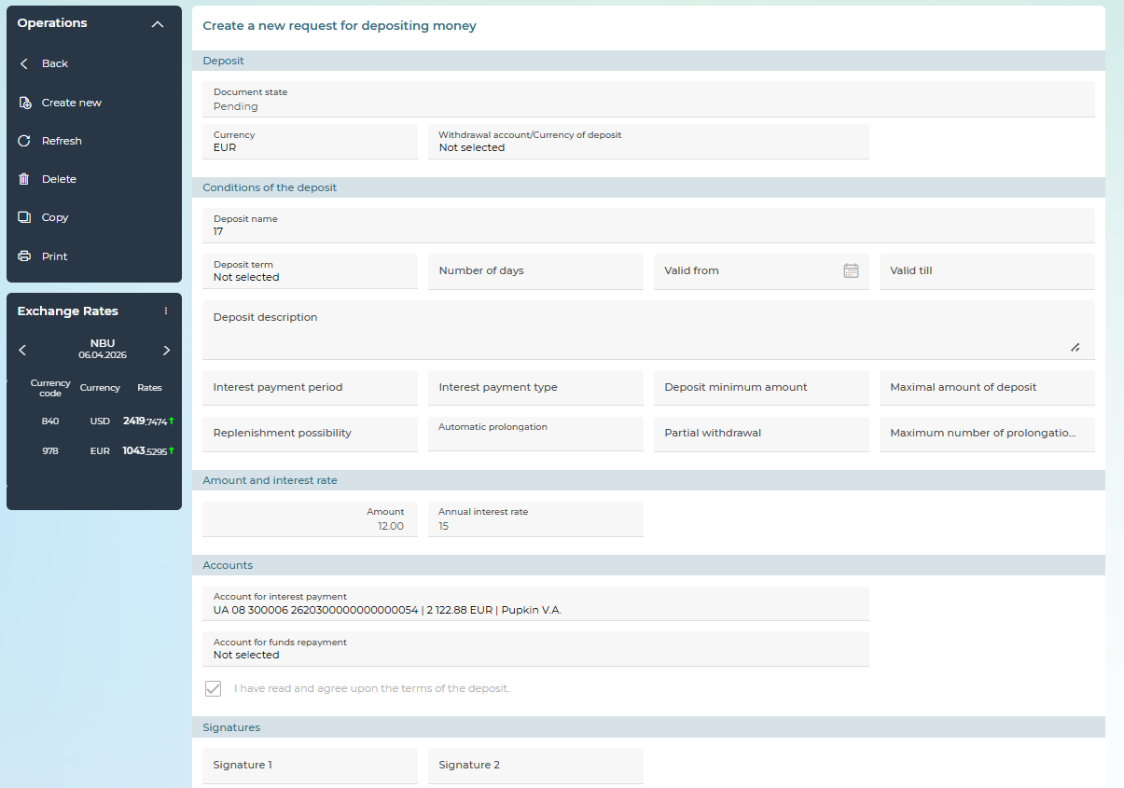

Creating a request for opening deposits
You can create and send a request to the bank to open a deposit of a legal entity, if the bank provides such a service.
To create a request for opening a deposit, select the Deposits/Create a new request for depositing money menu item and click:
- the "Create new" button on the deposit requests list (Deposits/ Create a new request for depositing money);
- the "Create new" button on the deposit request form.
A deposit request form will open, where you can:
- Fill in the fields with the necessary information (see description below);
- Save the request in the "Not all signatures" state - the "Save without signature" button;
- Return to the list of requests - the „Back“ button);
- Sign the document - the "Sign"/"Sign on behalf of another user" button.

Description of the elements of the form "Creating a new request for depositing money"
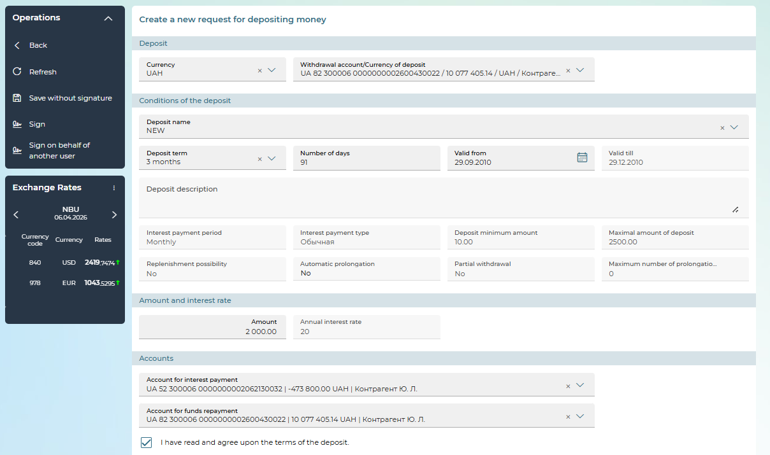
In the "Deposit" section, it is necessary to specify the deposit parameters:
- Currency – a field to select a currency from the list
- Withdrawal account - a field for selecting a deposit attraction account from the list of available ones. If you have only one account in the deposit currency, it will be substituted in the field automatically.
- The "From an account in another bank" checkbox – a checkbox for enabling the ability to enter the IBAN of an attraction account opened in another bank, is displayed subject to the setting set by the bank. If the checkbox is enabled, then instead of the Withdrawal account field, fields are displayed for entering the details of this account and the name of the counteragent on behalf of which the request is created:
- Account (IBAN) - a field for entering the IBAN of an account in another bank;
- Bank - a field for displaying the name of the bank according to the entered IBAN;
- Counteragent - a field for selecting a counteragent on behalf of which the order is created. If you have only one counteragent, the field will be filled in automatically.

In the section "Conditions of the deposit" it is necessary to specify the conditions for opening a deposit:
- Deposit name - a field for selecting the name of the deposit type from the deposit reference book. Available types of deposits in the currency of the attraction account;
- Deposit term - a field for selecting the deposit term. Depending on the settings set by the bank, available terms may be displayed with the delta of these terms;
- If the deposit conditions provide for the presence of a delta of terms (for example, 3 months + 10 days or -10 days), then in the Number of days field you can set the required deposit term within this delta (for example, if the deposit term is 3 months + 10 days, then you can count the number of days from 92 to 101). If there is no delta, then the Number of days field is not available for editing and displays the deposit validity period in days. For deposits on demand, the Number of days field is not displayed;
- Valid from - the field for displaying the start date of the deposit is automatically filled with the date of the current ODB, available for editing in terms of setting a later date.
- Valid till - a field to display the expiration date of the deposit. For deposits on demand, this field is not displayed.
According to the parameters of the selected deposit, the system displays its description and conditions. The list of displayed fields may also differ depending on the settings set by the bank.
In the "Amount and interest rate" section, it is necessary to specify the deposit amount. This amount must not be less than the minimum deposit amount and should not exceed the maximum deposit amount specified in the "Conditions of the deposit" section. After that, the system will display in the Annual interest rate field the interest rate for the selected deposit, term and amount.
In the "Accounts" section, you must specify the following parameters:
- Account for interest payment – a field for selecting an interest payment account from the list of available ones.
- Account for funds repayment – a field for selecting a deposit attraction account from the list of available ones.
- The "I have read and agree upon the terms of the deposit" checkbox is a checkbox to confirm the client's agreement with the terms of the deposit. For clients of individual entrepreneurs and self-employed persons, another text of the checkbox is displayed: "I have read and agree upon the terms of the deposit. I confirm that I am familiar with the content of the "Certificate on the System of Guaranteeing Deposits of Individuals". After enabling the checkbox, the buttons for signing and saving the request become active, and you can sign the request or save it without a signature.
Depending on the settings set by the bank, additional checkboxes "To an account in another bank" may be displayed on the form - if such a checkbox is enabled, then instead of the Account for interest payment or Account for funds repayment, fields for entering account details are displayed:
- Account (IBAN) – a field for entering IBAN;
- Bank - a field for displaying the name of the bank according to the entered IBAN.
After filling in the fields, the request must be signed or saved without a signature using the appropriate buttons.

Document exchange
The system allows the user to upload document files (for example, scanned copies of contracts, invoices, questionnaires, etc.), sign them with an electronic digital signature (unilateral signing), as well as when creating/editing payment orders in foreign currency, requests for purchase, sale, currency conversion, to link files of uploaded documents to them (see "DocUpload documents (unilateral signing, initiator – user)").
Depending on the bank's settings, you can also work with the functionality of two-way signing, i.e. documents that the bank has generated, signed and sent to you in order to receive your signature. You can view, upload a document and its signatures, sign such documents and send them to the bank (see "DocUpload documents (two-way signing, initiator – bank)").

Statuses and operations when working with documents
In the table below, you can find a description of the statuses that documents can acquire, and a list of operations available for each status that you can perform with these documents.
Name | Description | Operations available in iFOBS
Loading | Creating a document | - Return;  - Save without signature;- Sign / Sign on behalf of another user
Processing | Signed and shipped, not yet delivered to the bank's vault | - View;  - Save the file;  - Save file and signatures
Attached | Uploaded by iFOBS, not signed | - View;  - Delete;  - Edit a comment;  - Save without signature;  - Sign / Sign on behalf of another user;  - Save file
Rejected by client | Rejected by the client | - View
Check for virus | Virus Scan | - View
Deleted | Deleted by the client, or as expired | - View
Virus detected | Virus detected | - View
Rejected, virus scan error | Rejected, virus scan error | - View
Received | Received by a bank employee | - View;  - Save the file;  - Save file and signatures
Rejected | Rejected by the repository user | - View
Confirmed | User-verified storage | - View;  - Save the file;  - Save file and signatures
Signed by the bank | Signed by the bank | - View;  - Save the file;  - Save file and signatures
Awaiting customer signature | Waiting to be signed by the client | - View;  - Sign / Sign on behalf of another user;  - Reject;  - Save the file;  - Save file and signatures
Signed by the client and the bank | Signed by the client and the bank | - View;  - Save the file;  - Save file and signatures

DocUpload documents (unilateral signing, initiator – user)
To view a list of uploaded documents, select Additional data/Exchange of documents.
The system will display a list of uploaded documents (the default period is "Per date", but you can change it).
To set the display for a period:
- select the "For the period" option;
- indicate the start and end dates;
- click on the "Apply" button.
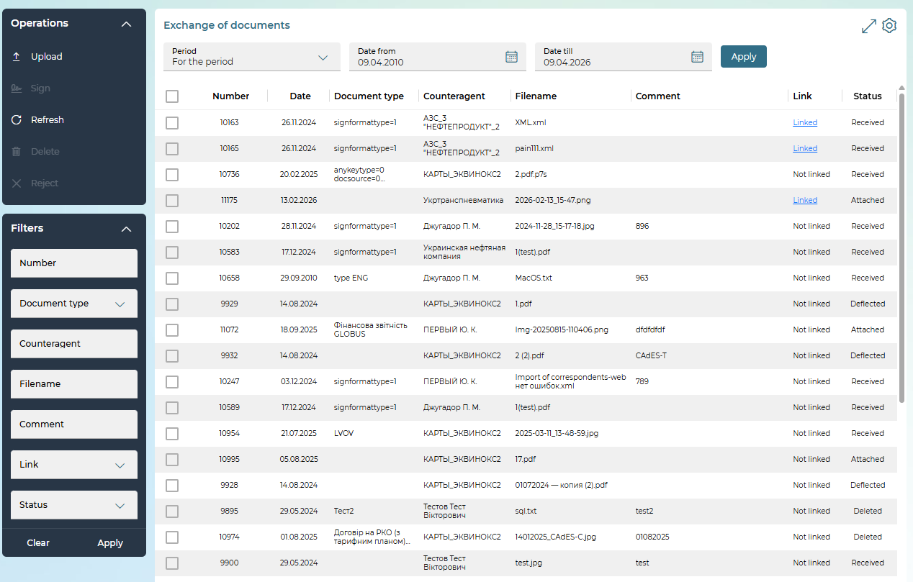
The page includes: sorting (depending on the type of column), adjusting the order and list of columns of the table, the ability to expand/collapse the table area of operations, signing and deleting (including bulk) documents (depending on their status, see "Statuses and operations when working with documents") and uploading a new document.
Depending on the rights granted to you, you can:
1. Go to the form with detailed information on the selected document, on which, depending on its status, you can:
- save the document after making changes (the "Save without signature" button);
- receive the attached document on your PC - click on the button - "Save" or "Save file and signatures" (uploading a file and/or p7s container is available only for the document, depending on its status). The "Save file and signatures" button is displayed on the form, provided that at least one signature is applied to the document;
- check the signature (the "Check EDS" button, available depending on the status of the document);
- sign the document ("Sign", "Sign on behalf of another user" button);
- delete it ("Delete" button).

2. Upload a new document to the system (the "Upload" button on the form with a list of documents, see "Uploading a document").
3. Go to the request to which a certain document is attached:
- on the form with a list of documents, click on the "Linked" link or click on the button  in the "Document Links" section on the detailed form;
- in the "Document Links" window, click on the line with the desired application;
- The corresponding request will be displayed on the screen.
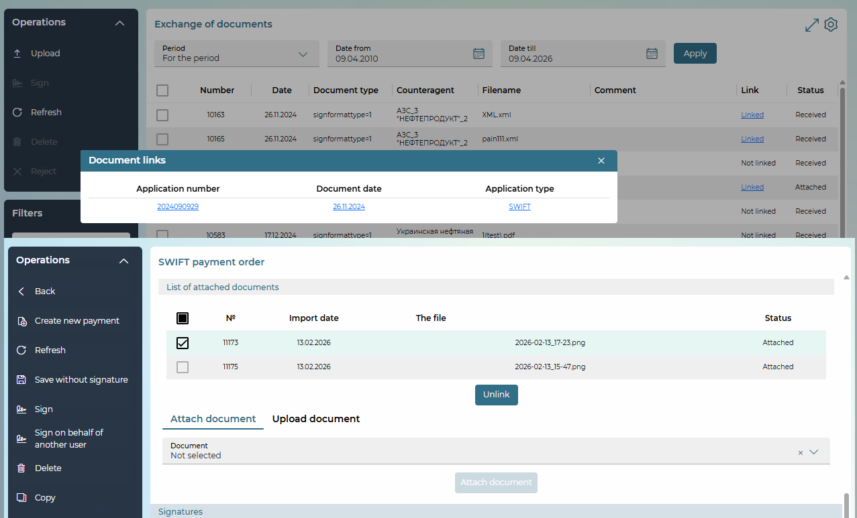
4. When creating and editing payment orders in foreign currency, as well as requests for the purchase, sale, conversion of currency, to link files of previously uploaded documents or new uploaded documents to them, see "Linking a document to a request".
5. Delete an unsigned document - to do this, select one or more documents from the list and click on the "Delete documents" button.
6. Edit unsigned documents - to do this, go to the form for viewing information about the document, edit the value of the available Comment field and click on the "Save" button.
7. Sign an unsigned document and send it to the bank:
- select one or more documents from the list and click on the "Sign documents" button;
- or go to the form to view information about the document and click on the "Sign" button.
Please note: the list of available transactions depends on the current status of the document (see "Statuses and operations when working with documents").

Downloading a document
In order to upload a document file and send it to the bank, follow these steps:
1. Go to the menu item Additional data/Exchange of documents.
2. In the side menu, click on the "Upload" button.
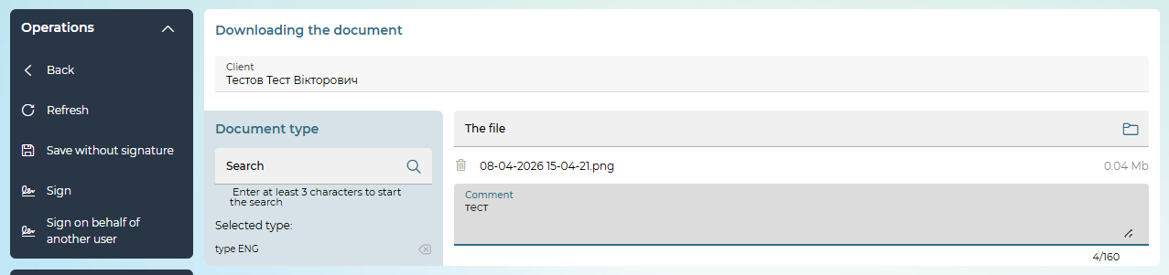
3. Select a counteragent from the list in the Client field.
4. Select a document type from the list. You can use the Search box to search for the document type (start typing the desired value). To return to the list of document types, click on the button in the Selected type box. Please note: next to some types in the list, you may see an icon  with a hint: "Signing with an external key only."
Also, the bank can configure the appropriate categories to select the document type in the form of a tree structure, then in the "Document type" section, the "category tree" will be displayed in collapsed form (you can expand or collapse categories by clicking on them).
Select the appropriate category and subcategory (if any) and document type.
After selection, the Selected type field displays the path and name of the selected type.
The button allows you to clear the selected type if you haven't downloaded any file yet, otherwise it will be grayed out.
5. Select the file to download - click on the button , specify the path to the file.
6. To upload another file, click on the button again, specify the path to the file.
7. To delete a file, use the button .
8. Enter a comment on the document, if required.
9. To sign the document, click on the "Sign" button.
10. To save the document, click on the "Save without signature" button. The document will be saved in the "Attached" status and in the future, it can be signed and sent to the bank.
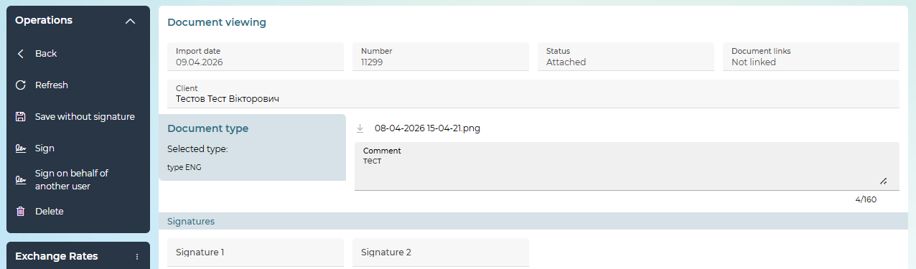

Linking a document to a request
When creating/editing payment orders in foreign currency, as well as requests for purchase, sale, currency conversion, you can link documents (for example, scanned copies of contracts, invoices, questionnaires) to them. To do this, follow these steps:
1. Proceed to edit the "Attached documents" section of the selected request. Please note: the section is editable only when creating a currency request or if the request is in the status "Not all signatures".
2. If a list of documents that you have already uploaded and sent to the bank via a secure system channel is available on the "Attach document" tab in the Document field (see "Upload Document"), select the desired file from the list, and click on the "Attach document" button, the document will be displayed in the list of subdocuments. To go to the form to view the attached document, select it from the list. To delete the link to the document, select the linked document and click on the "Unlink" button.
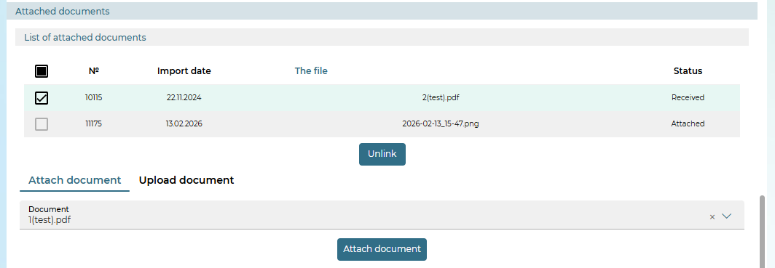
To upload a new document with automatic binding of it to the selected request, click on the "Upload Document" tab.
Next, select a value from the list in the Document type field.
Please note: next to some types in the list, you may see an icon with a hint: "Signing with an external key only". This type will be available for selection if you use an external key for signing;
Also, the bank can configure the appropriate categories to select the document type in the form of a tree structure, then in the "Document type" section, the "category tree" will be displayed in collapsed form (you can expand or collapse categories by clicking on them).
Select the appropriate category and subcategory (if any) and document type.
After selection, the Selected type field displays the path and name of the selected type.
The button allows you to clear the selected type if you haven't downloaded any file yet, otherwise it will be grayed out.
Select the file to download (click on the button );
If necessary, type a comment in the Comment box. Use the button if you want to delete the selected document.
Use the button if you need to add another file. The total number and total size of attached documents is limited by the bank's settings.

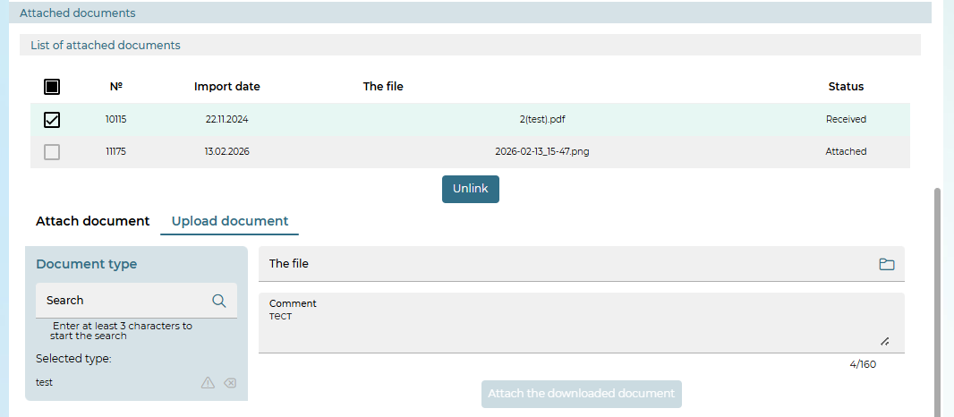
Click on the "Attach the downloaded document" button (it adds the entry (or records if several files of the same type are uploaded) to the list of attached documents, and then clears the fields of the "Upload document" block.
After filling in all the details of the currency payment order/request, sign the EDS document and send it to the bank (the "Sign" button) or save it without a signature (the "Save without signature" button).

DocUpload documents (dual-signed, initiated by the bank)
Documents created and signed by the bank are displayed in the general list of documents uploaded in the statuses "Uploaded by the bank", "Signed by the bank", "Awaiting customer signature", "Signed by the client and the bank".

Single-signed documents
For documents created and signed by the bank, which do not require signing by the user, the user can:
- Go to the Additional data/Exchange of documents menu item.
- Select the desired entry from the list in the "Signed by the bank" status.
- Open the information about this record.
- Download the document by clicking on the button ("Save") - save the attached document file to the user's PC;
- Upload the document and the signatures applied to it by clicking the button ("Save file and signatures") - save the document and the signatures applied to it in a file container of P7S format in order to further verify the signatures imposed on the document using third-party EDS verification services (for example, on the website of the Ministry of Justice). The button is displayed on the form, provided that at least one signature is applied to the document;
- Check the correctness of the electronic digital signature applied to the document by the bank at the client's point in iFOBS – to do this, you need to click on the button ("Check EDS"). The system will check and display the result in a pop-up message. The button is displayed on the form, provided that at least one signature is applied to the document.
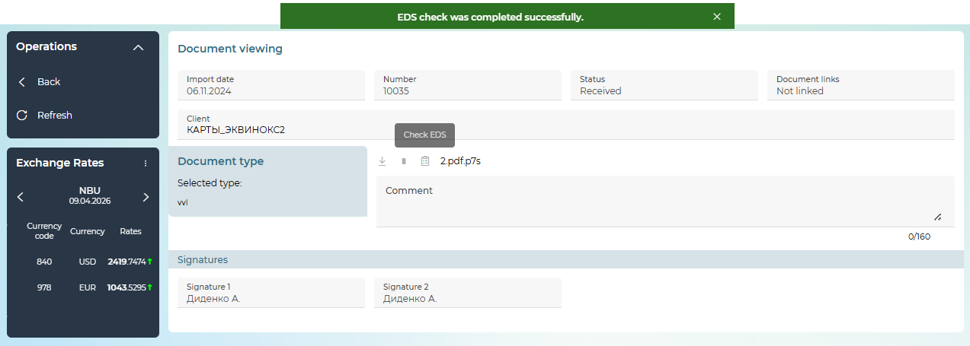

Dual-signed documents
For documents created and signed by the bank, which require signing by the user, the user can:
- Go to the Additional data/Exchange of documents menu item.
- Select the desired entry from the list in the status "Awaiting customer signature".
- Open the information about this record.
- Download the document by clicking the button ("Save") - save the attached document file to the user's PC;
- Upload the document and the signatures applied to it by clicking the button ("Save file and signatures") - save the document and the signatures applied to it in a file container of P7S format in order to further verify the signatures imposed on the document using third-party EDS verification services (for example, on the website of the Ministry of Justice).
- Check the correctness of the electronic digital signature applied to the document by the bank at the client's place in iFOBS – to do this, you need to click on the button ("Check EDS"). The system will perform a check and display the result in a pop-up message.
- Cancel the file by selecting the "Reject" side menu item. This will change the status before the signature is applied in cases where the document is not up to date.
- Sign the document with an electronic digital signature of the user viewing the document – to do this, click on the "Sign" or "Sign on behalf of another user" button.

Reference books
For the convenience of users, the system provides special reference books that allow you not to enter the same data many times. The data is stored in reference books and is used when filling in the fields in hryvnia and currency documents. This method of filling out documents not only facilitates and speeds up the user's work, but also allows you to avoid errors in account details, banks, and payment purposes.
The Additional data/Manuals menu item allows you to navigate to the following sections:
- Details of payment correspondents in national currency
- Payment purposes in national currency
- Authorized persons
- SWIFT correspondents
- Payment purposes (currency)

Details of payment correspondents in national currency
To access the reference book, select the menu item Additional data/Reference books/Details of payment correspondents in national currency.
The reference book contains a list of accounts and identification codes of correspondents of hryvnia documents, as well as data of correspondent banks.
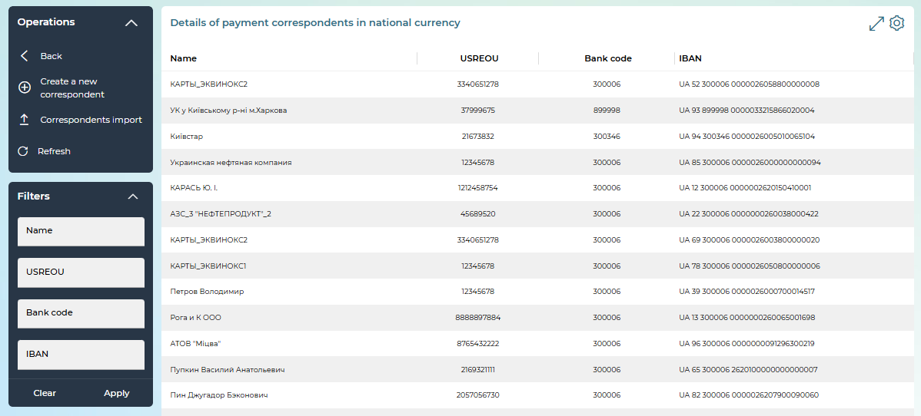
In the reference book, you can do the following:
- Set additional filters, sort data, configure the form (see "Settings on forms with lists").
- View and change the correspondent's data. To do this, click on the line with the desired entry in the list, on the detailed form that opens, make the necessary changes and click on the "Save" button. In order to return to the form with the list of correspondents without changes, click on the „Back“ button.
- Delete reference book data. To do this, click on the line with the desired entry in the list and on the detailed form that opens, click on the "Delete" button.
- Add a new correspondent. To do this, click on the "Create a new correspondent" button in the "Operations" section, fill in the data on the new form. To save the entry in the reference book, click on the "Save" button.
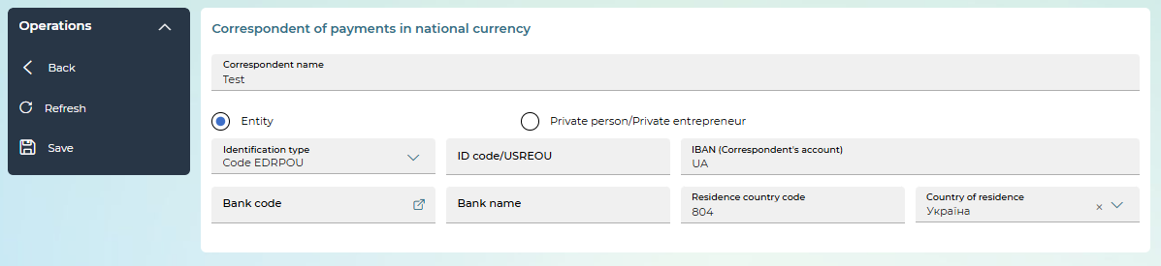
Element | Req. | Description
Correspondent name | + | Enter the name of the correspondent
"Entity"/"Private person/Private entrepreneur" | +  ________ | With the help of the appropriate switch, it is indicated that the correspondent is a legal entity or a private entrepreneur (according to ISO20022 is identified as a private person)
Identification type | + | Select the type of identification from the list. Depending on the selected value, the Id. code/USREOU field is filled in.  For entities:  - Code USREOU – 8 digits (not zeros),  - Tax ID (registration number) – displayed for the recipient – 9 digits (not zeros),  - Code not assigned (ID code field is filled with the value 0000000000)  For a private persons/ private entrepreneur:  - Individual tax number – 10 digits (not zeros),  - Passport – 2 letters and 6 digits or 9 digits (ID card) or 000000000 (for a non-resident),  - Other document – 2 letters and 6 numbers (for a resident),  - No information – the Id. code field is filled in with the value 99999. The display of this field depends on the bank's settings
Id. code/USREOU | + | For the field for entering data according to the selected type of identification, see above
IBAN (Correspondent’s account) | + | Field for entering a correspondent account
Bank code | + | Select the bank code from the reference book – button 
Country of residence | + | Select the name of the country of residence from the list
Location | -/+ | The block is displayed if the following is selected:  - For entities: type of identification – code not assigned and Tax ID,  - For private persons/private entrepreneur: type of identification – no information.  Fill in the following fields:  - Country (code), Country – select a name from the list or enter a code,  - Region,  - District,  - Place (mandatory),  - Street,  - House number (mandatory),  - Apartment,  - Postal code.  If at least one field of this block is filled in, then the required fields of the block must be filled in. The obligation to fill in data on the location depends on the bank's settings
Date and place of birth | -/+ | The block is displayed for private persons/private entrepreneur. Person type of identification – no information.  - Birth date (required).  - Place (mandatory),  - Country, Country (code) – select a name from the list or enter a code (required),  The obligation to fill in data on the date and place of birth depends on the settings in the bank

Payment purposes in national currency
The reference book contains the purpose of payments offered by default for correspondents of UAH payments.
To open the reference book, select the Additional data/Reference books/Payment purposes in national currency menu item.
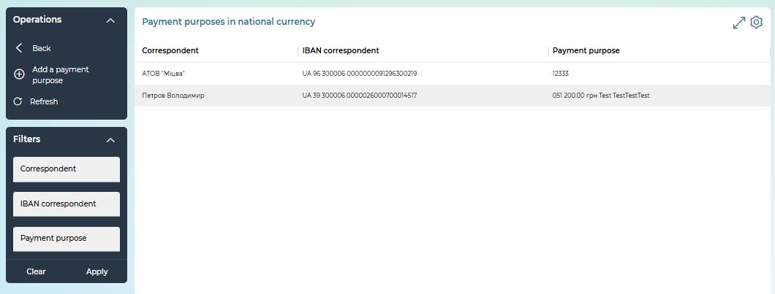
In this guide, you can:
1. Set additional filters, sort data, configure the form (see "Settings on forms with lists").
- View and change the data of the purpose of payments. To do this, click on the line with the desired entry in the list, on the detailed form that opens, make the necessary changes and click on the "Save" button. In order to return to the form with the list without changes, click on the „Back“ button.
- Delete reference book data. To do this, click on the line with the desired entry in the list and on the detailed form that opens, click on the "Delete" button.
- Add a new record. To do this, click on the "Add a payment purpose" button in the "Operations" section and fill in the data on the new form:
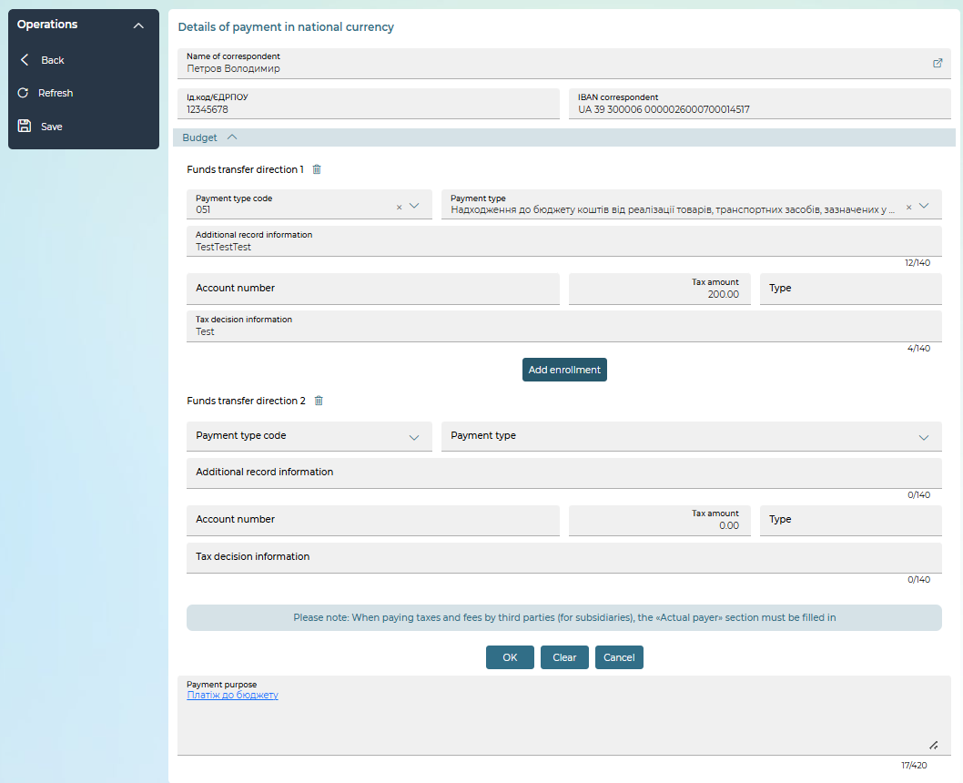

- Select the name of the correspondent from the reference book (the button ). This will automatically fill in the Id.code/USREOU and IBAN correspondent fields.
- Enter the purpose of the payment in the appropriate field (maximum 420 characters).
- If you want to create an assignment for a budget payment, fill in the appropriate fields in the "Budget" section (see description in the table below), click on the "OK" button. In the Payment purpose field, the text "Payment to the budget" will be automatically substituted, while the text of the payment purpose is not available for editing and is a link to the "Budget" form.
- To save the entry in the reference book, click on the "Save" button.

Description of the elements of the form with information on the structured purpose of payment to the budget
Element | Req. | Description
Payment type code, Payment type | - | Select the desired value of the payment type code from the list
Additional record information | - | Enter additional recording information (up to 140 characters)
Account number | - | Enter the account number in IBAN format
Tax amount | - | Enter the amount of tax.  Pay attention: the total amount of all directions of crediting should be equal to the amount of the hryvnia document
Tax decision information | - | Enter your tax notice (decision) information (up to 140 characters)
Type | - | Enter the budget revenue classification code (up to 35 characters)
"Cancel" |  | After clicking the button, the "Budget" form will be closed without saving the changes
"Clear" |  | Button to delete the entered data on the "Budget" form
"Add enrollment" |  | Button to add a new entry for enrollment in the budget. The number of crediting directions available for addition is regulated by the setting in the bank
"OK" |  | If all the required fields are filled in correctly, after clicking the "OK" button, the "Budget" section is minimized, a link "Payment to the budget" is formed in the Purpose of payment field
 |  | Button to remove the direction of enrollment in the budget

Authorized persons
In the system, you can view the list of authorized persons you can contact to get advice and promptly resolve issues related to banking services.
To access the reference book, select the menu item Additional data/Reference books/Authorized persons.
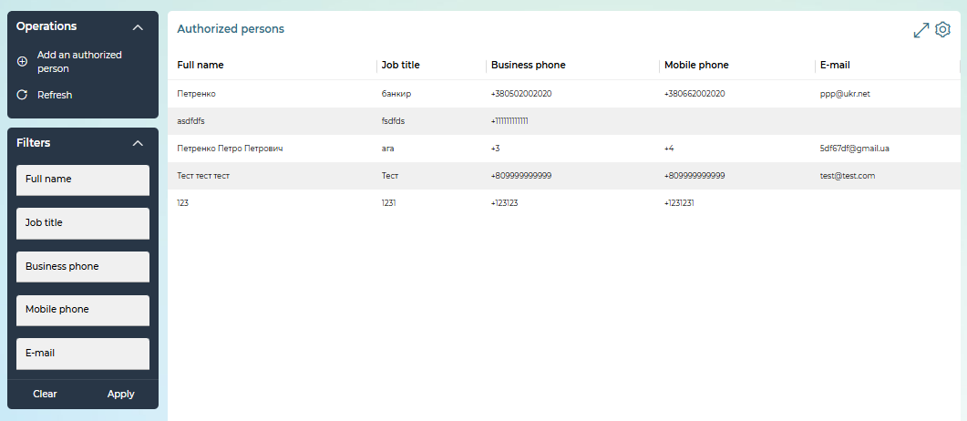
In this reference book, you can:
- View and change the data of the authorized person. To do this, click on the line with the desired entry in the list, on the detailed form that opens, make the necessary changes and click on the "Save" button. In order to return to the form with the list without changes, click on the „Back“ button.
- Delete reference book data. To do this, click on the line with the desired entry in the list and on the detailed form that opens, click on the "Delete" button.
- Add a new record. To do this, click on the "Add an authorized person" button in the "Operations" section and fill in the data on the new form: enter the person's name, position, phone numbers and email address in the appropriate fields.
- To save the entry in the reference book, click on the "Save" button.
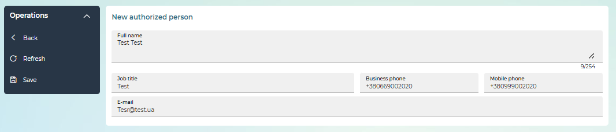

SWIFT correspondents
To call the reference book, select the menu item Additional data/Reference books/SWIFT correspondents.
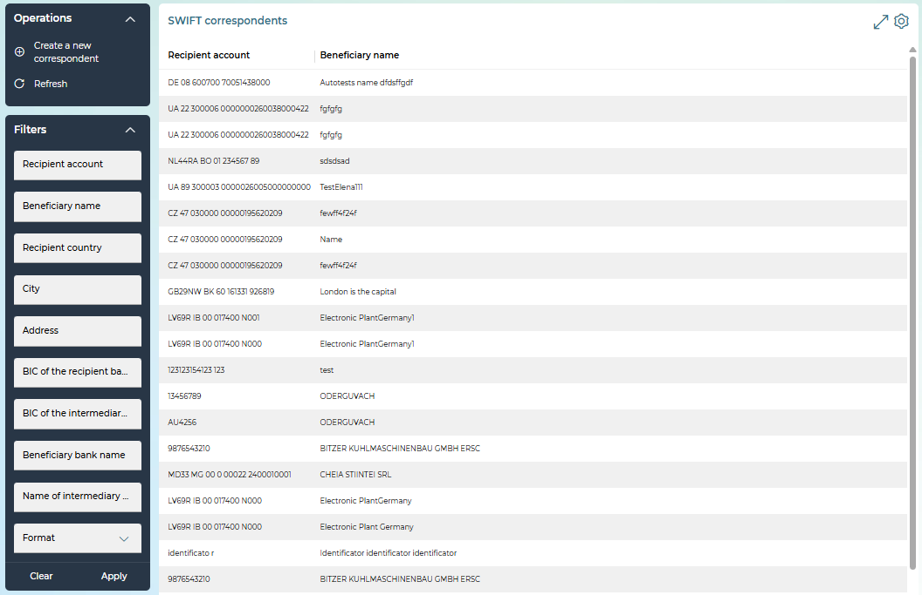
The reference book contains the details of the correspondents of currency documents: account number, as well as the name and address of the organization-recipient of the amount under the currency payment document, data on the recipient's bank and the correspondent bank.
On this page, you can:
- Set additional filters, sort data, configure the form (see "Settings on forms with lists").
- View and change the correspondent's data. To do this, click on the line with the desired entry in the list, on the detailed form that opens, make the necessary changes and click on the "Save" button. In order to return to the form with the list of correspondents without changes, click on the „Back“ button.
- Delete reference book data. To do this, click on the line with the desired entry in the list and on the detailed form that opens, click on the "Delete" button.
- Add a new SWIFT correspondent. To do this, click on the "Create a new correspondent" button in the "Operations" section and fill in the form fields in the new form. The sections of the "A new correspondent for the SWIFT" form correspond to the sections of the SWIFT document.
If the creation of SWIFT MX payments is configured, the creation of SWIFT MX correspondents is available, the creation of SWIFT MT correspondents is not available.
- To save the entry in the reference book, click on the "Save" button.
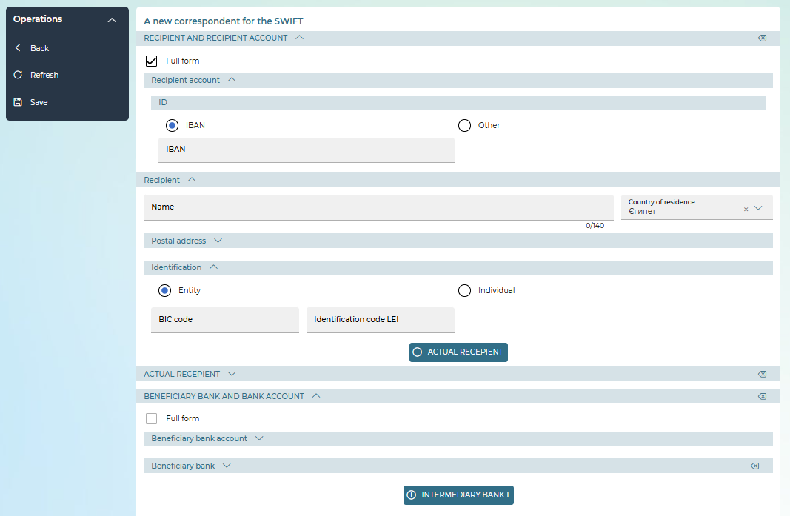

Payment purposes (currency)
The reference book contains the purpose of payments offered by default for correspondents of currency payment documents.
To open the reference book, select the menu item Additional data/Reference books/Payment purposes (currency).
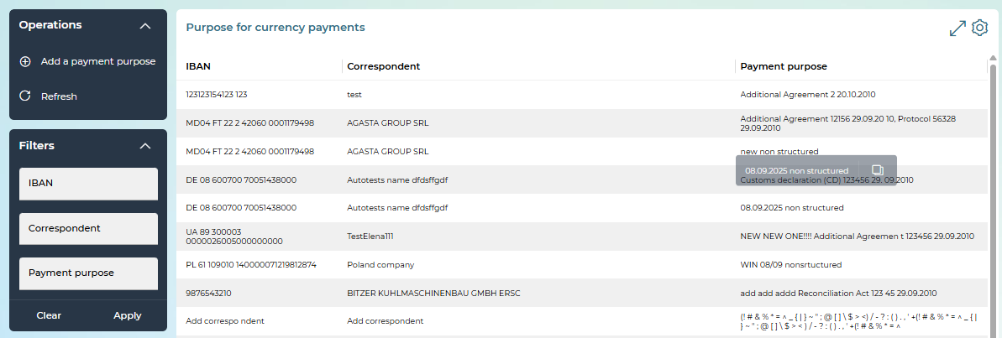
In this reference book, you can:
- Set additional filters, sort data, configure the form (see "Settings on forms with lists").
- View and change the data of the purpose of payments. To do this, click on the line with the desired entry in the list, on the detailed form that opens, make the necessary changes and click on the "Save" button. In order to return to the form with the list without changes, click on the „Back“ button.
- Delete reference book data. To do this, click on the line with the desired entry in the list and on the detailed form that opens, click on the "Delete" button.
- Add a new record. To do this, click on the "Add a payment purpose" button in the "Operations" section and fill in the data on the new form:
- Select a correspondent from the drop-down list – the button .
- If you are configured to work with SWIFT MX, use the checkboxes to select the type of purpose: unstructured (enter data in the appropriate field) or structured.
For a structured purpose, enter information about the document: select the type of document from the list, enter its number, date and amount. You can add (add button), clear (the button ) and delete added entries (the button ) for documents.
- To save the entry in the reference book, click on the "Save" button.
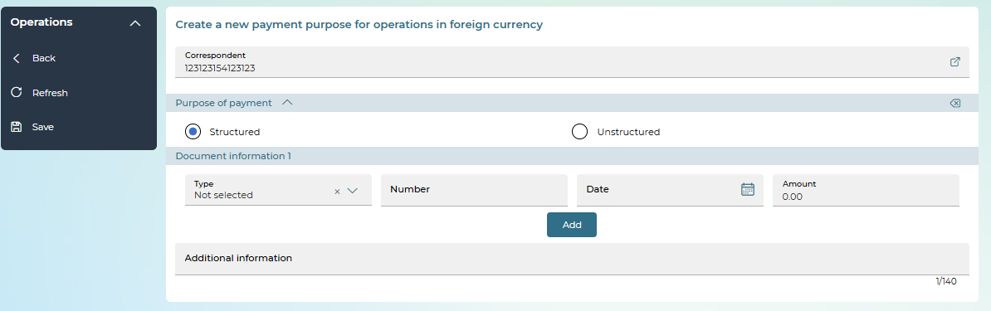

Messages
To view received and sent messages to the client banking, click on the envelope button, which is located in the upper right corner of the screen.
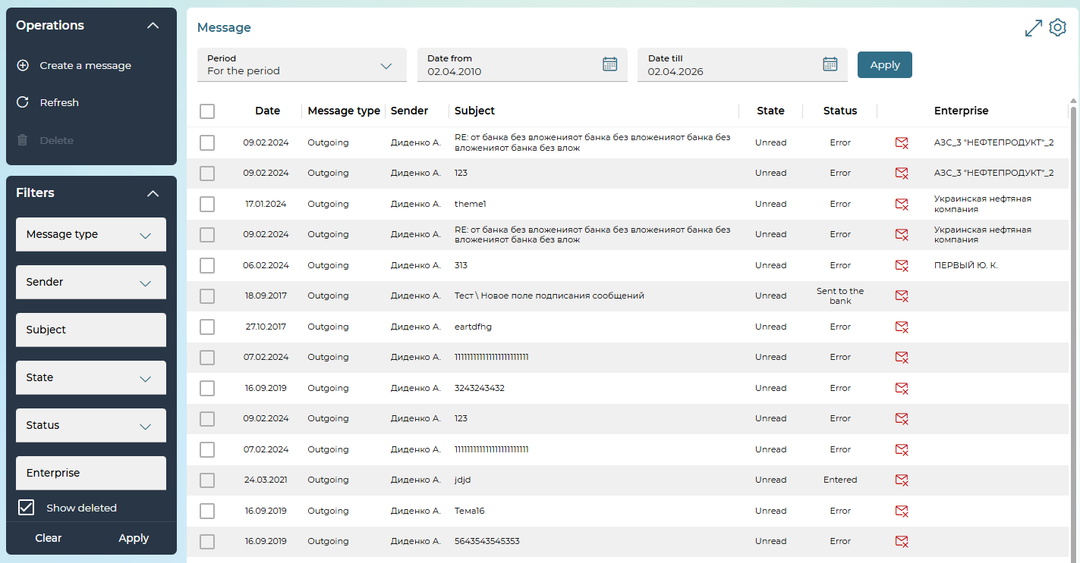
The list of messages contains general information:
- Date.
- Type of message: incoming, outgoing.
- Subject of the message.
- State: read, not read.
- Message status: received from the bank, not all signatures, entered, sent to the bank, sent to the bank, error etc.
On this page, you can:
- Filter or sort messages by the necessary categories of messages (see "Settings on forms with lists").
- Delete one or more messages: to do this, mark them with checkboxes and click on the "Delete" button. At the same time, deletion is not available for incoming messages in the "Not Read" state.
Please note: depending on the settings set by the bank, deleted messages may not be displayed or displayed in the general list of messages (in this case, they will be marked with an icon ).
- View detailed information on the message and attachments to it. To do this, click on the line with the required message. This will open a view form where you can:
- Delete messages – "Delete" button.
- To sign an unsigned message, see Sign an unsigned message. "Signing documents".
- Save message without signature – " Save without signature" button.
- Reply to an incoming message – the "Reply" button.
- Create a new message – "Create message" button.
Please note: the menu items are displayed depending on the system configuration and the rights granted to you, so some of them may not be present in your version of the application

Creating and editing messages

Create a new message
To create a new message:
- On the message list form or on the message view form, click on the Create a message button.
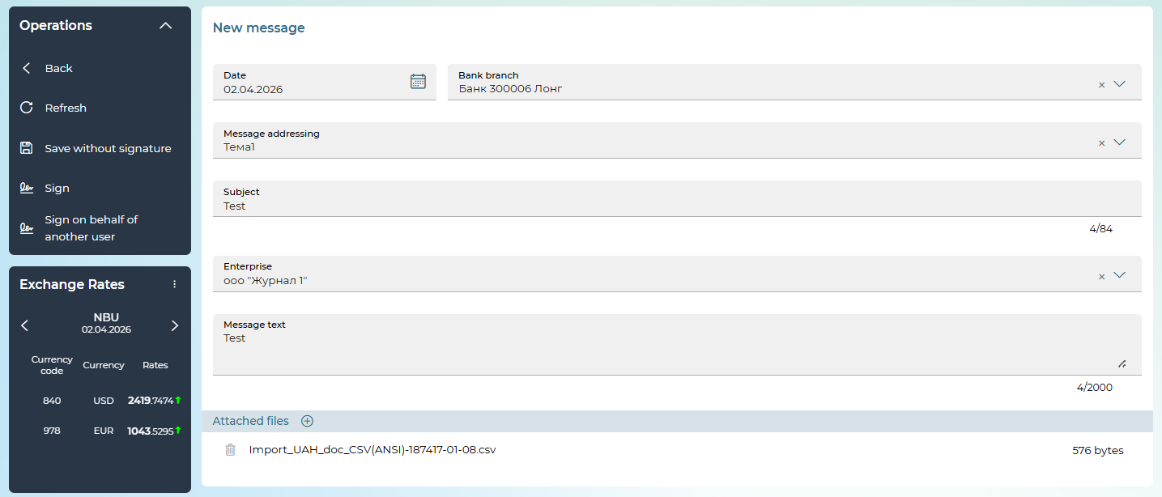
- On the new form:
- Select a bank branch.
- After selecting a bank branch in the Message addressing field, you can select the address (subject) of the message from the drop-down list. The obligation to fill in this field depends on the bank's settings. If only one option is available for selection, by default the field will be automatically filled with this value.
- Specify the subject of the message (up to 84 characters).
- If you have multiple enterprises, select the one you want from the list of available businesses. The obligation to fill in this field depends on the settings at the bank.
- Write the text of the message (no more than 2,000 characters).
- To add file(s) to a message, click on the "+" button. Select one or more files in the default window that opens the files. Alternatively, you can drag and drop files from your folder to the attachment area of the message. If you want to re-add the files, click on the button or drag the files. If you want to delete the attachments, click on the trash can button next to the file name.
Please note: the total file size is limited by your bank settings. In addition, the length of the file name is limited and it is unacceptable to attach files with the same name.

Please note: the menu items are displayed depending on the system configuration and the rights granted to you, so some of them may not be present in your version of the application
- If necessary, sign the message, see "Signing documents".
- To save a message without a signature, click on the "Save without signature" button.
- To return to the message list page, click on the „Back“ button.

Edit a message
Editing is available for messages in the "Not all signatures" or "Error" statuses.
The following operations are available on the message editing form:
- Add attachments – you can add new attachments using the "+" button.
- Deleting attachments - you can delete attachments added during editing using the button . At the same time, the removal or replacement of previously added attachments is not allowed.
- Editing other message fields – the fields of the message itself are available for editing within the logic provided by the current document status.
- Saving - at the same time as saving the message itself, new attachments are saved. If the message was previously signed, it will be reset and the message must be re-signed.

Settings
- Security settings
- Setting up the display of panels on the main page
- Settings on forms with lists
- Personal settings

Security settings
The Settings menu item (the button ) opens access to the section.
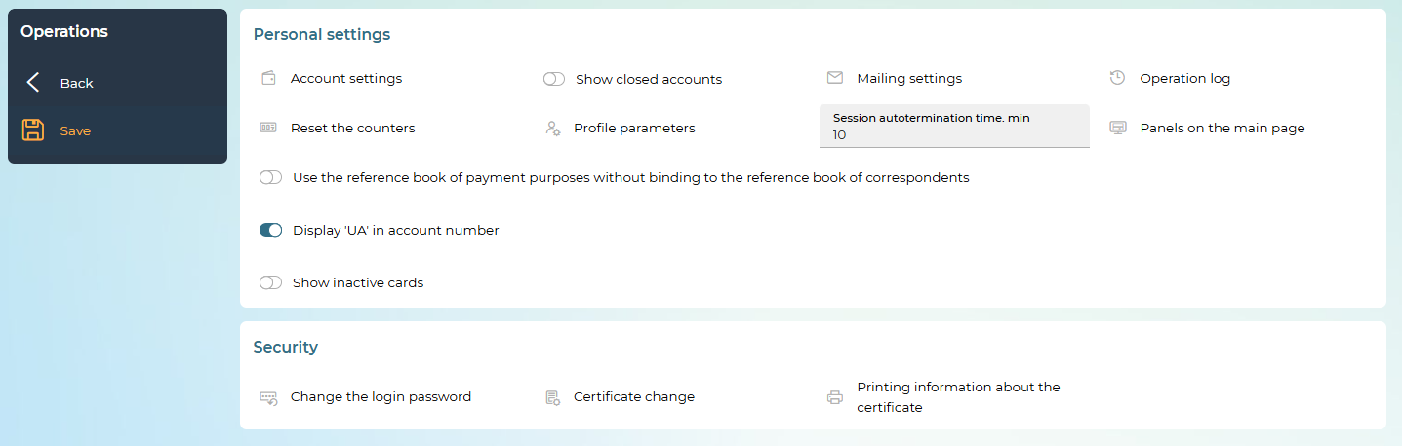

Change your login password
In order to change the password for logging in, click on the "Settings" button, in the "Security" section, select Change the login password.
On the "Change your login password" form, do the following:
- Enter your current login password in the Current password field.
- Enter a new password in the New password field and repeat it in the New password (confirmation) field.
- Click on the "Save" button.
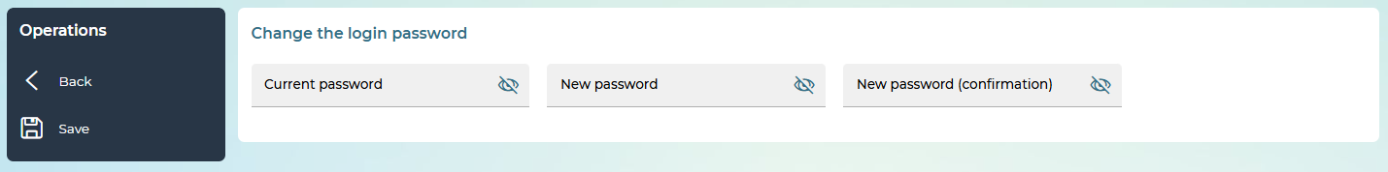
Please note: the system checks the password for valid characters. Latin letters of different cases, numbers and symbols are acceptable: ! "# $% & '() * +, -. /:; <=>? @ [\] ^ _` {|} ~ All other characters, space, and Cyrillic letters are ignored.

Certificate change
If you have a working key and a certificate, you will be able to perform its scheduled change regardless of whether you have the rights to sign documents.
To proceed to the replacement of the certificate, click on the "Settings" button, in the "Security" section, select Certificate change.

Request a new certificate
To request a new certificate, follow these steps:
- After you go to the certificate change, you will see a message that you need to perform the certificate change operation in the iSignDesktop application.
- In the new form, enter your current password to the private key.
- Please create, enter and confirm the password for the new private key.
- Check/select the key path.
- Click on the "Next" button.
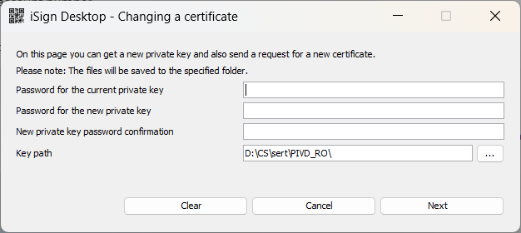
Your request for a new certificate will be sent for processing.
You need to print out the request (the "Print" button), sign it and submit the original to the bank. You will be informed about the result of processing later.
Before authorizing the certificate request, you can reprint the certificate request. When you use login keys, a message will be displayed after entering your login and login password.
Select the request file in the folder where the key is located, click on the "Print" button.
You can also print the request by selecting the Security/Printing the request about the new certificate.
Please note: this menu item is displayed when there is an unauthorized request.

Obtaining a certificate
The system will inform you when your request is authorized.
Enter the password to the new private key, specify/check the path to the key, click on the "Save" button.
The system will inform you about the results of changing the certificate, click "OK".

Certificate Printing
In order to print the certificate, in the "Security" section, select Print information about the certificate.
Certificate information will be saved to a pdf file.
You can view, save, or print the certificate using standard methods.

Setting up the display of blocks on the main page
To customize the display of blocks, select the Panels on the main page in the "Settings" block or go to the settings (the button ), select Panels on the main page.
You can choose to display the advanced panels "Accounts", "Documents to be signed", "Latest documents in national currency" and the standard panels "Exchange rates", "Message", "Statements", "Settings".
The "Advanced panels" and "Standard panels" blocks contain lists of panel names that are not displayed on the main page and are available for selection. You can place panels in the order you want by dragging and dropping them within the "Panels on the main page" block.
Note: you can place a maximum of two advanced panels on the main page.
To hide a panel, hover over it and click on the button displayed in the middle of the panel, the name of the panel will be displayed in the corresponding block "Advanced panels"/"Standard panels".
After setting the desired display of the blocks, click on the "Save" button.
Note: in the system, on the main page, the panels are automatically stretched and placed if there is free space.
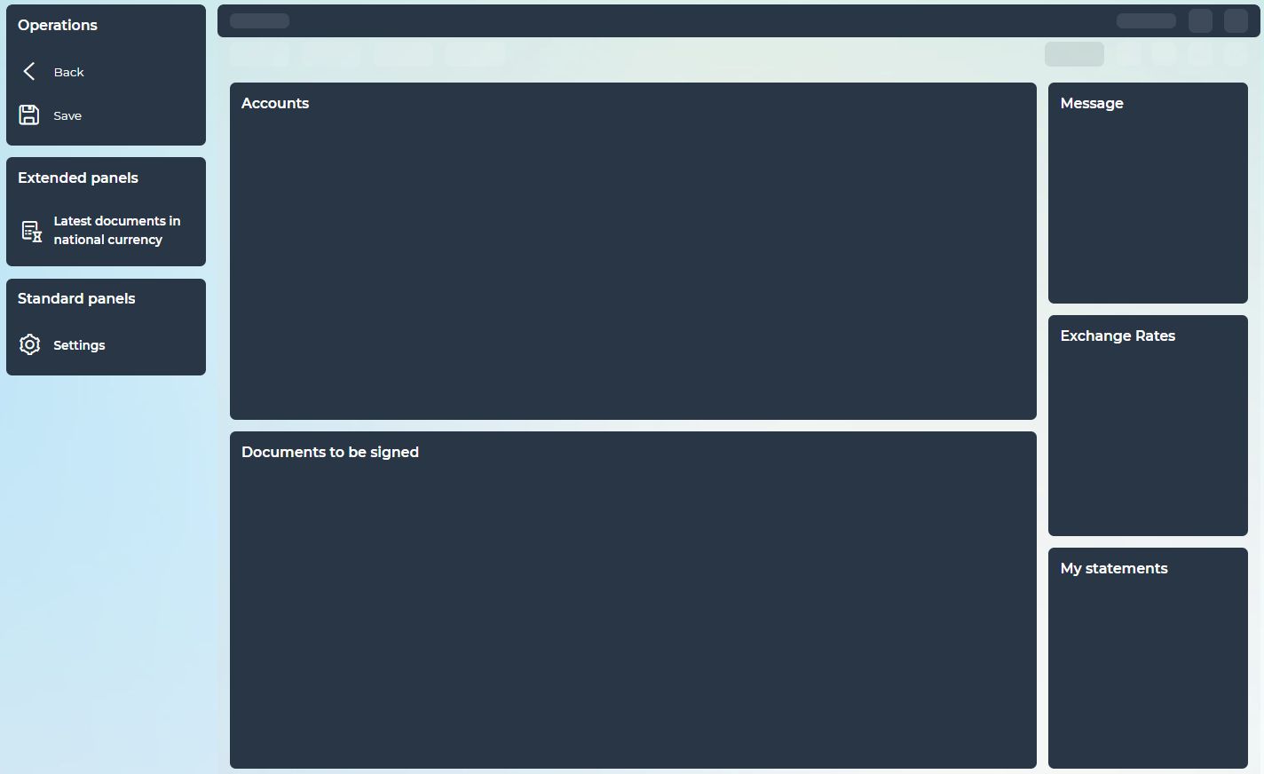

Settings on forms with lists
For the convenience of displaying and searching for data in the system, you can use the following features:
1. Display columns on a form with lists.
If an icon  is displayed on the right above the list of documents, click on it. This will open a panel with a list of columns available for display. Select the checkboxes next to the required columns (the minimum number of selected columns is 3). You can also adjust the order in which the columns are displayed on the form. To do this, drag the rows with the left mouse button and arrange them in the desired order. displayed by default and the default order of the columns, click “Reset”.
After all the necessary settings are done, click on the "Save" button. This will close the panel, and the form will automatically update in accordance with the settings.
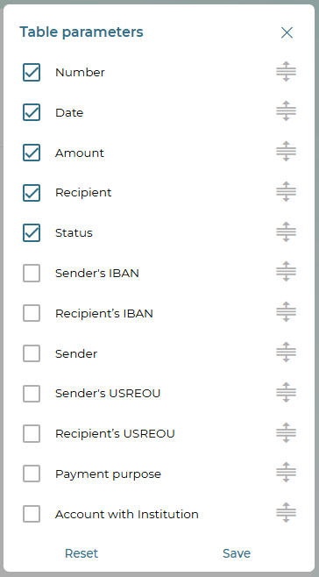
Customized view is saved in the future when you switch to the form in the current session and when you log in again.
You can change the order of the columns in the displayed form. To do this, drag the columns behind the headings with the left mouse button and arrange them in the desired order.
To change the width of the columns, drag the dividing line between the column names.
2. Scaling the form with a list. To enlarge the combo form, click on the button on the right above the list of documents. To return to the normal display of the list, click .
3. Filters. If filters are provided on forms with lists, when setting their parameters, it is possible to get information only about the required category of data.
To configure filters, you need to perform the following actions in the "Filters" block:
- For text boxes, enter the options according to which the data will be filtered.
- For drop-down lists, select a value from the list.
- Click on the "Apply" button.
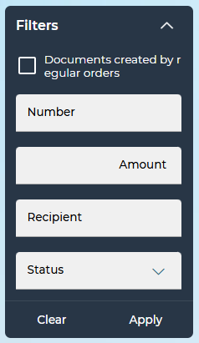
To remove all filtering options, click on the "Clear" button.
4. Sorting data in tables. If sorting by table column is available, the button will be available in its header. To sort by one of the columns, click .
If the sorting was carried out in ascending order (the symbol is displayed ), then when you click on the title again, it will be sorted in descending order (the symbol is displayed ).
5. Copying data. For text fields, you can view and copy the data. Hover over the desired field. A tooltip with detailed information about the field will be displayed. To copy the desired data, click .
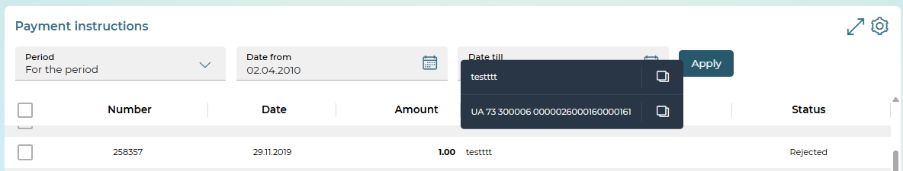

Personal settings
The Settings menu item (the button ) opens access to this section.
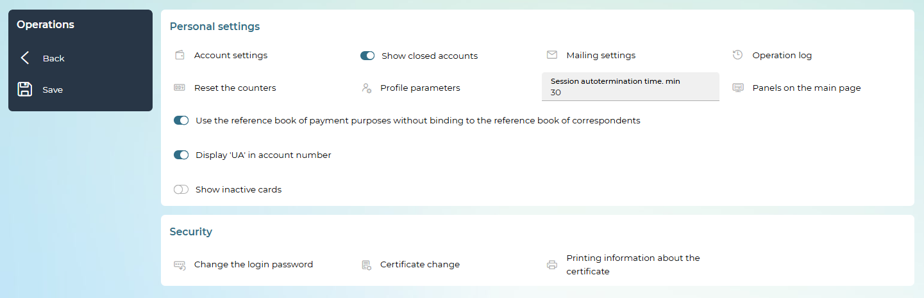
In the personal settings section, you can do the following:
Go to the account setup form, where you can:
- View a list of all available accounts;
- Give the account its own name for the convenience of working with it (press the button , enter a nickname and press the button ).
- Mark the account as selected ( ). At the same time, it will be displayed first in the list of selecting your accounts for debiting.
- Include the account to be displayed on the main page and on the page "All accounts" (see "Accounts");
- Include the account to be displayed on the page of the statement generation (see "Statement of accounts");
- View information on account status;
- Save changes (the "Save" button).
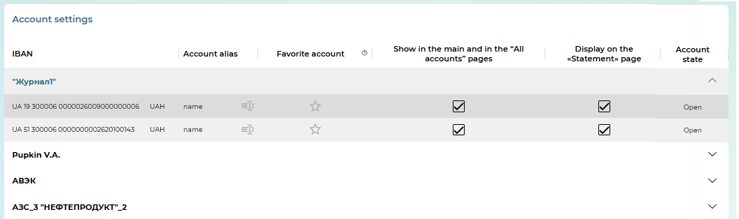
Set the "Show closed accounts" option, which regulates the display of accounts in the "Closed" state and information on them in the account block on the main page.

Go to the form of settings for sending statements and information about the movement of funds in SMS and e-mail (the “Mail settings” option). By configuring the appropriate switches, you can set individual parameters for sending reports on the movement of funds on each account, as well as set the maximum amounts, if exceeded, you will receive SMS notifications about debit and credit transactions on the account.
Please note: the availability of this option depends on the bank settings set for you.
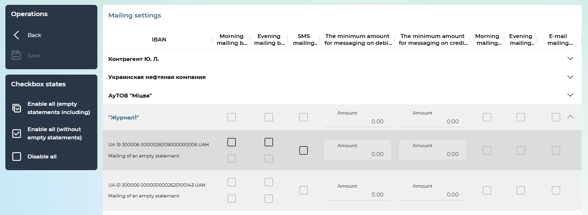

View the User’s operation log – the last 10 user actions in the system. The log logs information about the operations of creating, deleting, changing documents and messages, information about logging in, about regenerating certificates, etc. To view the details of the operation, click on the selected entry.
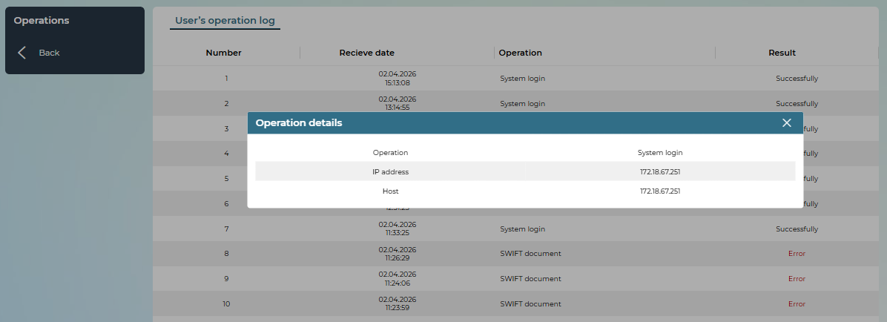
Please note: for corporate card users, there is a separate tab "Card transaction log" in the log, where you can view the details of non-financial card transactions: changes in card limits, card blocking, card cancellation, etc.).
Each line of the log is a link to the form for viewing detailed information about the operation.
Reset counters by selected counteragents and document types: set the appropriate switches, then click on the "Save" button.
Please note: resetting counters to zero is possible only if you do not have any entered documents for the current business day.
If there are such documents, the system will display a corresponding warning on the screen and the numbering will continue taking into account the number of the last entered document.
Thus, it is recommended to reset the counters at the beginning of the operating day.
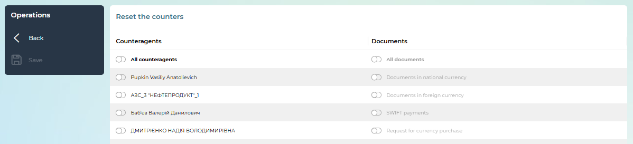
Go to the form for viewing account parameters (the “Profile parameters” option) – email and phone number for mailing. If the fields are available for editing, set/change the parameters if necessary, click on the "Save" button.
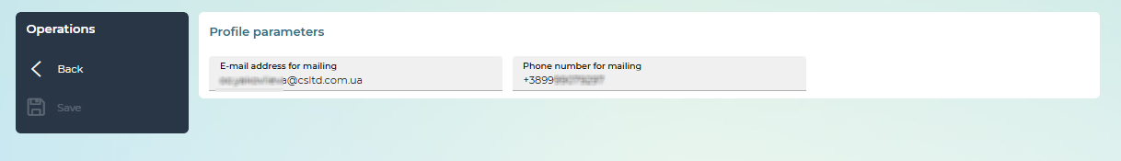
Set the option "Use the reference book of payment purposes without binding to the reference book of correspondents", which regulates the use of the reference book of payment assignments.
Set the time (in minutes) until the session ends automatically if the user has not performed any actions on the system.
Customize panels on the main page: change the position and number of elements on the main page (see "Block Display Settings").
If instant payment is available, you can set limits on instant payments. Set limits for one transaction, per day and per month (in UAH). At least one of the fields must be filled in and must be greater than zero. The limit of one transaction cannot exceed the limit per day, and the limit per day cannot exceed the limit per month. User limits cannot exceed the limits set by the bank. The operation of changing the limits on instant payments requires signing.
To save your changes, click on the "Save" button.

Key recovery
If your certificates have expired, or you have forgotten the password for the key, or the key is damaged, you need to contact the bank and get the password to recover the key.
- On the login page, enter your username and password, click on the "Enter" button. Proceed to generate a new key.
Note: If you have the right to log in without keys, you can go to the Settings/Security/Certificate change to generate a new certificate. In addition, when you try to sign documents, the system will prompt you to proceed to the recovery of keys.
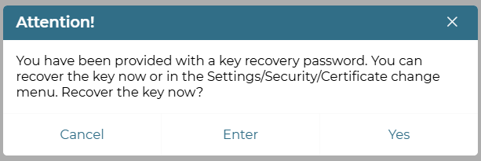
2. In the new form, enter the key recovery password.
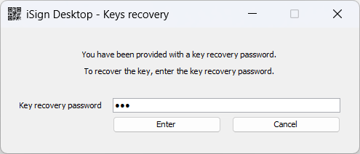
3. Press the "Enter" button, confirm the action (the "Yes" button).
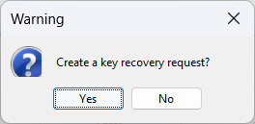
4. In the new form, please create, enter and confirm the password for the new key.
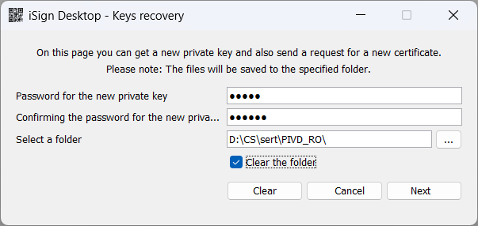
5. Select the path to the key using the button 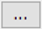. If the folder with the key is not empty, you can clear it by setting the displayed checkbox "Clear the folder".
6. Click on the "Next" button and confirm the action.
7. If you use the OTP code sent via SMS to confirm the transaction, enter the confirmation code and click on the "Next" button.
8. Your request for a new certificate will be sent to the processing queue. You need to print out the request (the "Print" button), sign it and transfer the original to the bank.
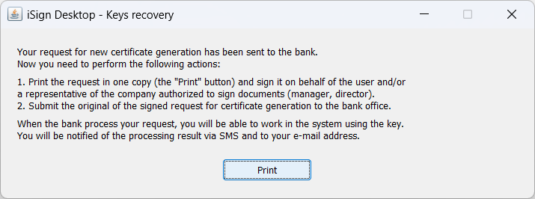
If you have keyless login, you can log in until you receive new keys.
- You will be provided with information when your request is processed and the new certificate is ready for delivery. On the login page, enter your login and password, if necessary, enter the OTP code, click on the "Enter" button.
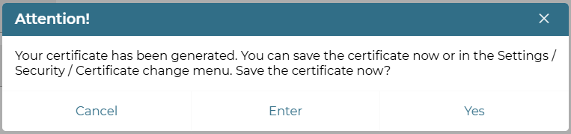
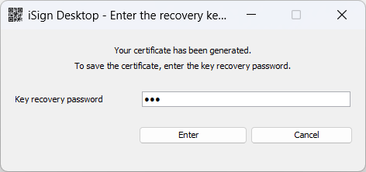
- Enter a new password for the new key, specify the path to the key, click on the "Save" button.
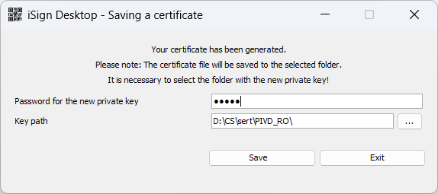
- Click on the "OK" button.
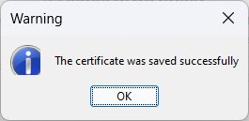

Working with external keys
Connecting an external key
Login with an external key
Signing documents with an external key
Printing an external certificate
Locking the work with the external key

Connecting an external key
In order to work in the system with a key issued by an external Certification authority, it is necessary to link the external key to the account.
To do this, follow these steps.
On the login page, follow the link "Connecting external key".
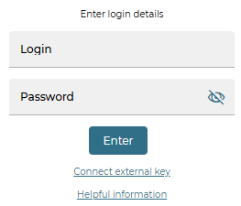

If the system prompts you to allow the launch of JAWA (TM) Web Launcher, click on the "Open JAWA (TM) Web Launcher" button.
Please note: if you check the "Always allow..." box, this window will no longer appear during the next logins.
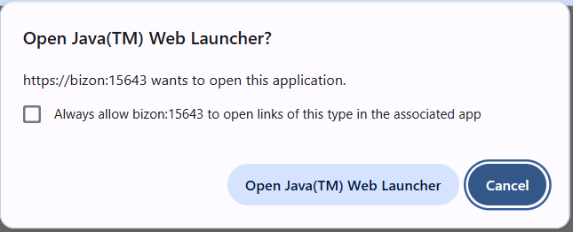
Next, the "iSign Desktop – Connecting an external key" window will open.
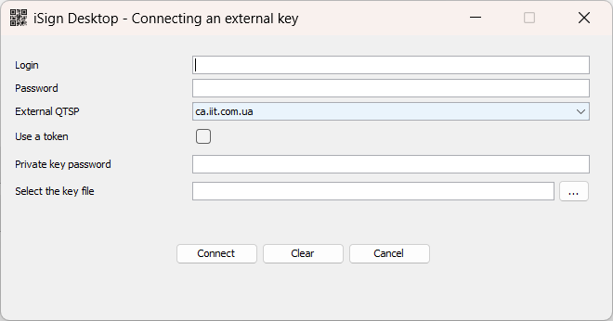
In this window, enter the following data:
- in the Login field – your user login;
- in the Password field – password for logging in;
- in the External QTSP field – select (if available) from the drop-down list the qualified provider of electronic trust services that issued you the key;
- in the Private key password field – the password to the external key;
- in the Select the key file field, click on the button 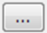 and select your external key file.
Click on the "Connect" button.

If an OTP code is used to confirm the connection of the external key according to the system settings, enter it, click on the "Next" button.
You can re-request the code ("Request…" button).

Please note: only one external key can be linked to their own account by a single user. When registering a new external key, the previous external key is blocked in iFOBS.
If all the data is specified correctly, a request for authorization of your external key will be sent to the bank.
In the mode of automatic authorization of the application for connecting the external key, the system reports that the key has been successfully connected.
In the mode with manual authorization of the application for connecting the external key, the system displays a message about the need to print out the request for connecting the external key (the "Print" button), sign it and transfer it to the bank.
After your request is authorized by the bank, you will be able to work with the system using your external key.

Login with an external key
On the login form, enter your login and password to enter the appropriate fields, click on the "Enter" button.

The number of login attempts with incorrect credentials is limited. Once they are finished, the user will be blocked.
If you do not have working certificates, the system will prompt you to generate new certificates or connect an external key on the login page.
If you have a working external key certificate and do not have the right to enter without a key, then in the absence of an internal certificate, the system will offer to log in with an external key.
If you have a working external key certificate and there are still days left before the expiration of internal certificates, which is specified in the system settings, a window will be displayed with a warning about the expiration of the certificate.
You can perform a scheduled regeneration of the key and certificate, or log in with an external key.
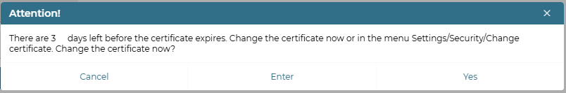

If you have a working external key certificate and the internal certificates have expired, then the system will prompt you to log in with the external key.
When logging in with an external key on the "iSign Desktop - Keys entering" form, select the "Use an external key" checkbox, specify the key password and select the key file, or select the "Use a token" checkbox and select a token with a private key.
To ensure the correct operation of the IFOBS.iSign Desktop application, it is necessary that the latest version of Java is installed on the user's computer.
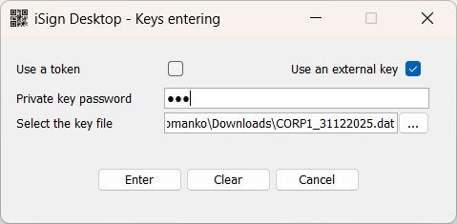
If you have an OTP login confirmation, the OTP confirmation form will open. Enter the verification code.
If the data is entered correctly, you will be logged in.

Signing documents with an external key
If you use a login key, the documents are signed with the same key with which you signed in.
If you do not have working certificates, you will be prompted to generate new certificates in the system settings or connect an external key on the login page.
If you have a working external key certificate, you will be prompted to perform external key signing if you do not have an internal certificate.
If you have a working external key certificate and there are days left before the expiration of internal certificates, which is specified in the configuration set of the system, then a window will open with a warning about the expiration of the internal certificate. You can perform a scheduled regeneration of the key and certificate, or perform an external key signing.

If you have a working external key certificate and the internal certificates have expired, you will be prompted to perform external key signing.
If the system has set up confirmation of payments with an OTP code, enter the confirmation code from the received SMS message or from the hardware OTP token and click on the "Next" button to go to the application signing form.
When signing with an external key, the next step will display a message asking you to perform a signing operation in the iSign Desktop app.
To ensure the correct operation of the IFOBS.iSign Desktop application, it is necessary that the latest version of Java is installed on the user's computer.
A new window will open with information about the document(s). Check the details, click on the "Sign" button.
In the signing window, enter the password to the private key and specify the path to the key. If a token is used to store the private key, select the "Use a token" checkbox, and the folder selection field on the form will be hidden.
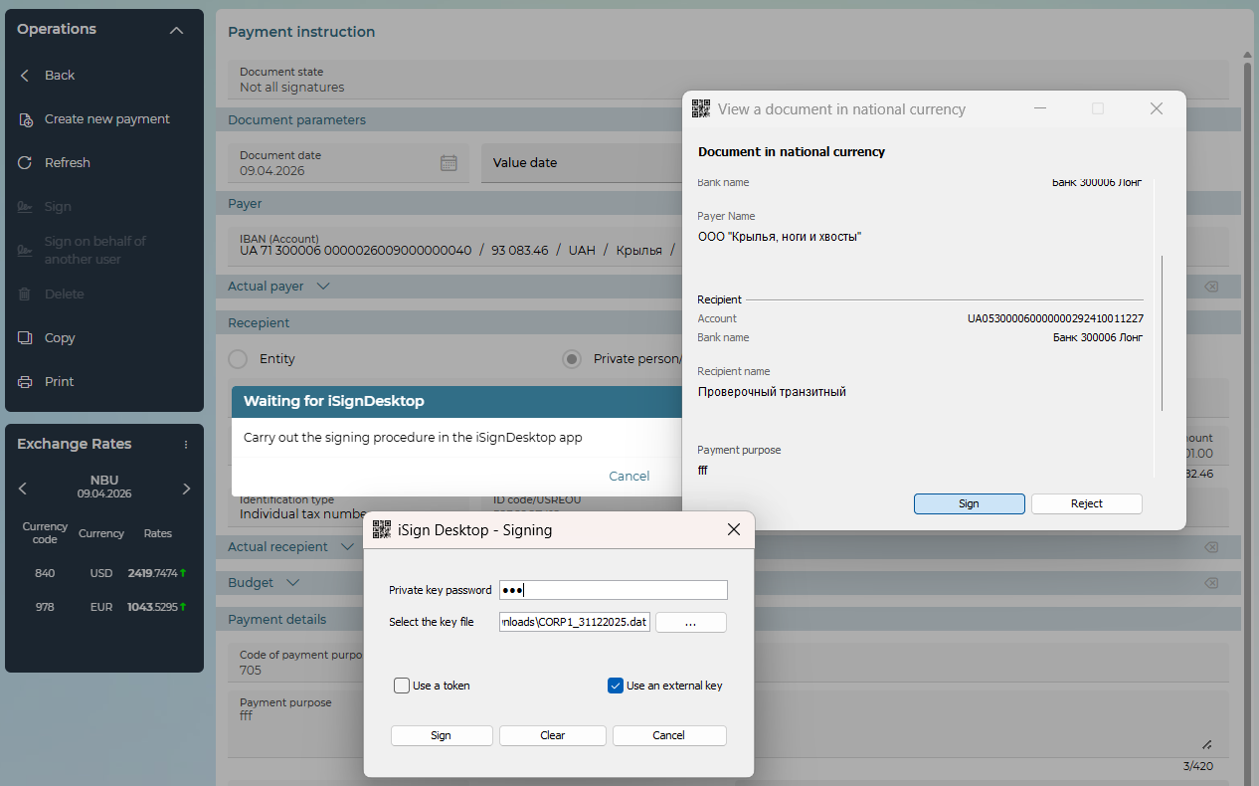
If the data is entered correctly, the system displays a message about the successful result of signing on the application details form or the list of documents to be signed.

Blocking the work with the external key
To block the work with the external key, go to the settings by clicking  the button, in the "Security" section, select External key blocking.
Confirm the action in the dialog box by clicking "Yes".
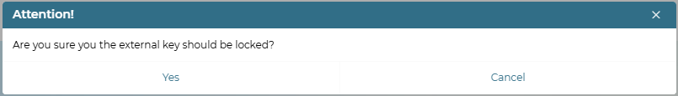

Printing an external certificate
In order to print the certificate, go to the settings (the button ) and in the "Security" section, select Print information about an external certificate.
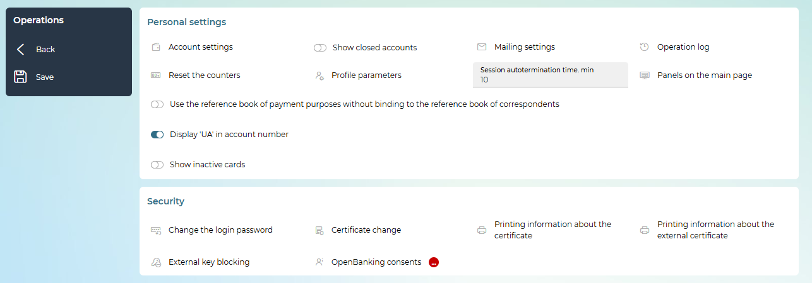
The certificate information will be saved to a pdf file.
You can view, save, or print the certificate using standard methods.

Ordering services
The availability of the "Connect products and services" item depends on the settings in the bank.
Depending on your rights, you can:
- only view and print existing requests,
- view, create new ones, edit them (depending on the status), sign, print and delete requests.
To work with online requests, go to the Additional/Additional Services/Connecting products and services section.
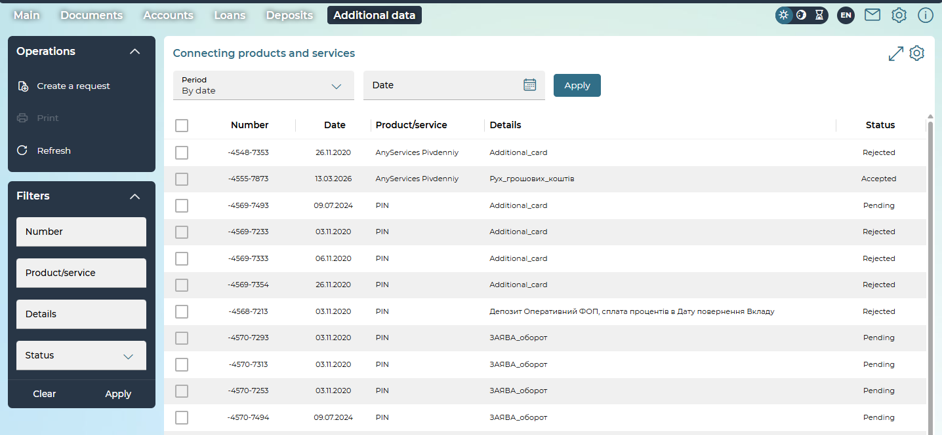

A list of your requests will open. On the page, you can filter requests for the period, with the ability to select a date from the calendar. In addition, sorting and filtering are provided.
The following operations are available for requests for connecting products and services:
- "Create a request" – allows you to proceed to the creation of a new request;
- "Print" – activated when selecting a request/requests using checkboxes. When you click on the "Print" button, data is automatically saved in the archive, while the archive contains as many pdf documents as there are selected requests.
Each line of the list is a link to the page for viewing detailed information about the request and performing available operations.

To view and edit the request, click on the corresponding line in the list of requests.
For a request, depending on its status, it is possible:
- review of the request;
- editing the request with the ability to change all fields available for editing on the form;
- saving the modified request (the "Save without signature" button);
- signing the request (the "Sign", "Sign on behalf of another user" button);
- printing (the "Print" button);
- return to the list of created requests (the „Back“ button).
For rejected documents, information about the reason for the rejection is additionally displayed above the request.
You can create a request on the page with the list of your requests by clicking the "Create a request" button.
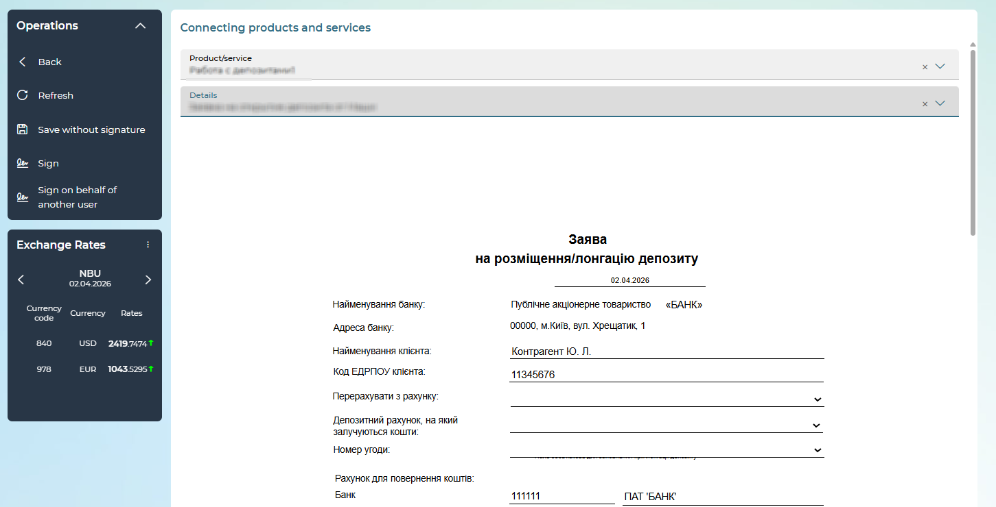

When creating a new request, you need to select a product/service and details from the drop-down lists.
Depending on the selected request type, the corresponding document with a certain set of fields will open.
In the document, you need to fill in the fields or select data from drop-down lists.
The request form provides:
- return to the list of existing requests – the „Back“ button.
- saving the request – the "Save without signature" button, after saving the request remains in the status "Not all signatures";
- signing the request – the "Sign"/"Sign on behalf of another user" button.

Product Portfolio
The functionality provides the user with the opportunity to order new products and services, the request for which requires the process of consideration by the bank and the signing of documents and agreements (contracts).
If the bank has set the appropriate rights for your account, you can proceed to use the functionality by clicking on the "Product Portfolio" button in the upper right corner of the screen.
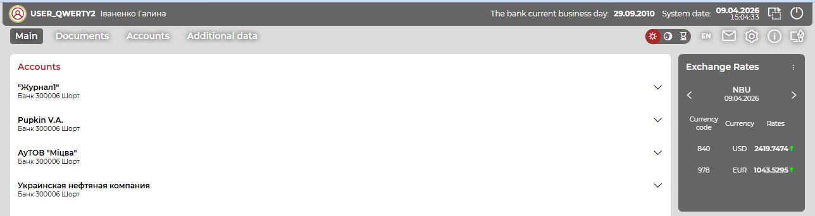
You can return to the normal interface by pressing the button.
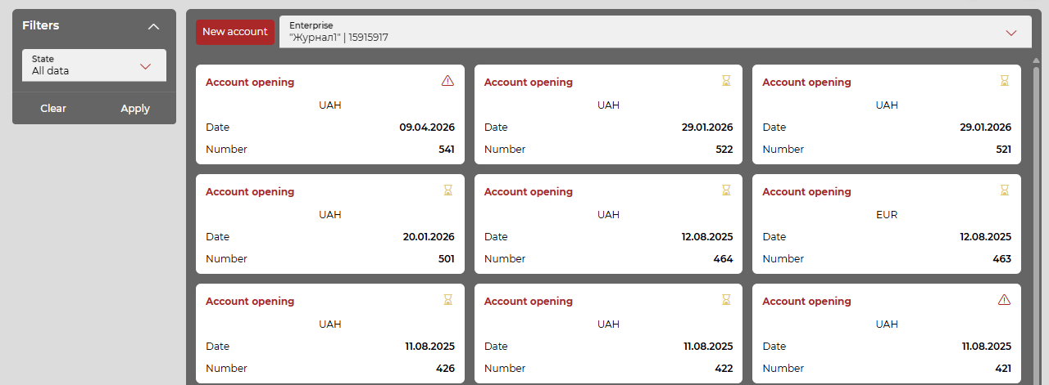
On the Product Portfolio page, you can:
- view the existing products available at the client's enterprises – a list of brief information about the product with their accompanying documents and an electronic contract (provided that the product is opened within the framework of the "Electronic contracts" subsystem);
- view products available for ordering and opening (displayed as tabs at the top of the screen);
- view product requests by product types under consideration;
- create and sign a new request for a product of a certain type;
- add document files to the request, sign them and send them to the bank (if the product provides for the transfer of files);
- receive electronic contract documents for review and signing;
- receive information from the bank about the current status of request processing, comments of the bank's services on the documents or request parameters;
- in certain statuses, the user has the opportunity to change the parameters of the request, add a comment in response to the comments of the bank's services, attach or replace the files of documents in the request (if the product provides for the transfer of files);
- in the status of readiness for signing, the user has the opportunity to sign the agreement prepared on the bank's side (or created automatically according to the template) for the product and service;
- In the final status, the user has the opportunity to view the request parameters, the history of communication with the bank, attached documents and agreements signed with one or two signatures.
At the current stage of subsystem implementation, the following products/services are available:
- electronic contract: "Opening an account" - see "Opening a current account".

Opening a current account
In the "Product portfolio" section of the "Current Accounts" tab, a list of requests and products with concise information is displayed. The list is presented in the form of blocks with data: one block – one request/product.
The filter block allows you to filter existing requests by statuses (select the desired status from the drop-down list and click on the "Apply" button).
The "New account" button allows you to proceed to the creation of a request for opening a new account (see "Creating and signing a request").
The first on the page are requests that are being processed, i.e. they have the following statuses:
- "Pending";
- "Not sent";
- "Rejected";
- "Waiting for processing";
- "Under processing";
- "Requires clarification";
- "Cannot be executed";
- "Waiting for signature by the client";
- "Canceled".
Please note: you can hover over the icon in the upper right corner of each block to see its status.
After the requests that are being processed, completed requests are displayed, i.e. in the "Executed" status, for which an account was opened and an electronic contract was concluded, and at the end of the list, open accounts of the enterprise that were opened outside the "Electronic contracts" subsystem are displayed. Invoices for the enterprise are displayed without reference to the rights of the current user to them.
Each block is a reference, when selected, the corresponding transition is performed:
- from the block of the request that is being processed – to the form of viewing or editing the request (see "Review the request");
- from the block of the completed request – to the form of its review (see "Product and Electronic Contract Review");
- from an account block that was opened outside the "Electronic Contracts" subsystem, the transition is not expected.

Creating and signing a request
To create a request for opening a new current account on the "Product portfolio" page in the "Current accounts" subsection:
- in the Enterprise field, select the enterprise on behalf of which the request will be created;
- click on the "New account" button;
- fill in the request fields (see the description in the table below);
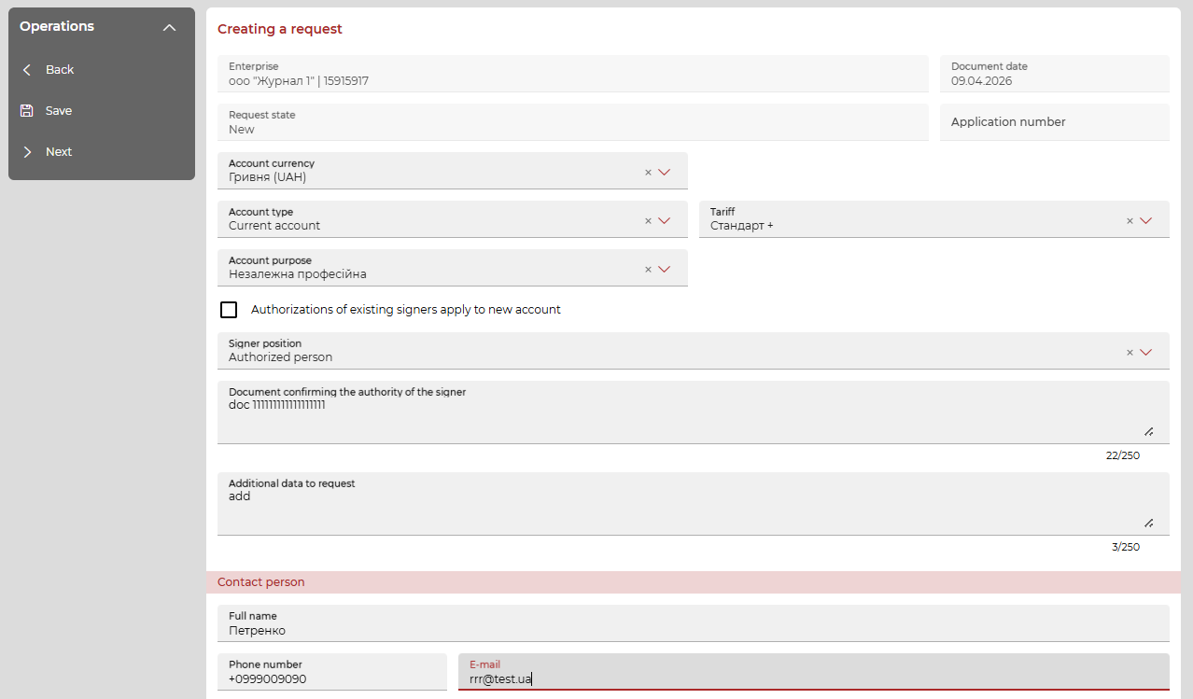
Description of elements:
Element | Description
The "Request" section
Enterprise | Enterprise from which the request is created.
Request number | Request number. Generated by the system and filled in automatically without the possibility of editing. The number is assigned when saving the request, i.e. the field will be empty on the form for creating a new request, when hovering over it, the prompt "The field will be filled in automatically when saving the request" is displayed.
Request state | Current status of the request. Displayed for information. When creating a new request, the value "New" is displayed. If the request has already been saved, then its valid assigned current status is displayed
Request date | Date of creation of the request. Filled in automatically with the current calendar date without the possibility of editing. Format – DD.MM.YYYY
Account currency | Drop-down list with available currencies. The list contains the following currencies:  - Hryvnia of Ukraine (UAH);  - Euro (EUR);  - US Dollar (USD);  - Polish zloty (PLN);  - Swiss franc (CHF);  - Pound sterling (GBP).  The user has the opportunity to select several currencies from the list.
Account in national currency | Drop-down list of accounts in national currency.  - if you select a national account in the "Account currency" list, it means that you want to open a new account in the national currency, in which case the Account in national currency field is not displayed;  - if there is no national currency in the "Account Currency" list among the selected currencies, it means that you want to open a new account in foreign currency, i.e. a multi-currency account linked to an existing account in the national currency, in which case the Account in national currency field is displayed and can be edited. Required for a foreign currency account
Account type | Drop-down list with types of accounts to open:  - Current account. Required
Tariff | Drop-down list for selecting a tariff.
Purpose of using the account | Drop-down list for selecting a target:  - economic/entrepreneurial;  - independent professional;  - activities that are not related to entrepreneurial activity. Several positions are available for selection.
Checkbox "Authorizations of existing signers apply to new account" | Optional. With the checkbox disabled, the request can only be saved without a signature. With the checkbox enabled, the request can be signed and sent to the bank
Signer position | Drop-down list:  - "Chief executive";  - "Authorized person". Required
Document confirming the authority of the signer | Data about the document confirming the authority of the signatory of the request for opening an account. Text field for entering data on the document. Maximum 250 characters. Required
Additional data to request | Additional information to the request for opening an account.  Text field for entering additional information on the request. Maximum 250 characters. Required
The "Contact person" section
Full name | Entering the name of the authorized person for contacting the request. Maximum 90 characters. Required
Phone number | Entering the phone number of the authorized person for contacting on the request. Maximum 13 characters. Only numbers and a "+" sign as the first character
E-mail | Entering the email of the authorized person to contact the request. Maximum 60 characters. Required
The “Signatures” section.
The section and data in it are displayed by the presence of a signature on the request.
Signature | The full name of the user who has applied an electronic digital signature to the request and documents on it is displayed
The following operations are available on the form:
- "Back" – return to the "Product portfolio" section to the "Current Accounts" section without saving the current changes.
- "Save" - save the data of the electronic request form. You can save the request without filling in the required fields, while the system will display the message "Required fields not filled in" with the "Save" and "Cancel" buttons. The "Save" operation saves the request, the "Cancel" operation does not save and you will remain on the form.
- When performing the "Next" operation, if you have not checked the checkbox "The powers of current signatories are confirmed", the system will display a message - "Update the data of the legal case and provide the bank with supporting documents data change. After updating and checking the documents by the bank, you will be able to make a request to open a new account", further actions with the request will not be possible until the data is updated. See "Signing a request and electronic documents").

Signing the request and electronic documents
After completing the "Next" operation on the request form for opening an account, the system will generate and display the relevant supporting documents and offer to view and sign them.
Documents for viewing are displayed in the form of PDF files in the browser pop-up window "Electronic contract" – each on a separate tab.
For a request for opening a current account, the window displays the following documents, each on a tab with its respective name:
- "Request for opening a current account";
- "List of persons authorized to manage the account";
- "Bank account agreement".
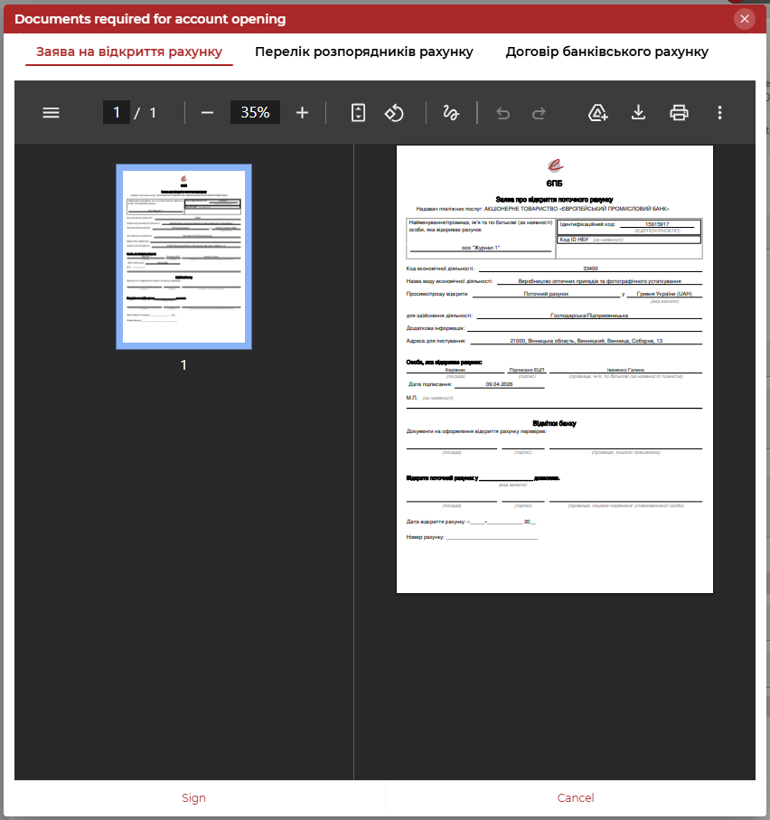
View the generated documents in the appropriate tabs; You can also download or print them using the standard capabilities of the browser.
- "Sign" - EDS is applied to the documents.
Please note: the button is displayed if you have the appropriate signing right and the EDS key. If there is a signing error, the window with documents closes, you remain on the request form in edit mode with an error message, and you can continue to perform operations with this request.
- "Cancel" - the window with documents closes, you remain on the request form and can continue to perform operations with it.

Viewing the request
The previously created request has a structure with additional functionality - the ability to exchange messages with the bank. The page is divided into tabs with the following names:
- "Editing a request" or "View a request" - tab with request, the name of the tab depends on the mode in which the request was opened;
- "Comments" - a tab for exchanging comments (messages) with the bank;
- "Documents" - the tab contains a list of documents that are included in the package of the electronic contract for opening an account.
At the top of the request view form, there is an icon for updating request data , with which you can force updating the request (its status, comments, etc.).
To view the request for opening a new current account, go to the "Current accounts" subsection and click on the block with the desired request.
The request, depending on the status, opens in view or edit mode.
A request in the "Not sent" status opens in full editing mode: you have the opportunity to edit all request fields (except for the Request Number and Request Date fields). If you change any fields, the signatures will be deleted, so you will need to sign again. The request form looks the same as the form for creating a new request - see. "Creating a request". In this case, only the tab with the main parameters of the request is active, there are no comments and documents).
A request in the status "Requires clarification" opens in view mode, all fields on the main tab of the request are not available for editing. You have the option to add comments in the "Comments" tab.
The "Comments" tab displays all comments and allows you to add a new comment (fill in the Comment field and click on the "Add comment" button). After successfully adding a comment, you can either close the request and go to the tabular form with requests, or stay on the view form and update the comments (the button).
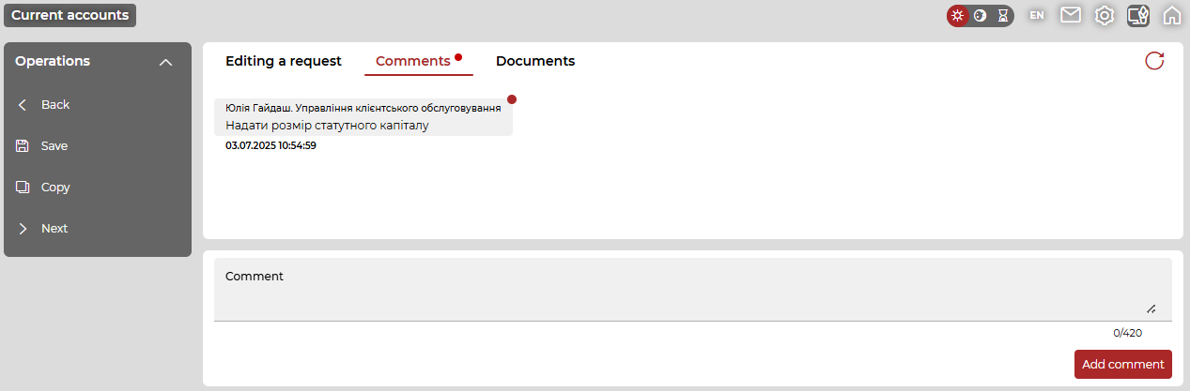
The "Documents" tab is available and displays a list of documents, each document can be downloaded by clicking on the corresponding icon next to the document.
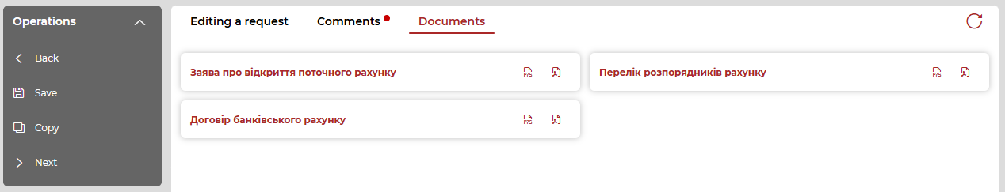

Requests in all other statuses are opened in view mode, i.e.:
- on the "View request" and "Comments" tabs, all data is available only for viewing without the ability to edit them;
- The following operations are available:
  - “Back” – return to the list of the "Current accounts" section;
  - "Delete" – delete the request; the operation is available for requests in the final statuses: "Rejected", "Cannot be executed", "Canceled". The deletion operation is accompanied by a request for additional confirmation.
  - "Copy" - an operation for copying a request. When copying in a new request:
    - the enterprise remains as in the old request;
    - the number and date of the request are generated new as when creating a new request;
    - other fields are transferred to the new request as is, except for those fields that are selected from the reference books;
    - The status is displayed as "New" for the new request.
    - Correspondence from the "Comments" tab is not transferred.

Product and e-contract review
To view the completed request for opening a new current account – for both the "completed request" type and the "open account" type, in the "Current accounts" subsection, select the block with such a request or the block with the account.
- "Executed request" is a request that is in the "Executed" status and for which an electronic contract and an open account have been signed, but this account is not monitored by the iFOBS client;
- "Open account" is a request that is in the "Executed" status and for which an electronic contract was signed and an account was opened, which is monitored by the iFOBS client.
The completed request is opened on the page in view mode (see above).
When you select the "open account" type, a page with the name "View an account" opens in the view mode. A description of the data displayed on the page is given in the table below.
Element | Description
The "Account Information" section:
IBAN | Account number in IBAN format.Format: UA NN NNNNNN NNNNNN NNNNNN NNNN.
Account currency | Account currency
Account status | Current account status in the iFOBS database. Account status name displayed
Account type | Account type as specified in the opening request
Account opening date | Account opening date. Format: DD.MM.YYYY
Branch | Name of the branch where the account was opened
Current balance | Current account balance in account currency
Last movement date | Date of the last movement of funds on the account. Format: DD.MM.YYYY.
The "Electronic Contract" section:
Date of signing | Date and time of the last signature on the electronic contract for opening an account. Format: DD.MM.YYYY; HH:MM.
Electronic contracts | The list of documents that made up the package of the electronic contract for opening this account:  - "Request for opening a current account";  - "List of persons who have the right to dispose of the account";  - "Bank account agreement".  - "Account opening certificate".  Next to each document, there are icons linking to document files:  - "Save P7S" - to download the file by means of the browser in the form of a P7S container to the user's workplace;  - "Open PDF" – to open a PDF file of a document in a browser window, in which you can view it, send it for printing or upload it to your workplace.

Bank facsimile on printed documents
You have the opportunity to print out payment documents issued by the bank, as well as statements with a facsimile display of the stamp and signature of the authorized bank.
The facsimile seal and signature of the bank in Internet banking is applied to the following types of documents:
- Statement of accounts (stamp and signature at the end of the statement, if the statement consists of two or more pages, the facsimile will be displayed on the last page);
- Payment instruction in national currency (stamp and signature on the right in the Signature of payment service provider field);
- Payroll (stamp and signature on each page of the document in the lower right corner of the page);
- Payment instruction in foreign currency and SWIFT document (stamp and signature in the lower right corner under the Execution date field);
- Currency requests: sale/purchase/exchange (stamp and signature in the lower right corner of the document).
Applying a facsimile to a document is carried out only for documents in the "Approved" status (in this case, the bank must set the appropriate right for your account with parameters corresponding to the types of documents to be printed).
Applying a facsimile to a document is performed not only when printing the document, but also when it is saved (PDF format).
When generating a statement, you can set or disable the "Bank stamp" checkbox to display/not display the facsimile.
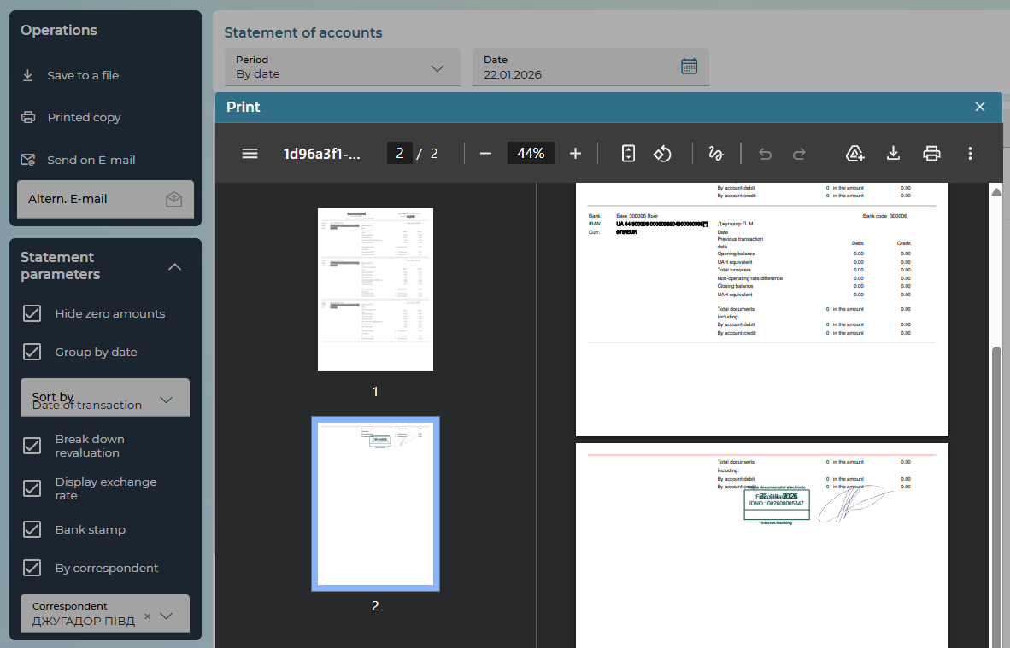

OpenBanking consents
If the bank is configured to work with OpenBanking consents, go to the settings (the button in the upper right menu), in the "Security" section, select OpenBanking consents.
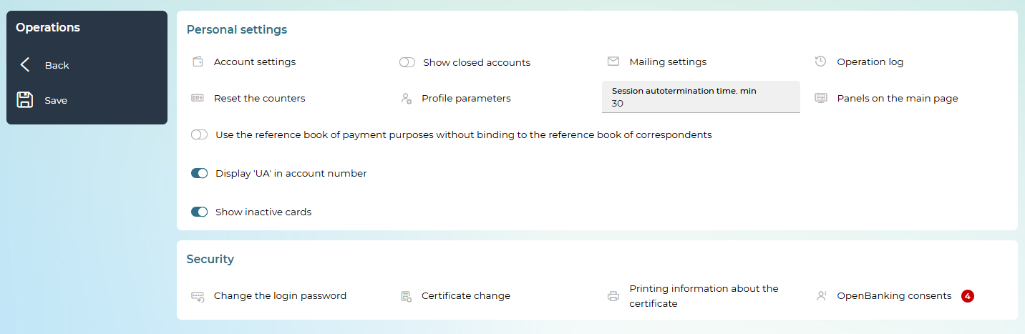

If the system has received consents for counteragents that are monitored by you, an indicator on the button will show the presence of such consents. Next to the OpenBanking consents menu item there is an indicator of the number of available consents will be displayed.
The counting of consents pending confirmation occurs when logging into the web client.
After opening the section, a list of existing consents will be displayed, the "Unconfirmed consents" tab is displayed by default.
The display of the "Unconfirmed consents" and "Consents given" tabs, as well as the operations available on the forms, depends on the set of rights that the bank sets for your account.
Sorting by type, date of creation or end, name of the enterprise or service provider is available on the form.
You can also search and filter using standard methods in the filters section.
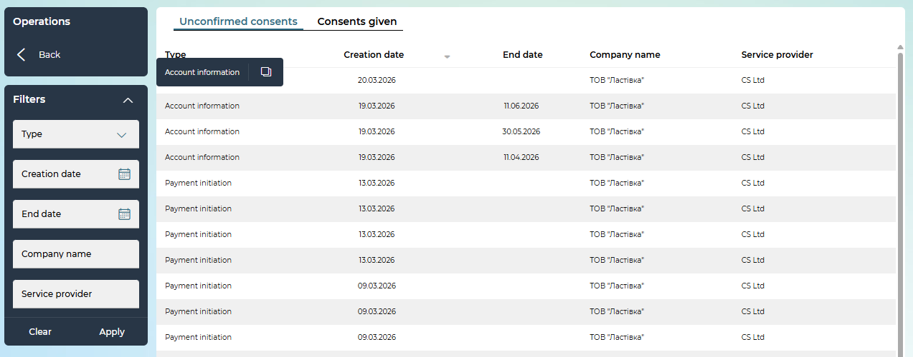
For approvals of the "Payment Instruction" type, the "Expiration date" parameter is missing.
Each line of the list is a link to a detailed form for viewing the consent, depending on its type: consent to the transfer of information on the account or consent to confirm payment.

Consent to the transfer of information on the account
At the top of the form, an informational text is displayed, containing the name of the third-party system from which the request was received, and a list of parameters for accessing accounts that the third-party system will receive: account details, balance check, transaction history.
The table displays the name of the counteragent for which the request was received, and the list of accounts, the relevant information on which will be transferred to the third-party system after confirmation of consent. Options for accessing accounts are determined by a request from a third-party system and are not editable (i.e., you cannot uncheck the active boxes in the columns "Account details", "Balance check", "Transaction history").
At the bottom of the form, the name of the third-party system from which the request was received and the date by which the consent is valid is displayed.
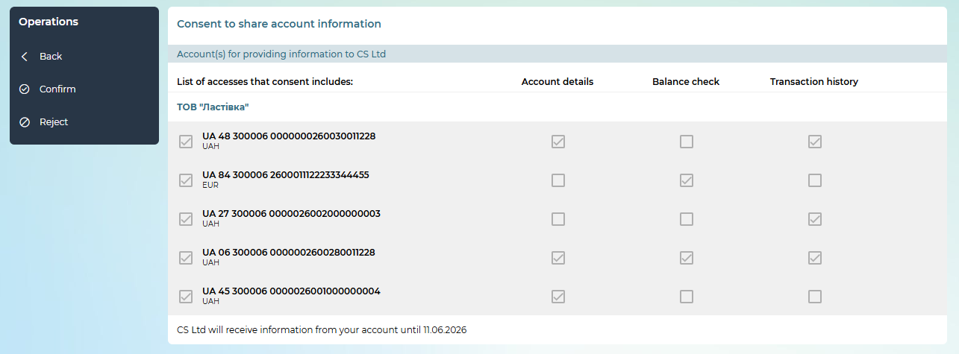
Please note: the accounts to which access must be granted may be defined in the request of a third-party system and in this case they are shown already marked (checkboxes are active in the first column on the form, you cannot uncheck the boxes).
When the accounts are not defined in the request, you will see a list of accounts in which you can select those that you want to provide access to as part of the consent (activate the corresponding checkboxes in the first column).
Please note: the "Confirm" button is only active if at least one account is selected.

The following active operations are available on the form:
- Return to the "Unconfirmed consents" list - the „Back“ button;
- Confirm consent – the "Confirm" button, see "Signing of documents". The number of signatures required to confirm consent is regulated by the bank's settings. After signing the consent with the required number of signatures, it is considered to have been granted, and the system recalculates the consents pending confirmation. You can view the list of consents provided in the "Consents granted" tab (see below "List of consents granted");
Note: additional confirmation using the OTP code for signing consents is not used.
- Reject consent – the "Reject" button, after clicking, the system displays a message about the successful rejection of consent and recalculates the consents pending confirmation.

Consent to confirm payment
You can initiate the creation of a payment from a third-party system and confirm such a payment on the iFOBS side. After selecting an unconfirmed agreement with the "Payment Instruction" type, the system will display an intermediate form with the data received in the request, after checking which you can go to the main form of creating a payment.
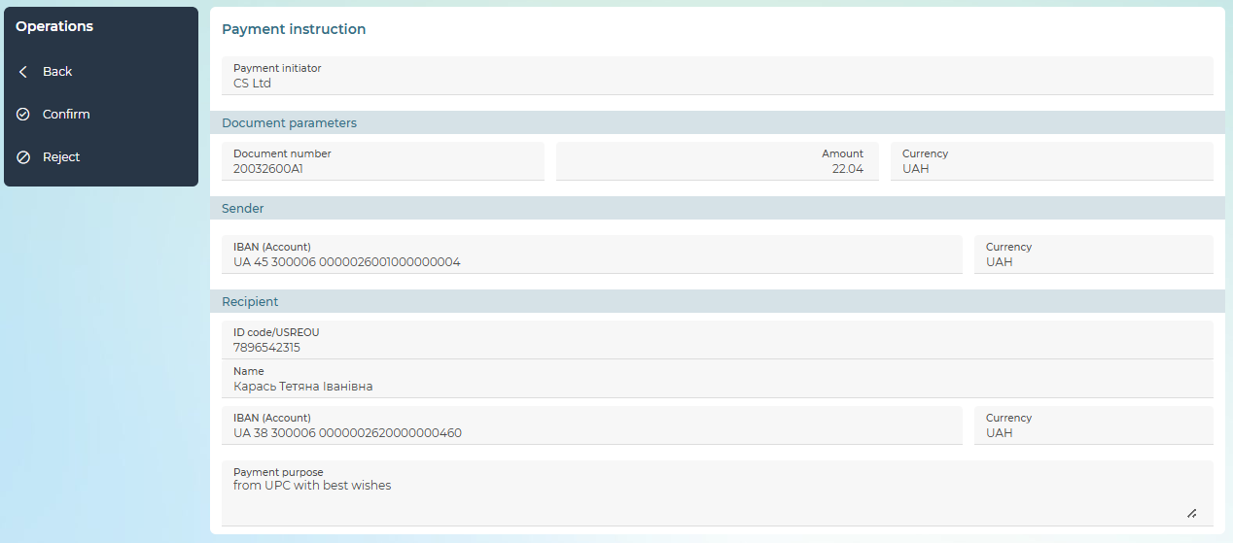
The following active operations are available on the form:
- Return to the "Unconfirmed consents" list - the „Back“ button;
- Reject consent – the "Reject" button, after clicking, the system displays a message about the successful rejection of consent;
- Confirm consent – the "Confirm" button, after clicking, the system takes the user to the form of creating a payment in the national currency, filled with consent data, see below.
Please note: this data will not be available for editing.

Please note: the number of signatures required to sign the request is regulated by the bank's settings for documents in the national currency. If the request was saved without a signature or not signed with the appropriate number of signatures, the request will go to the "Not all signatures" status, and the consent on the basis of which the request was created will still be displayed on the "Unconfirmed consents" tab. To re-sign the document, you need to go to the consent form and click on the "Confirm" button, after which the request form for creating a document in the national currency will open, on which the user can put the necessary signatures on the document.
After signing the document with the required number of signatures, it is sent to the bank for processing, and the consent is considered granted. Please note: Consents of this type are no longer displayed in the list of consents granted.

List of consents given
The “Consents given” tab displays a list of counteragents that are monitored by the user (if there are several counteragents). By default, all spoilers are displayed minimized. If there is only one counteragent, the list of consents provided under it will be immediately displayed.
To display consents by counteragent, click on the "Expand" button for the relevant counteragent. Please note that this list will only display consents with the "Account Information" type.
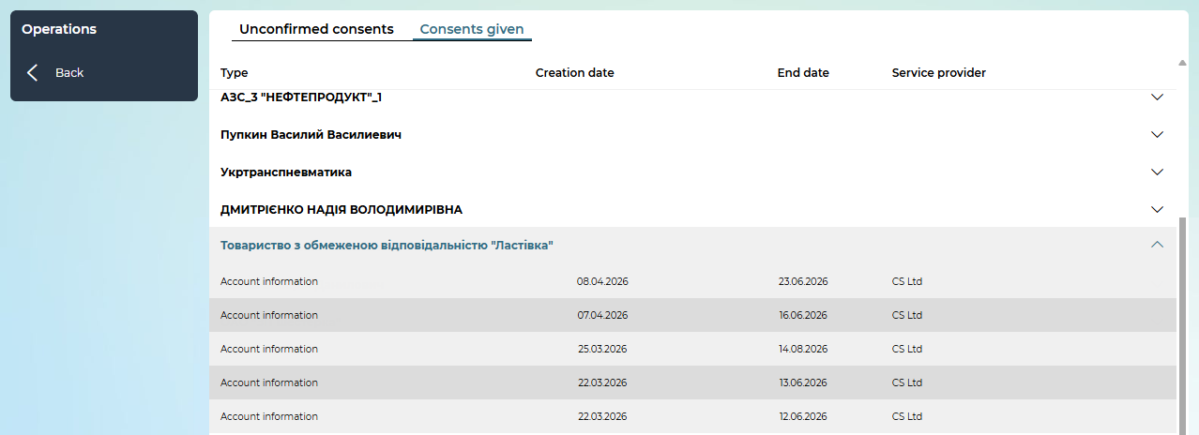
If available, the provided consents are displayed in the form of a list.
Each line is a link that you can follow to view a detailed consent form.
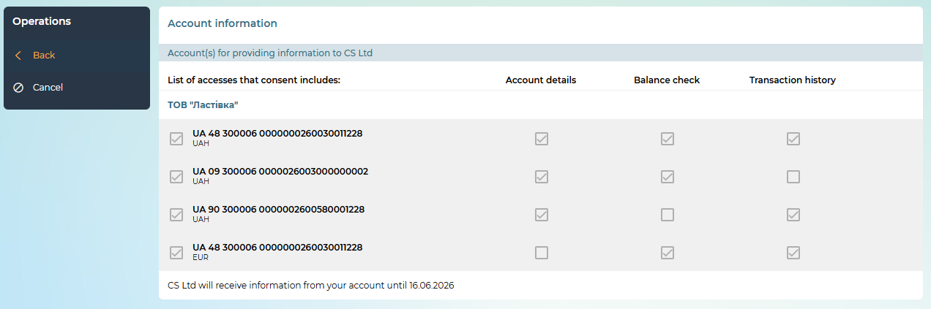
The following operations are available on the form:
- Back to the list "Consents granted" - the „Back“ button;
- Withdraw consent – the "Cancel" button, after clicking, the system displays a message about the successful withdrawal of consent.
If there are no consents for the counteragent, the system will display a corresponding message.

System Security Information
Do not disclose your username and password to third parties
The system identifies the user by login and login password. To avoid unauthorized access to your confidential information, do not disclose your data to third parties.
Use the "Exit" button after completing the system.
Distraction from the computer during active login, without ending the session with the program, can provoke a third party to take advantage of the situation.
It is not recommended to work with the system:
- in internet cafes and other similar places where there is no guarantee that your actions are not monitored by another person;
- in places where video surveillance devices are installed, with the help of which information about user passwords can be obtained;
- if there is no confidence in the security of the software you use (the presence of viruses, special programs that send user passwords to third parties, etc.).
If you suspect a security breach, contact the bank's contact center immediately.

